



United Nations Development Programme
Project Document template for nationally implemented projects
financed by the GEF Trust Funds

Project title: Sustainable development of Comoros Islands by promoting the geothermal energy resources.
Country: Union of Comoros | Implementing Partner: Vice-Presidency responsible for Energy – Comoros Geological Authority |  | Management Arrangements : National Implementation Modality (NIM)
UNDAF/Country Programme Outcome 4: The most vulnerable segment of the population is resilient to climate change and crises.
UNDP Strategic Plan Output 9: The country has in place a political, legal and regulatory framework to promote and develop renewable energy.
UNDP Social and Environmental Screening Category:  High Risk |  | UNDP Gender Marker:  GEN1: Gender equality as significant objective.
Atlas Project ID/Award ID number: 106929 |  | Atlas Output ID/Project ID number: 107410
UNDP-GEF PIMS ID number: 5484 |  | GEF ID number: 9040
Planned start date: July 2018 |  | Planned end date: June 2024
LPAC date: 21 April 2018

Brief project description:
This project aims to formulate a conducive policy/regulatory framework to develop and utilise geothermal energy on Grande Comore and promote investment in the development of geothermal resources for base power electricity generation. It will do so by leveraging almost $ 46 million in multilateral and private sector financing over its six-year implementation period. Over the same period, a 10 MW geothermal base power plant will be developed to supply the Grande Comore electricity grid to displace diesel fuel that is presently utilised. Operation of the geothermal plant will result in generation of some 2,390,000 MWh of electricity over an expected 30-year projected life of the installation. This, in turn, will result in avoiding 1,882,125 tonnes of CO₂ over the same 30-year projected lifetime of the equipment. The project will achieve this target by introducing a conducive framework for investment promotion in geothermal resources development on Grande Comore.

Financing Plan
GEF Trust Fund |  |  | USD 5,905,662
UNDP TRAC resources |  |  | USD 500,000
- Total Budget administered by UNDP |  |  | USD 6,405,662
Parallel co-financing (all other co-financing that is not cash co-financing administered by UNDP)
Government |  |  | USD 680,000
World Bank |  |  | USD 5,000,000
European Union |  |  | USD 3,700,000
African Development Fund |  |  | USD 20,000,000
Arab Fund for Economic Development |  |  | USD 10,000,000
Government of New Zealand |  |  | USD 5,000,000
Sustainable Energy Fund for Africa |  |  | USD 480,000
Fund for Countries in Transition (FAT) |  |  | USD 3,000,000
- Total co-financing |  |  | USD 47,860,000
- Grand-Total Project Financing (1) +(2) |  |  | USD 54,265,662
Signatures
Signature: print name below | Agreed by Government | Date/Month/Year:
Signature: print name below | Agreed by Implementing Partner | Date/Month/Year:
Signature: print name below | Agreed by UNDP | Date/Month/Year:

Table of Contents

I. Table of Contents 3
II. Development Challenge 5
III. Strategy 26
IV. Results and Partnerships 30
V. PROJECT MANAGEMENT 41
VI. PROJECT RESULTS FRAMEWORK 51
VII. Monitoring and Evaluation (M&E) Plan 56
VIII. Governance and Management Arrangements 61
IX. Financial Planning and Management 65
X. Total Budget and Work Plan 68
XI. Legal Context 72
XII. Mandatory Annexes 73
Annex A - Multi Year Work Plan: 74
Annex B - Monitoring Plan 76
Annex C - Evaluation Plan 79
Annex D - GEF Tracking Tool 79
ANNEX E: Terms of Reference 80
Annex F. Social and Environmental Screening Template 85
SESP Attachment 1. Social and Environmental Risk Screening Checklist 91
ANNEX G: UNDP Risk Log 95
ANNEX H: GHG Calculations 95
ANNEX I: FEASIBILITY ANALYSIS 97
ANNEX J: Environment and Social Management Framework 108
Annex H: STANDARD LETTER OF AGREEMENT BETWEEN UNDP AND THE GOVERNMENT FOR THE PROVISION OF SUPPORT SERVICES 112

List of Acronyms
AfDB African Development Bank
APR Annual Project Review
CO UNDP Country Office
CO₂ Carbon dioxide
EDA Electricité d’Anjouan (Anjouan Electricity Company)
EIA Environmental Impact Assessment
EU European Union
GEF Global Environment Facility
GHG Greenhouse Gas
IPP Independent Power Producer
kW Kilowatt
kWh Kilowatt-hour
MAMWE Madji Na Mwendje Ya Komor (Comoros Electricity and Water Company)
M&E Monitoring and Evaluation
Mtoe Million tonnes of oil equivalent
MW Megawatt
MWh Megawatt-hour
NGO Non-Governmental Organisation
NSDP National Strategic Development Plan
PANA/NAPA Programme d’Action Nationale sur l’Adaptation (National Adaptation Programme of Action)
QPR Quarterly Progress Report
PIF Project Identification Form
PIR Project Implementation Review
PMU Project Management Unit
PPA Power Purchase Agreement
PPG Project Preparation Grant
PV Photovoltaics
RSC UNDP Regional Service Centre
RTA Regional Technical Adviser
toe Tonnes of oil equivalent
UNDAF United Nations Development Assistance Framework
UNDP United Nations Development Programme
UNFCCC United Nations Framework Convention on Climate Change
$ United States dollar (Exchange Rate: 1 $ = 464 KMF, April 2017)

Development Challenge

The Union of Comoros is an archipelago island nation in the Indian Ocean, located at the northern end of the Mozambique Channel off the eastern coast of Africa, between Mozambique and Madagascar. The archipelago is comprised of three main islands: Grande Comore (Ngazidja – 52% of the population), Anjouan (Nzwani – 42% of the population) and Mohéli (Mwali – 6% of the population), totalling a land area of 2,034 km² and a fourth island, Mayotte, which has been administered by France since 31 March 2011. As per the last census undertaken in 2003, the total population was 576,000 inhabitants; in 2016, it was estimated to be almost 800,000, with approx. 72% living in the rural areas. Comoros is classified as a Small Island Developing State (SIDS) and a Least Developed Country (LDC). Mohéli (Fig. 1) is located some 50 km to the south of Grande Comore, while Anjouan is 60 km to the south-east. Just some 600 metres from the coastline, the ocean floor separating the islands makes a sudden sharp drop to 2,000 metres.

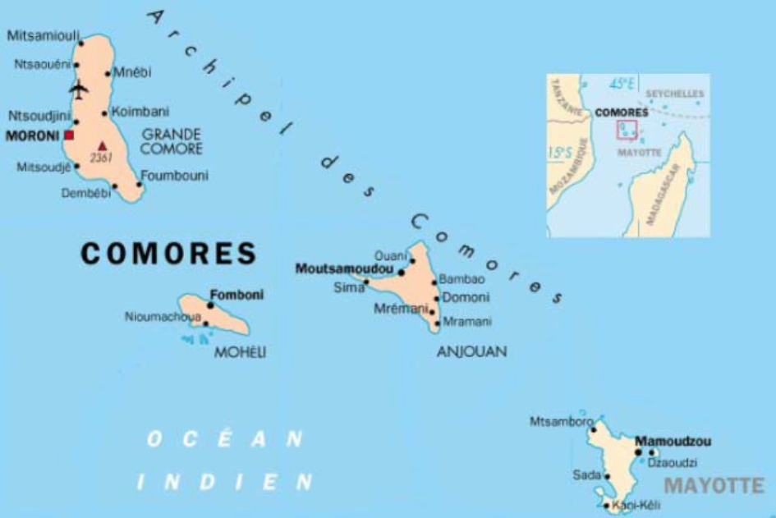
Fig. 1: Map of Comoros

The islands have a tropical climate, with two distinct seasons; a hot and humid season with relatively high precipitation from November to April and a dry season from May to October. There is little temperature variation throughout the year, with a max. of 31 deg. C and a min. of 24 deg. C.

Country Situation and Development Context

The main economic activities in the country are agriculture, fisheries, retail and public services. Agriculture represents 34% of the GDP (2016) and consists of the cultivation and sale of food crops such as cassava (tapioca), bananas and coconut intended for self-consumption; some products or their derivatives like vanilla and ylang-ylang are mainly meant for export. As per Government data, the per capita GDP in 2016 was $ 1,411 (654,825 FKM) and the GDP growth rate has been an average of 2%/year over the last few years. Data for 2014 show that almost 35% of the population then lived below the national poverty line. On the Human Development Index scale, the 2017 UNDP Human Development Report (HDR) ranks Comoros at 160th out of 168 assessed countries.

The primary energy supply in Comoros in 2016 consisted of biomass (in the form of wood, plants and crop residues – 72,020 toe), petroleum products (42,397 toe), electricity (16,553 toe) and renewable energy (78 toe), and their respective share in terms percentages is presented in Fig. 2 below.

Fig. 2: Primary Energy Supply (2016)

The main sources of energy are biomass (fuelwood and charcoal) and fossil fuels. Petroleum products, all imported, account for 38% of the energy balance and are used for transport, electricity production and, to a lesser extent, household use. Electricity generation is mainly based on diesel power plants. Biomass, in the form of plants and ligneous biomass, is used mainly for household cooking needs (75%), Ylang-Ylang distilleries (19%) and other activities (copra drying, lime carbonisation – 6%). Apart from biomass, the other renewable sources of energy (geothermal, hydropower, PV and wind) still occupy a negligible share in the energy mix. With regard to energy consumption by sector (Fig. 3), in 2016, transport dominated at 57%, with the remaining 43% shared between the electricity and household sectors.

Fig. 3: Energy consumption by sector (2016)

As per available data (2016), almost 100% of rural households and 80% of urban households use exclusively fuelwood for cooking while the remaining 20% of urban households use mainly charcoal, LPG or paraffin for that purpose. This massive use of biomass (Fig. 4) consisting of fuelwood and charcoal contributes to rapid depletion of the country’s forestry resources, leading to deforestation, with hardly any reforestation being undertaken to replenish the biomass stock. In this connection, it is estimated that the annual biomass consumption in Comoros is approx. 225,000 tonnes.

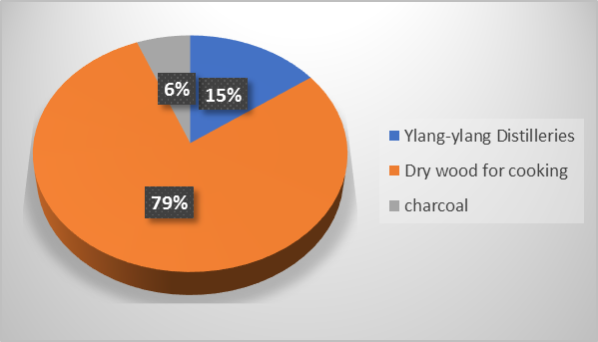

Fig. 4: Biomass consumption by sector

Paraffin, locally known as “pétrole lampant”, used to be the fuel of choice for lighting in the rural areas and at times of power cuts during the night hours, but has gradually been replaced by candles and/or small solar PV lighting kits utilising LEDs.

Electricity Supply
Electricity in the country is provided by the Government-owned national power company MAMWE (Madji Na Mwendje Ya Komor), which has the mandate to generate, transmit, distribute and market electricity throughout Grande Comore and Mohéli; MAMWE is also responsible for potable water supply on the islands. For Anjouan, electricity services are under the responsibility of the Anjouan Electricity Company (EDA); it is also Government-owned but operates independently of MAMWE.

While access to electricity services in the country is slightly above 50 percent (Grande Comore – 60%, Anjouan - 50% and Mohéli - 20%), the World Bank Country Partnership Strategy (April 2014) notes that “similar to the rest of sub-Saharan Africa, electricity is only available sporadically”. Consumers living in the capitals of the 3 islands and in their immediate vicinity receive unreliable electricity supply for most of the day. On the rest of the islands, electricity is supplied for only a few hours a week, if at all. “The main constraining factor to normal service provision is the high cost of imported petroleum products used for power generation. Due to their poor performance in terms of billing and collection, the two Comorian power utilities (MAMWE and EDA) are only able to pay for a portion of their fuel consumption. The corresponding losses are borne by the Société Comorienne des Hydrocarbures (SCH) which in turn finds itself unable to fully pay the State for the taxes collected on fuel. As a result, the energy sector represents a high burden on public finances: it is estimated that total de facto subsidies to the energy sector annually reaches approximately 10 percent of the operating budget of the State. The average electricity tariff (around 33 US cents/kWh - see more below) is high compared to most Sub-Saharan countries, reflecting the economics of a small system with generation based almost exclusively on expensive diesel fuel. Nevertheless, MAMWE is unable to purchase fuel and carry out periodic maintenance on generators”. In this connection, it is worth noting that MAMWE and EDA consume approx. 35,000 litres of diesel on a daily basis for electricity generation and the cost of this fuel amounts to $ 20 million/year, representing almost 4% of the country’s GDP and a heavy drain on the country’s hard currency reserves. Any spikes upward in the presently relatively “low” price of oil can cause a major shock to the country’s economy.

Both MAMWE (initially known as Electricity and Water Company of Comoros (EEDC - Entreprise Electricité et Eau des Comores), then renamed «Société Comorienne de l'Eau et de l'Electricité (CEE – Water and Electricity Authority of Comoros) in June 1997 and renamed again in June 2003 to MAMWE) and EDA are companies that were established in 1994 and 1997 respectively; they are both fully owned by the Government. Their total installed generation capacity (Tables 1) is 31.12 MW, consisting of 30.48 MW of diesel on all 3 islands and 590 kW of hydro plants only on Anjouan and Mohéli – there is no hydropower potential available on Grande Comore. However, as of December 2016, only 250 kW of hydro capacity at Lingoni was in operation, with the remaining 340 kW being under maintenance.

Table 1: Installed and available generating capacity for Comoros (Grande Comore, Anjouan and Mohéli (May 2017)
Type | Location | Installed Capacity | Available Capacity | Present Status
Diesel | Voijdou, Grande Comore | 16 MW | 16 MW | Operational
Diesel | Itsambouni, Grande Comore | 2.8 MW | 2.8 MW | Operational.
 | Total Grande Comore | 18.8 MW | 18.8 MW
Diesel | Fomboni, Mohéli | 5.38 MW | 5.38 MW | Operational
Diesel | Trenani and Lingoni, Anjouan | 6.3 MW | 6.3 MW | Operational.
Grand Total Diesel |  | 30.48 MW | 30.48 MW
Hydro | Miringoni, Mohéli | 40 kW | 0 | Under maintenance
Hydro | Lingoni, Anjouan | 250 kW | 250 | Operational
Hydro | Marahani, Anjouan | 300 kW | 0 | Under maintenance
Grand Total Hydro |  | 590 kW | 250 kW
Grand Total (Diesel + Hydro) |  | 31.07 MW | 30.73 MW

To supplement the diesel-based electricity generation on Grande Comore, the Government has signed a cooperation agreement with the Government of India to construct an 18 MW heavy fuel power station that is scheduled to enter into operation in early 2018. This decision was made in order to relieve Grande Comore of the almost daily occurrence of load shedding due to the absence of sufficient generation capacity on the island.

Transmission of electricity from the power stations serving Grande Comore is through 285 km of medium voltage lines at 21 kV (except for part of Moroni that is supplied by the Itsambouni power station at 20 kV – on the other islands, the medium voltage is 21 kV), with 3 separate feeders departing from the Central Voijdou power station. Feeder 1 supplies power to the city of Moroni and includes the Itsambouni diesel generation facility. Feeder 2 supplies power to the northern and eastern part of the island and Feeder 3 supplies the southern part of the island. The low voltage 380/400 V 3-phase distribution system on Grande Comore (the same low voltage is used on Anjouan and Mohéli) covers 3,050 km of lines. With regard to Anjouan and Mohéli, the corresponding lengths of medium voltage (MV) lines are 211 km and 38 km respectively, while the lengths of low-voltage (LV) lines are respectively 2,155 km and 630 km.

Table 2: Consumers, Transmission and Distribution Lines Overview
Line | Number of Consumers | Length of medium voltage lines, km | Length of low voltage lines, km
Grande Comore | Admin. Bldgs: 150  Medium Voltage: 58  Low Voltage: 45,130 | 285 | 3,050
Anjouan | Admin. Bldgs: 51  Medium Voltage:15  Low Voltage: 26,348 | 211 | 2,155
Mohéli | Admin. Bldgs: 29  Medium Voltage: 1  Low Voltage: 6,500 | 38 | 630

Table 3 below provides figures of total electricity generation in the country over the last few years, with a breakdown between hydro and thermal sources.

Table 3: Electricity Generation

Year | Grande Comore (kWh) |  | Anjouan (kWh) |  | Mohéli (kWh)
 | Diesel | Hydro | Diesel | Hydro | Diesel | Hydro
2008 | 33,755,139 | 0 | 9,126,355 | 2,628,000 | n/a | 148,920
2009 | 23,683,566 | 0 | 12,965,440 | 2,628,000 | n/a | 148,920
2010 | 32,737,542 | 0 | 15,399,225 | 2,628,000 | n/a | 148,920
2011 | 23,715,021 | 0 | 15,622,862 | 2,628,000 | n/a | 148,920
2012 | 26,205,824 | 0 | 16,857,081 | 2,628,000 | 4,507,750 | 0
2013 | 46,064,826 | 0 | 18,773,192 | 2,628,000 | 3,492,261 | 0
2014 | 39,169,216 | 0 | 12,361,145 | 2,628,000 | 3,180,360 | 0
2015 | 22,308,456 | 0 | 12,445,676 | 2,628,000 | 3,568,605 | 0
2016 | 38,121,961 | 0 | 15,349,085 | 2,190,000 | 3,890,900 | 0

The domestic sector (households) is the biggest electricity consumer at 63% followed by the services sector at 18%, industry at 14% and public lighting at 5. The annual per capita electricity consumption is 51 kWh , significantly below the African average of 579 kWh and the world average of 2,777 kWh. As per Jacobs, MAMWE’s losses in its transmission and distribution system are reported to be as high as 48% (Aboud, 2015). Conservatively, 17% of these are technical losses due to the “dilapidated nature of the power grid”, and commercial losses (including fraud/illegal connections) amount to 31% (AfDB, 2016). The World Bank (2013) indicates that “MAMWE’s billing rate is 55% and it then collects only 58% of the amount billed, with no collection from the public sector, as the Government pays for about 60% of fuel purchases and offsets their power consumption against fuel bills”. While 96% of the villages on Grande Comore have been electrified, only 60% of the households is reported to be connected to the grid. The corresponding figure for Anjouan and Mohéli are, respectively, as follows: Anjouan – 98 % of villages electrified and 48% of households connected; Mohéli - 71% of villages electrified and 65% of households connected.

Both MAMWE and EDA use a simplified tariff for billing consumers. For low and medium consumers (consumption of up to 1,400 kWh/month), the flat rate of 132 KMF/kWh (equivalent to US 28.4 Cents/kWh) and for large consumers (consumption over 1,400 kWh/month), the flat rate is 90 KMF/kWh (equivalent to US 21.6 Cents/kWh). It should be noted that the cost of diesel electricity generation at the bus-bars of MAMWE and EDA power stations is an average of US 48 Cents/kWh, to which should be added the cost of delivery of electricity to consumer premises, inclusive of the grid losses. However, as the cost of electricity generation is on an average twice the rate charged to consumers, it is evident that the utilities (especially on Grande Comore where electricity generation is 100% diesel-based) run at considerable loss year in, year out. For Anjouan and Mohéli, the average cost of hydro-electricity generation at the bus-bars is US 0.04 US Cents/kWh.

The last MAMWE financial audit report for 2011 was issued in July 2012; there is an audit exercise being implemented now and the report is expected to become available within the next few months. The latest financial audit report took note of the “Absence of a budgetary system that did not allow for the definition of objectives to be achieved, the measures to be implemented, the conditions of operational equilibrium with regard to jobs and resources and a system of checks and balances”. It also revealed discrepancies between bank and in-house account statements.

Renewable Energy Sector

At the present time, there exists no Government policy nor a defined framework for renewable energy (geothermal, hydro, biomass, solar, wind, etc.) development in the country. This is despite the fact that the country possesses, following preliminary investigations, very good geothermal potential on Grande Comore, solar resources on all three islands and hydro resources on Anjouan and Mohéli that can be further developed to put it on a sustainable energy development path.

At the request of the Government, UNESCO did formulate a Renewable Energy Policy in 2010 that proposed a strategy that would include a reduction in the importation of fossil fuels through increasing the share of renewable energy in the energy mix, development of pilot projects that have the potential for demonstration and replication, formulation of financial mechanisms to support Government plans, strengthening the institutional framework and capacity development.
Unfortunately, the Renewable Energy Policy still remains at the draft stage and has yet to be finalised and approved by the Government.

Geothermal Energy

Mount Karthala is an active volcano located on Grande Comore at 2,361 m above sea level. It is the southernmost and larger of the two shield volcanoes (named as such for the solidified lava resembling a warrior’s shield lying on the ground) on the island, with the second smaller one being the Massif de la Grille located in the northern part of the island - Karthala is somewhat similar to the Mauna Kea, a shield volcano on the Big Island of Hawaii. The Massif de la Grille has not been active for many years now and is not considered to have good potential for geothermal resource exploitation, although its proximity to the Karthala (10 km away) may suggest otherwise. On the other hand, the Karthala volcano (Photo 1) is very active, having erupted more than 20 times since the 19th century. Frequent eruptions have shaped the volcano’s crater which is 3 km wide from east to west by 4 km wide from north to south. Access to the caldera is by vehicular traffic along a rough terrain for the initial part up to the village of Mvuni and the remaining 15 km from there is presently accessible only on foot. The last lava flow at Karthala was in January 2007, but eruptions have been documented to occur every 11 years, on an average.

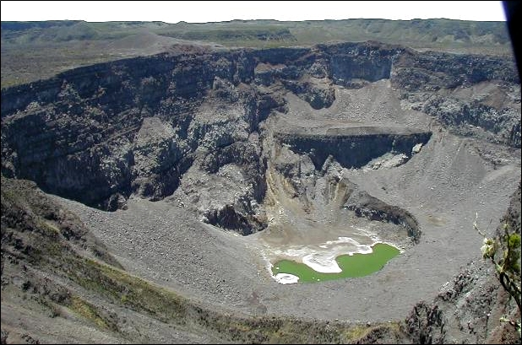

Photo 1: Karthala Crater

A first assessment, made ​in 2008 as part of a geophysical survey and supported by New Zealand, revealed the presence of an active geothermal reservoir, with the key indicator of a potentially exploitable geothermal resource being the rift system associated with the active volcano that may extend all the way west to Kenya’s Great Rift Valley where 636 MW of geothermal energy is presently under exploitation. This first assessment, coupled with subsequent surface exploration around the Karthala basin undertaken with the support of international partners, point towards the potential of ultimately generating some 40 MW of base-load electricity.

Hence, the scope for harnessing the geothermal resource potential resources of Karthala for electricity generation appears very promising, but the bottleneck has been lack of Government resources to complete the studies that would definitely confirm the potential for development. In addition to completing the technical studies, such social issues as land ownership, access to the site, public education about the project, potential benefits to the local community, lower cost electricity supply, etc. need to be assessed. This would also include a strategy for geothermal power development, recognising the facts that any development will put on harbour facilities to bring in heavy equipment from overseas, roads (existing and new) to transport the equipment to the site, local water supplies required during drilling and construction, and availability of competent contractors on the island. Finally, the absence of a clear policy that will promote and facilitate private sector participation in renewable energy development, including that of geothermal energy, acts as a deterrent and needs to be addressed.

Hydropower

There are no rivers on Grande Comore and, thus, there is no potential for hydropower development on this island. However, the situation is very different on Anjouan and Mohéli, as illustrated in Table 4 below. At the present time, only 2x300 kW each run-of-the-river power stations exist on Anjouan, while the exploitable potential, as per reports prepared by MECPL (Mohan Energy Corporation Pvt Ltd.) in 27 January 2014 and a Mauritanian Consulting Group in 2016 on behalf of the Vice-Presidency responsible for Energy, points to a potential of 7.45 MW that can be developed. With regard to Mohéli, the presently installed capacity is 20 kW, again, a run-of-the-river power station, while the estimated exploitable potential is reported to be 970 kW.
Table 4: List of Identified Small Hydropower Sites and Potential Power Generation on Anjouan and Mohéli
 | Site | Installed Capacity | Proposed Capacity *
 | Anjouan
1 | Tatinga | None | 3.5 MW
2 | Marahani | 300 kW | 900 kW
3 | Lingoni | 300 kW | 2.8 MW
4 | Galani | None | 250 kW
Total for Anjouan |  | 600 kW | 7.45 MW
 | Mohéli
1 | River Ouabouchi in Miringoni | 20 kW | 120 kW
2 | River Chikoni | None | 50 kW
3 | Fomboni | None | 440 kW
4 | Bangoma | None | 180 kW
5 | Mioumachou | None | 180 KW
Total for Mohéli |  | 20 kW | 970 kW
*Sources: Interim Report, Vice-Presidency responsible for Energy, July 2016 and MECPL Report.
Solar Energy
Comoros has good solar energy resources with an average of 7 hours of sunshine per day throughout the year and an average annual radiation level of 6 kWh/m²/day. Average monthly values of solar radiation indicate that they are lowest (5.1 kWh/m²/day) in January through March and highest from May through December (7 kWh/m²/day). Hence, solar energy is considered as having a very good potential on all 3 islands of the country.
In Comoros, Solar energy is traditionally used for drying agricultural products in the open; in addition, since the 1990s solar PV panels started being available in the country for battery charging and for use as Solar Home Systems (SHS) from such companies as Netisse Energie, Station Energy, Comores Enercom, etc. In 2013, the Chinese Government supported the installation of 500 SHS of 200 W capacity each at public buildings such as health centres, police stations, mosques, schools where evening classes are held, etc.: 200 of these SHS were installed on Grande Comore, 180 on Anjuoan and 120 on Mohéli. In addition, the Government of India sponsored the training of 6 women in 2014 on the installation and maintenance of solar home systems.
As per the Comoros Customs Department, an estimated 1 MW of PV panels of various capacity ranging from 5 W to 200 W have been imported into the islands, but there is no inventory of the sites where they have been installed or are being used. In view of the frequent power cuts on the islands, some “higher-income” households have purchased SHS for lighting, charging mobile phones and watching TV during black-outs. With regard to cost, a 200 W SHS complete with battery and DC/AC converter retails for approx. $ 1,000 installed. In addition, the 2 mobile phone companies operating on the islands power some of their transmitters with PV.
Wind Energy
Very little data is available that can validate the potential for utilising wind energy in the country. At the present time, the only in-country experience with wind electricity generation relates to the following:
A Ukrainian company installed 2x1.5 kW wind generators at Mremani on Anjouan in 2009 for mechanical water pumping, but these never got to operate successfully and were subsequently abandoned. In addition, in 2016 a private consumer installed 2x1 kW and 1x1.5 kW wind generators on the roof of his house at Singani (Grande Comore) to operate in a hybrid configuration with PV (Photo 2) and the electricity generated is used to power his home appliances.
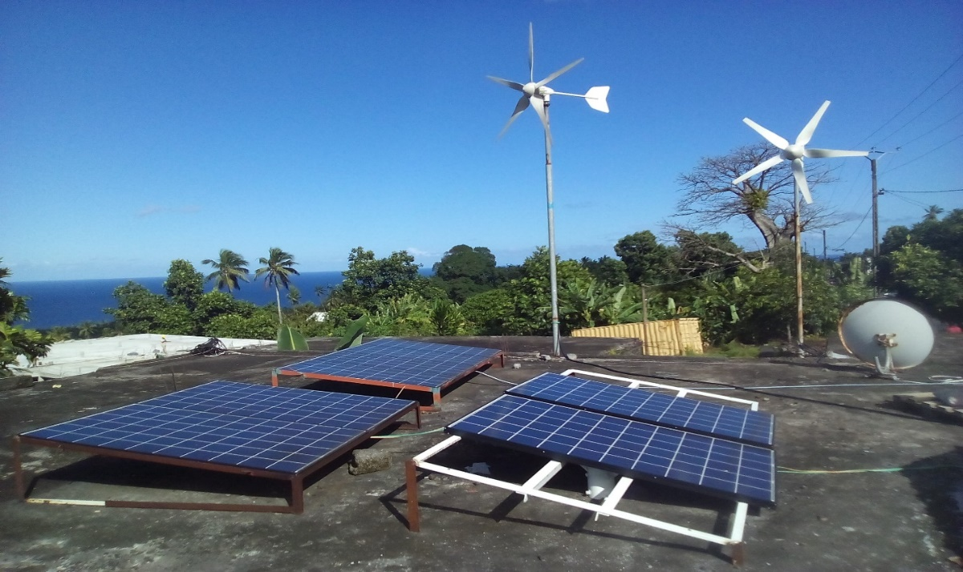
Photo 2: Hybrid Wind-PV system for private home (Courtesy: Dr Abdou Ali Soumail).
Moreover, a study financed by the European Union in 2012 estimated, through extrapolation of data at the “meteorological height” of 10 metres, that the average wind speed at a height of 50 m would be slightly above 5 m/s, but this was never validated through actual measurement. However, a wind map for the whole of Africa prepared jointly by the Agence Française de Développement (AFD) and the African Development Bank (AfDB) in 2009 indicates an average wind speed of 4 m/s at a 50-m height for Comoros. Be that as it may, a wind speed of 4-5 m/s at a hub height of 50 m does not lend itself for bulk electricity generation from wind. However, there may be certain sites high up in the mountains, especially on Grande Comore, where the average wind speed could be higher at 50 m height (the minimum hub height of a wind electricity generator) and these could potentially be used for installing wind generators. Hence, it might be worthwhile to initiate a serious study to determine the wind power potential on all 3 islands of the country to ascertain the share of wind energy, if any, in the country’s energy mix for grid electricity generation.
Biomass
As indicated earlier, wood remains the fuel of choice for 80% of the population for cooking and all the wood utilised is harvested locally, with no reforestation taking place. In addition, it is used to meet the needs of Ylang-Ylang distilleries. Wood consumption has been increasing over the years due to the demographics of the country. Annual wood consumption is estimated at 170,000 m³ at the household level and 55,000 m³ at Ylang-ylang distilleries; it is retailed at approx. $ 225/tonne. With regard to household trash, approx. 3 tonnes are produced and collected on Grande Comore on a daily basis, as per data provided by the Moroni mayor’s office; hence, the feasibility of a biogas/landfill gas project is being looked into to utilise this biodegradable waste for electricity generation. With regard to woody biomass for electricity generation, no serious project can be envisaged, as utilising forestry biomass for this purpose will lead to a massive depletion of the vegetation/forestry cover on the islands, resulting in weather-related soil erosion and land degradation.
The Case for utilising geothermal energy on Grande Comore for base-load electricity generation
Based on preliminary studies made using local weather data, the performances of both wind and solar technologies were established. Using information available from the project development team, a series of economic assessments were made for wind, solar, hydropower and geothermal.
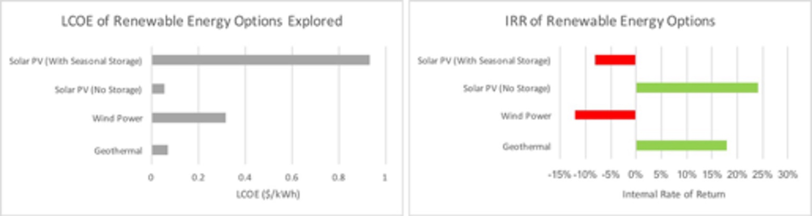
As part of the pre-feasibility assessment, technologies were modelled in their conventional use cases i.e. on-grid, without taking into account the cost of enabling mechanisms such as peaker plants and storage. As can be seen from the figure above, Wind Power does not yield an attractive LCOE, whilst Solar PV (No Storage) shows itself to be a highly competitive technology in this use case. Geothermal, which delivers firm power, also has a relatively low LCOE. The study then goes on to show that if a Solar PV system is set up to deliver power of the same quality as Geothermal, the additional cost associated with this leads to undesirable results; the capacity of battery storage required must meet seasonal variations in both irradiation and grid loads. Moreover, the space requirement for a Solar PV system of this size brings into question the technical feasibility of this setup. Based on this analysis, Geothermal has been singled out as the most technically and economically performant option. Annex H: Feasibility study provide details of this analysis.
Introduction to the project site
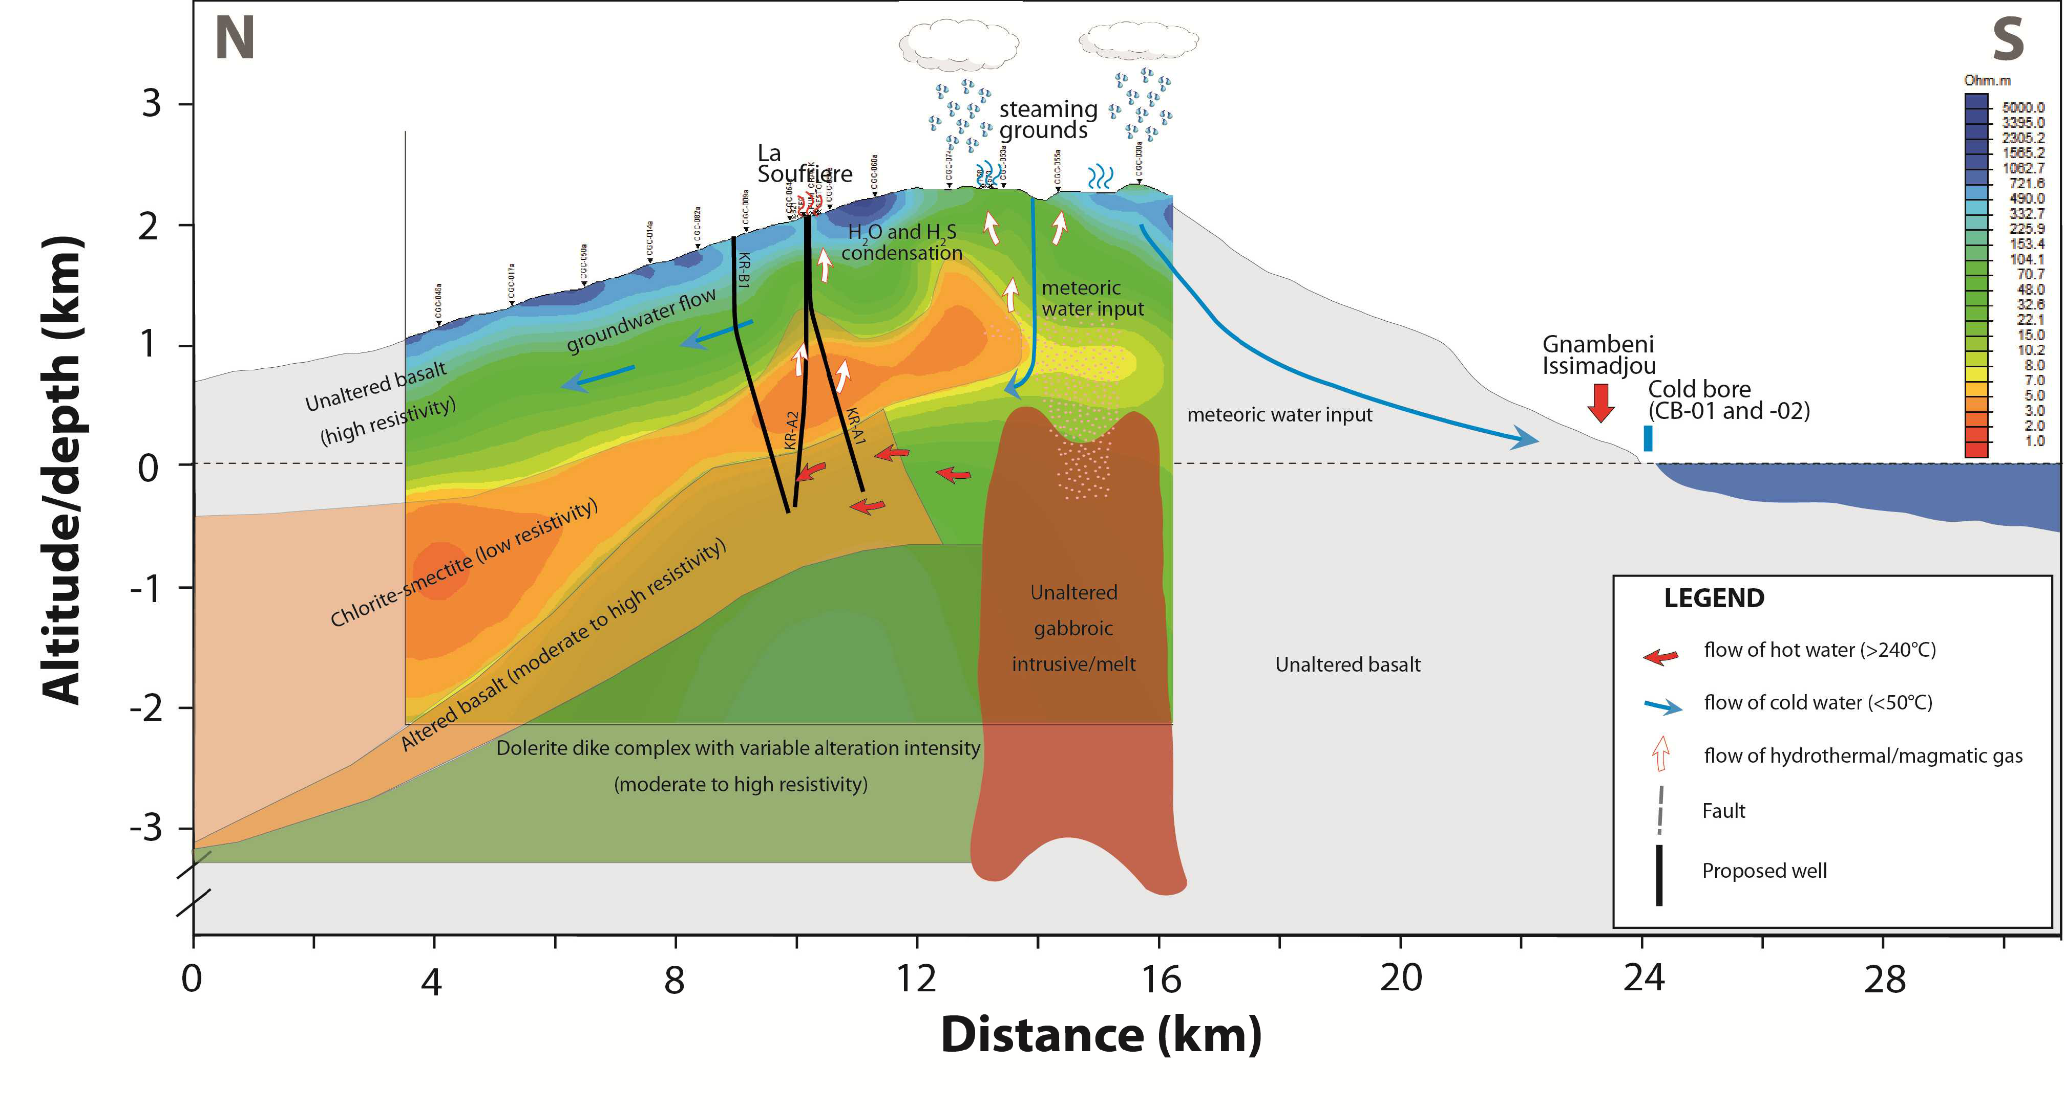
As noted earlier, the Karthala volcano has been identified as a potential useful source of geothermal energy for the island of Grande Comore. The majority of the thermal features are directly related to the caldera of the Karthala volcano, but with little geochemical or geophysical support for there being an exploitable geothermal system immediately beneath the caldera. However, the solfatara (La Soufriere - fumarole that emits sulphur gases) on the upper northern flanks of the volcano (Fig. 5) within a rift has both gas chemistry and the resistivity pattern of a potential resource at depth. It appears to be analogous to the successfully developed resource at Puna, Hawaii (Jacobs, 2016), where lava flow has been going on since 1983.
Figure 5: Schematic conceptual model along the rift hosting known thermal activity, and proposed exploration wells (Jacobs, 2016).
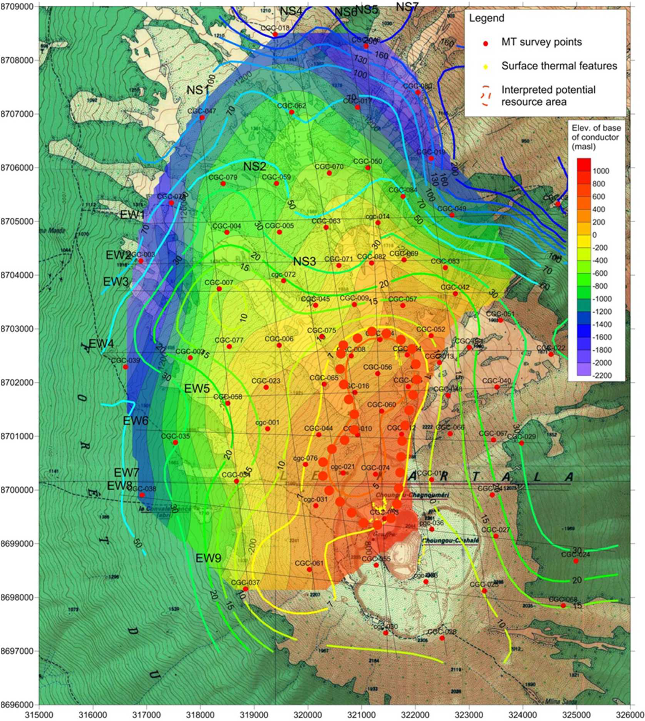
Figure 6: Interpreted potential 4 km² geothermal resource area (in red) shown with filled contours of the elevation of the base of the conductive zone and contour lines showing resistivity value (Jacobs, 2016).
At the current stage of development, the geothermal heat resource potential has been determined using volumetric assessments of the size of the reservoir, the heat contained within it and estimates of how much energy can be extracted and converted using existing technologies (Jacobs, 2016).
The definition of the reservoir area is based on the area of elevated resource potential highlighted in Figure 6 above, derived from an integrated review of geochemical, geophysical and geological data. The size of this resource area, located at 800 m above sea level, is 4.2 km² and it exhibits low resistivity which is expected to occur over a high temperature geothermal system.
Based on gas geothermometric results, Jacobs assumes an average reservoir temperature of 280°C and the reservoir thickness was modelled with a triangular probability distribution between 500m and 1,300m, with a most likely value of 1,000m. A Monte Carlo analysis was run with 10,000 iterations, which gave a median (P50) value of 38.9 MWe, a 10th percentile value of 18.1 MW and 90th percentile value of 64.9MW. These values give sufficient confidence for an initial development size of 10 MWe (Jacobs 2015b).

1.1 Stakeholder Analysis and Institutional Framework
- Vice-Presidency responsible for the Ministry of Economy, Planning, Energy, Industry, Handicrafts, Tourism, Investment, Private Sector and Land Development
The Vice-Presidency responsible for Energy (short form of Vice-Presidency) (Fig.7) has the overall responsibility for formulating, implementing and monitoring policy in the energy sector. In accordance with Decree N°16-095/PR/31-05-2016 that relates to the organisation and functioning of the Vice-Presidency, it exercises its role through the Directorate General of Energy, Mines and Water which, in turn, has supervisory authority over the following Directorates that deal specifically with energy, viz. Directorate of Energy and Mines, Directorate of Renewable Energy, Comoros Geological Authority, MAMWE and EDA (the Directorate of Water and Sanitation only superficially deals with water as it relates to run-of-the-river hydropower generation on Anjuoan and Mohéli).
The electricity sub-sector in the Comoros is managed by two independent legal entities that vertically ensure generation, transmission and distribution: (I) MAMWE is responsible for Grande Comore and Mohéli; and (Il) EDA is in charge of Anjouan since the commencement of the secessionist movement in 1997. It has been reported these 2 entities operate in total independence and this has not encouraged them to practice rigorous management or to develop long-term visions, resulting in inefficient daily management and low recovery rates that have contributed to their poor financial health.
The functions of the Directorate General of Energy, Mines and Water together with those of each of the “energy-related” Directorates under its purview are described below:
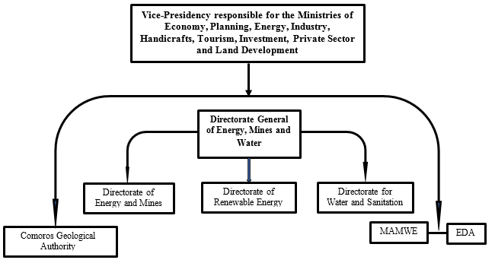

Fig. 7: Organisational Chart of Vice-Presidency responsible for Energy

• Directorate General of Energy, Mines and Water
The Directorate General of Energy, Mines and Water is entrusted with the formulation, planning supervision, control, follow-up and coordination of the implementation of programmes and activities of the Government in the sectors of Energy, Sanitation and Mineral Resources. As such, it is responsible for, among others, the following activities (those specifically related to the Energy Sector are managed by the Directorate of Energy and Mines):
- Collect, establish, update and manage a sectoral database for Energy, Water, Mining and Sanitation;
- Commission and supervise the rational development of Energy, Water and Mineral resources over the whole national territory;
- Implement programmes and activities for the optimal development, management governance of these resources within the framework established by the Government;
- Formulate, develop and implement activities related to the rational utilization of renewable sources of energy;
- Provide technical support to regional and community organisations active in the sustainable development, integrated management, protection and development of resources in these sectors;
- Collaborate with national, regional and international, bilateral, multinational organisations as well as with NGOs for coordination of activities in line with national sectoral development plans, within the frameworks of various international conventions to which the country is a party;
- Evaluate the impact of measures implemented by the Government with regard to rational utilization of resources at both the national and regional levels; etc.
- Directorate of Renewable Energy

The Directorate of Renewable Energy was established in 2009 and is tasked with the following responsibilities (other than for geothermal energy) under the overall supervision of the Directorate General of Energy, Mines and Water:
- Formulate and implement the Renewable Energy Policy (in draft stage since 2010) of the country.
- Formulate and implement the national strategy aimed at decreasing energy dependence and preserving the environment.
- Promote renewable energy sources such as hydro, solar, wind, biomass and other alternative sources within an institutional framework that is attractive to investors and with a choice of efficient and sustainable technologies for consumers.
- Provide follow-up to all renewable energy projects in the Union of Comoros.
- Contribute to solutions with the objective to eliminating load shedding due to insufficient generating capacity in the country.

- Comoros Geological Authority (Bureau Géologique des Comores)

Established on 12 April 2010, the Comoros Geological Authority is an autonomous administrative entity under the direct supervision of the Vice-Presidency responsible for Energy and is entrusted with the following responsibilities specifically related to geothermal energy:
- Formulate and implement national policy with regard to research and development of geothermal energy;
- Propose, formulate and implement the laws and regulations related to mining activities, either alone or in collaboration with other Ministerial Departments;
- Coordinate and promote all geological and infrastructural activities with regard to research and development of geological resources;
- Supervise all geological and related infrastructural activities as they relate to the development of geological resources.

- MAMWE
MAMWE, under the direct supervision of the Vice-Presidency responsible for Energy, is responsible for electricity generation, transmission, distribution and sale on Grande Comore and Mohéli, in addition to its functions for potable water supply. On Grande Comore, as indicated earlier, MAMWE has to resort to load shedding almost on a daily basis due to the absence of sufficient generation capacity on the island. In addition, MAMWE has for several years now been plagued by several problems related to, among others, recurring negative commercial performance, outdated equipment and high transmission/distribution/commercial losses. Suffice it to mention that technical losses in the transmission/distribution system, coupled with commercial losses due to electricity theft, absence of proper metering and non-payment of electricity bills result in MAMWE being unable to recover any payment for over 40% of the electricity that it supplies to consumers.

- EDA

Like MAMWE, EDA is responsible for electricity generation, transmission, distribution and commercialisation, but only on Anjouan and reports directly to the Vice-Presidency responsible for Energy. EDA was established in 1997 as a response to the secessionist movement on the island. Prior to that, these functions were under the responsibility of MAMWE. The status quo regarding EDA operating independently of MAMWE is likely to be maintained during the coming years in order to avoid a repeat of the pre-1997 events that led to disturbances on Anjouan.

AfDB/WB Support to MAMWE/EDA

The African Development Bank (AfDB) initiated a 3-year $ 20 million project entitled “Projet d’Appui au Secteur de l’Energie” (Energy Sector Support Project) in December 2013 to formulate an Energy Sector Masterplan, improve electricity generation and strengthen the transmission and distribution system with a view to substantially decrease system technical losses and put MAMWE/EDA on a stronger technical and financial foothold. Other components of AfDB’s support, which are still on-going, included a tariff study, the formulation of a legal framework for IPPs to operate under PPAs with MAMWE, and the purchase of 3 diesel generator sets as well as fuel for operating MAMWE’s diesel generators.

On the other hand, The World Bank initiated a 3-year $ 5 million “Projet de Redressement du Secteur Energie” (PRSE – Energy Sector Reform Project) in September 2013 to strengthen MAMWE’s governance and financial management, with the objective to assist MAMWE/EDA in decreasing their commercial losses due to non-payment/under-payment of electricity usage by consumers. These activities concluded in December 2016 and included the procurement and installation of 4,000 prepaid STS (Spécification de Transfert Standardisée) electricity meters and equipment/software for billing.

In addition, the World Bank had planned to assist the Government in formulating a regulatory and institutional framework for the electricity sector. The objective of this framework would be to, among others, define the duties and responsibilities of public and private operators, as well as those of consumers, diversify energy sources and promote the development of renewable energy so as to reduce dependence on imported fossil fuel, improve security, viability and durability in the procurement of traditional (including biomass) modern energy sources, promote energy efficiency and management through the introduction of innovative solutions, etc. Unfortunately, the Government was advised in early 2017 that formulation of the regulatory and institutional framework would not proceed as planned due to the fact that all allocated resources had been fully utilised within the project’s 3-year timeframe.

- Electricity Regulatory Authority
There is presently no Electricity Regulatory Authority that is mandated to ensure regulation, control, monitoring of activities in the electricity sub-sector and establishment of electricity tariffs. In the absence of a Regulator, the Directorate of Energy and Mines is itself tasked with these functions and they include supporting the energy needs of consumers within a sustainable development context, bearing in mind economic, social and environmental issues, ensuring the streamlined and economically viable development of electricity services for industries, establishing electricity tariffs, etc. However, the Government wishes to address this issue in the proposed Energy Code by establishing a Utility Regulatory Authority that will encompass both the electricity and water sub-sectors.
- National Investment Agency/One-stop Shop
The Government established on 31 August 2007, under Law No. 07-010, the “Agence Nationale pour les Investissements (ANPI)” (National Investment Agency) that reflects the Government’s desire to support and promote investment in the country through streamlining of the administrative procedures and reducing the timeframe for processing applications for establishing enterprises. ANPI is under the responsibility of the Ministry of Economy and its main objectives are to facilitate the following:

a) The creation of new enterprises;
b) Job creation;
c) Setting up of business enterprises in the interior regions of the country;
d) Innovation and development of existing enterprises; and
e) Promotion and encouragement towards free enterprise;

ANPI will be a useful instrument in promoting investment not only for geothermal development in Comoros, but also for all the ancillary services that will be required to support this initiative and the development of other renewable sources of energy.

1.2 National Strategies and Plans

National Energy Policy

The Government has yet to formulate a National Energy Policy that would include both conventional as well as renewable sources of energy. However, conscious of the fact that it disburses $ 20 million annually on imported fuel for electricity generation, the Government wants to privilege development of renewable sources of energy both to meet the base load and the morning/evening peaks. It is in this context that it wants to develop the Karthala geothermal resources for base-load electricity generation to replace imported diesel fuel, without disregard for utilising other sources of renewable energy, where feasible. In doing so, it is motivated by its desire to improve the quality of life of the population through the increase in the electricity access level and to ensure energy independence in security of energy supply through the development of locally-available energy resources through public-private partnerships and participatory approaches.

National Energy Strategy

In the absence of a National Energy Policy, the Government solicited the support of the European Union to prepare a National Energy Strategy for the next 20 years. This document entitled “Elaboration d’une stratégie sectorielle nationale Energie aux Comores – Strategie Sectorielle à 20 ans” was issued in January 2013 and covers the period 2013 - 2032. It is a comprehensive document that deals with the various energy sub-sectors, viz. traditional energy (wood and charcoal, as they relate to forestry management), fossil fuels, electricity generation and supply, and energy management. It also outlines the main parameters that should constitute a National Energy Strategy and defines its main and operational level specific objectives.

The main objective of the National Energy Strategy is to “contribute to the country’s sustainable development path through the provision of energy services that are affordable to a larger segment of the population, at least cost and that promote socio-economic activities”. At the operational level, the specific objectives are, among others, to (i) reduce the country’s dependence on imported fossil fuels for electricity generation and transport and (ii) provide access to energy services”. The National Energy Strategy also calls for improving the institutional, legal and regulatory framework for the energy sector, with due consideration being given to the environmental impacts associated with energy development and utilisation.

Electricity Code

Law No. 94-036 of 21 December 1994 established an Electricity Code that to this date regulates electricity generation, transmission and distribution in the Comoros. It entrusts the Ministry of Energy with the responsibility to, among others, define energy policy, undertake an inventory of all energy resources in the country, undertake forecasting of energy needs for matching with sources of supply to meet the demand, prepare development plans, etc. It also delegates the responsibility of providing electricity (and water) services to the population to the Electricity and Water Company of Comoros (EEDC - Entreprise Electricité et Eau des Comores). In June 1997, EEDC was renamed «Société Comorienne de l'Eau et de l'Electricité (CEE – Water and Electricity Authority of Comoros) » before changing its name again in June 2003 to MAMWE.

In addition, the Electricity Code indicates that « In the public interest, EEDC (the predecessor of MAMWE) may conclude agreements with self-producers for the supply of excess electricity to the grid …”. Hence, the Electricity Code already allows private sector promoters to generate and sell electricity to the MAMWE grid, but there has been no uptake in either electricity generation or distribution by the private sector.

Rural Electrification Agency/Energy Regulator

The country being small in surface area (just over 2,000 km² of land area in respect of all 3 islands), the Government, rightly, does not deem it appropriate to have a specialised Agency/Unit for Rural Electrification, as the country is almost 100% electrified. What this means, though, is that while the bulk of the population has access to electricity services, in reality, only an average of 50% of consumers on the 3 islands can afford to get connected to the electricity grid and pay for the services; the others are left out of electricity services for economic reasons. In addition, as there is no private sector participation in the electricity sector, the whole business of generation, transmission, distribution and sale of electricity is regulated by the Government itself and, therefore, there is to date no Independent Regulator for the electricity sub-sector. However, as indicated earlier, the Government has foreseen the setting up of an independent Utility Regulatory Authority, in light of its interest to open the electricity sector to private investment.

Energy Code

The Government is presently in the process of formulating an Energy Code that will restructure the sector, taking into account the present-day challenges that the country faces. Once a first draft is formulated, it will be submitted for external review prior to making its way to the Parliament for consideration, hopefully, during the session that will start in April 2018 at the earliest or October 2018 at the latest. The new Energy Code is likely to absorb the earlier-mentioned Electricity Code of 1994, but will also create a Utility Regulatory Authority for the sector and will be accompanied by regulations that will define model PPA contracts, tariff determination, feed-in tariff, measures to promote renewable energy development and the setting up of an entity for geothermal resource development utilising a public-private sector modality.

Stratégie de Croissance Accélérée et de Développement Durable (SCA2D – Accelerated Growth and Sustainable Development Strategy)

In January 2014, the Government launched the formulation of the Accelerated Growth and Sustainable Development Strategy (SCA2D) designed to be a comprehensive framework that would encompass all initiatives related to development and poverty reduction. The SCA2D process was based on the lessons learned from implementing the Growth and Poverty Reduction Strategy (Document de Stratégie de Croissance et de Réduction de la Pauvreté - DSCRP) 2010 – 2014. DSCRP achieved substantial results in the strengthening of democracy, peace and national cohesion aimed at promoting stability and resuming international cooperation under the Heavily Indebted Poor Countries (HIPC) Initiative. However, the Government felt that the DSCRP had set objectives that were too ambitious in relation to the available resources and a re-direct was necessary to secure the full participation of all stakeholders, including Government, local population, civil society, private sector and development partners. Therefore, the need for SCA2D covering the period 2015 – 2019 that will enable the country to emerge from its fragile status that was the result of the situation in the country in the not too distant past.

The objectives of SCA2D 2015 -2019 are to:
- Strengthen the foundation of a strong, viable, sustainable, equitable and inclusive economic growth;
- Improve the quality of life of the population and guarantee equity with regard to access to basic social services;
- Promote the national and cultural heritage, and optimal utilization of natural resources; and
- Promote good governance and resilience in the face of political fragility.

With regard to the energy sector, SCA2D underscored the Government’s commitment for “In the short term, to develop an 18-MW power station to operate on heavy fuel to meet the country’s needs for stable and accessible electricity services (pending a more permanent solution that would include renewable energy in the country’s energy mix) and to refurbish the diesel power stations operated by MAMWE on Grande Comore and EDA on Anjouan. For the medium term, SCA2D will promote a “transitional” energy strategy aimed at reducing costs, dependence on imported fuel and promotion of locally-available energy resources”.

First (Initial) National Communication to UNFCCC: The First (Initial) National Communication (INC) to UNFCCC prepared in December 2002 by the General Directorate for Environment of the then Ministry of Development, Infrastructures, Post and Telecommunications, and International Transport showed that in 1994 the country had emissions of 1,315,888 tonnes CO₂-Eq (corresponding to a per capita emission of 2.63 tonnes CO₂-Eq), but the national uptake of GHG by sinks in the same year was 1,670,566 tonnes CO₂-Eq, thus providing a net balance of minus (negative) 354,678 tonnes CO₂-Eq. Emissions from the various sources were as follows: Land-use change and forestry – 59%, Agriculture – 35%, Energy – 5% and Waste – 1%. The INC indicated that “The analysis of carbon dioxide emissions sources and sinks suggests that mitigation actions in the Energy Sector would contribute to reduce Comoros’ GHG emissions. Alternatives to the use of fossil fuel resources are hydroelectricity, solar energy, wind energy and geothermal energy”. It further indicated that “On Grande Comore, advanced studies must be conducted before any geothermal energy development can be considered. In the case where studies are positive about the geothermal potential of the island, exploitation could be envisaged to begin in 2020. One geothermal deposit would provide enough energy to supply half of the Grande Comore demand of 2020.”

Second National Communication to UNFCCC: The Second National Communication (SNC) prepared by the General Directorate for Environment and Forests of the Vice-Presidency in charge of Production, Environment, Energy, Industry and Handicrafts was submitted in December 2012. It showed that the total GHG emissions in 2010 (the base year) were 995,354 tonnes CO₂-Eq, while the absorption capacity was 3,764,652 tonnes CO₂-Eq, thus providing a net balance of minus (negative) 2,769,398 tonnes CO₂-Eq, corresponding to a net per capita absorption of 5.05 tonnes CO₂-Eq. This contrasts markedly with the inventory undertaken in December 2002, reported in the Initial National Communication, of a per capita absorption of 0.71 tonne CO₂-Eq and is attributed to improved data collection and analysis.

The SNC identified the energy sector as being the third-highest emitting sector after forestry and agriculture, having increased to 9% of total GHG emissions in 2010 (Fig. 8) from 5% in 1994. Projections show that, under the business as usual scenario, the energy sector will become the largest emitting sector by 2030, representing 48% of total GHG emissions by that time. The same projections also indicate that GHG emissions will eventually fall in the forestry and agriculture sectors, while significantly increasing in the energy sector. The SNC concludes by observing that “emissions in the energy sector are increasing in contrast to the other sectors. This can be explained by a significant increase of the population in urban areas and a slight increase in energy needs in the industrial sector. These trends should alert our policy-makers that they must further develop mitigation measures for the energy sector.” Adoption of renewable energy is one of the mitigation measures identified in the SNC and geothermal energy offers a very realistic near-term solution.

Fig 8: CO₂ emissions by sector of activity in 2010 (Source: 2015 INDC Comoros Report)

From Fig 8 above, it is noted that emissions attributed to the energy sector increased from 5% in 1994 to 9% in 2010. As in the case of the INC, the SNC advocated exploring the potential for utilising geothermal energy and implementing energy efficiency measures at the level of electricity consumption. Despite the need for the country to develop its economy, it plans to reduce its per capita emissions of CO₂ and increase its absorption capacity.

Nationally Determined Contribution (NDC): Projections made in 2015 during preparation of the Intended NDC for submission to UNFCCC point towards the Government’s objective of reducing GHG emissions by 47% by year 2020, 69% by year 2025 and 84% by year 2030 compared to the base year of 2010. One of the options for achieving this and being explored by the Government is to develop geothermal energy for base-load electricity generation. In this connection, the NDC states that “Geothermal energy is being explored for several years now and the Government is confident of its potential as a source of renewable energy for electricity generation in the future. Given the lead times required to complete the studies and commence electricity generation, this option has been considered to materialise towards 2030, with an expected generation capacity of 14 MW”.

Finally, Comoros is a member of the Global Geothermal Alliance (GGA) that was launched by IRENA at COP21 in Paris in December 2015. GCA has a membership of over 40 countries, both developed and developing ones, and “aspires to achieve a 500% increase in global installed capacity for geothermal power generation and a 200% increase in geothermal heating by 2030”.

1.3 Baseline Situation and Problem to be addressed

- The present situation regarding Geothermal Energy in Comoros

The Government is cognisant of the fact that it is becoming an increasingly very difficult task to annually spend $ 20 million in hard-earned foreign currency on the purchase of diesel fuel to meet the country’s needs for electricity and, that too, when budget resources are scare. In addition, this massive annual bill for imported fuel is likely to increase over the years due fuel prices going up. Consequently, there is a keen awareness among decision makers of the need to develop the Karthala geothermal reservoir for electricity generation that would be able to meet the country’s base-load for the next 30 years. Among the priorities of the Government for the electricity sub-sector, there resides a focus for an increase in reliable electricity services through rehabilitation and increase in existing generation capacities, strengthening of the transmission and distribution system, reform of MAMWE/EDA for better governance, increased utilisation of solar PV to even out the evening peak in electricity demand and solar water heating for hotels, hospitals and other Government/private institutions. The Government of Comoros has for many years now been discussing exploration and exploitation of the island’s geothermal resource and remains committed to the pursuit of successful development of this resource.
As discussed earlier, both electricity generation and geothermal development are under the Vice-Presidency responsible for Energy and this, to a large extent, facilitates coordination of activities. And in view of the promising results that have been obtained to date regarding the country’s geothermal potential, the Government is keen to proceed towards the path of geothermal power development for base-load electricity generation to replace imported diesel (some diesel generators will need to be kept to meet the fluctuating electricity demand (load curve) and will be used much less and only when required to compensate for any shortfall in base-load power) and considers a Public Private Partnership as an important vehicle to achieve this. However, before the private sector can decide whether to invest in geothermal power development or not, it needs to be certain that the geothermal potential exists. Consequently, this leads towards the Government implementing some upfront “derisking” activities required to eventually provide assurance to the private sector that its investment is not likely to go to waste.
- Barriers to Geothermal Energy Development
In light of the above and with regard to electricity generation, the Government proposes to utilise the availability of geothermal resources on Grande Comore for base-load grid-electricity generation; this does not exclude utilisation of the abundance of solar energy to supplement electricity generation utilising PV whenever the sun is shining and for thermal water heating. This is in line with the 3 objectives of the Sustainable Energy for All Initiative, viz. to ensure universal access to modern energy services, double the rate of improvement in energy efficiency and double the share of renewable energy in the global energy mix by 2030. Thus, the transformation of the energy sector to an economically viable and environmentally friendly system requires a comprehensive and multi-faceted approach in the design of appropriate policy and institutional frameworks, and incentives to fully integrate geothermal energy (and other renewable energy technologies) into the country’s energy mix.
Moreover, the Second National Communication advocated exploration of the potential for utilising geothermal energy as one of the mitigation measures that would change the country’s economic growth from intensive carbon mode to low carbon mode. This was reinforced by the INDC (Intended Nationally Determined Contribution) formulated for COP-21 (Paris, 2015) that singled out emission reduction by 84% hinging upon the development and utilisation of geothermal energy, indicating that “Given the lead times required to complete the studies and commence electricity generation, this option has been considered to materialise towards 2030, with an expected generation capacity of 14 MW”.
As indicated earlier, there is at the present time no experience in the country with electricity generation from geothermal resources. An evaluation of preliminary data, coupled with surface exploration around the Karthala basin undertaken with the support of international partners, point towards the potential of ultimately generating some 40 MW of base-load electricity. However, in view of the high investment costs involved, it is proposed to initially develop a 10 MW power station as a first phase and to proceed in increments of 10 MW additional every 2 years to reach the estimated reservoir potential of 40 MW. Therefore, the present project will provide a start to utilising geothermal resources for grid-electricity generation on Grande Comore and this will assist in reducing GHG emissions and improving livelihoods of the population through a reliable and stable supply of base-load electricity that would curtail the present frequent service disruptions. A novel approach will be applied through enabling the private sector to drive the initiative to develop the geothermal field for electricity generation for sale to the MAMWE grid; the crucial role of the Government will be to create the appropriate environment for this private sector-driven modality to successfully move forward.

In line with the foregoing, GEF intervention is needed to remove the policy, regulatory and market barriers which hamper realisation of the Government plans to harness the geothermal potential of the country. In addition to geothermal energy, there is the potential in the country to utilise other renewable energy sources like biomass (very unlikely due to the country’s limited total surface area, coupled with the concern to preserve the forest cover and avoid soil erosion/degradation), solar, wind and wave/ocean energy, as and when such technologies are technically suitable and commercially viable, for electricity generation to supplement the grid or for off-grid purposes. In such circumstances, the Government may on its own adapt the policy and other regulations developed for geothermal energy to cater for the other renewable energy sources. In fact, this should not be too complicated to accomplish as both the Comoros Geological Authority (which deals specifically with geothermal energy) and the Directorate of Renewable Energy (which deals with renewable energy resources other than geothermal energy) are under the purview of the Vice-Presidency responsible for Energy (see Fig. 7 referred to earlier).

A summary of the barriers to geothermal power development (and other renewable sources of energy only as far as policy and regulations are concerned), together with the strategy for addressing them are presented in Table 5 below.

Table 5: Summary of barriers and mitigation strategies
Barrier | Present Situation | Strategy for addressing barrier
Policy/Regulatory | Absence of a conducive policy and legal/regulatory framework is a deterrent to geothermal development for on-grid electricity generation. | A set of regulations will be developed to facilitate private sector investment in geothermal energy for base-load grid electricity generation.
Financial | Absence of financial derisking instruments does not facilitate the development of base-load electricity generation from geothermal resources. | Cornerstone financial derisking instruments will be developed to promote the development of geothermal energy for base-load electricity generation.
Technical | Insufficient information on geothermal resource potential for electricity generation to elicit interest of developers.  Insufficient human resource capacity for geothermal development. | Local institutions and project developers will be supported with up-to-date and accurate information on geothermal reservoir for electricity generation.  Human resource capacity will be strengthened at the local level to support geothermal development.
Knowledge management and investment promotion. | Absence of promotional/outreach activities to generate investor interest in geothermal development. | Outreach/promotional activities will be implemented and project experience/lessons learned will be documented.

Strategy

Project Rationale and Policy Conformity

The project’s goal is to reduce GHG emissions by creating a conducive legal, regulatory and market environment and building institutional, administrative and technical capacities to promote the development of geothermal energy resources for base-load electricity generation as a substitute for the presently-used diesel generators. In the future, this conducive environment to be created can be adapted to cover other potential renewable energy resources, including solar, wind, biomass, wave energy, etc. that can be developed to supplement any electricity required to meet the utility’s daily peak or near-peak demand.

Island nations like Comoros are most vulnerable to the devastating effects of climate change. Rising sea-levels, higher temperatures and increased natural disasters from changing weather patterns is a calamity for these islands. This is a serious threat to Comoros even though its emissions are negligible compared to larger countries, responsible for 0.00045 % of total worldwide carbon emissions in 2010 (Source: INDC-2015). Islands like Comoros contribute little towards global warming, yet they face the most immediate threat from it due to sea level rise that flood coastal areas resulting in loss of lives and property, coastal erosion and putting stress on freshwater resources.

Presently, the bulk of electricity generation on all the 3 islands of Grande Comore, Anjouan and Mohéli is predominantly through diesel generators (with a less than 3% hydro contribution) operated by MAMWE/EDA at an annual cost of $ 20 million for imported fuel only, excluding lubricants and spare parts. Despite this heavy foreign currency drain on the State, as indicated earlier, consumers located in the island capitals and their immediate surroundings get unreliable electricity supply for most part of the day; outside of the island capitals, electricity is supplied for only a few hours a week, if at all. There are, however, a few self-generators in the country who produce electricity for their own consumption, either through solar PV (SHS) or small diesel generator sets; these are mainly entrepreneurs (bakeries, hotels, restaurants, etc.) who, from a business point of view, have a need “to ride out” the frequent black-outs that would, otherwise, negatively impact upon their commercial operations. They also use solar water heaters, where appropriate, to improve on the quality of service that they provide.

The Government is committed to reducing GHG emissions associated with the heavy usage of diesel fuel for electricity generation and is conscious of the efforts that are required to reduce the country’s expenditures in terms of foreign currency, while providing the population with a reliable and stable supply of electricity. Towards this end, it advocated both in its Second National Communication (SNC-2012) and its Intended Nationally Determined Contribution (INDC-2015) exploration of the potential for utilising geothermal energy as one of the mitigation measures that would change the country’s economic growth from intensive carbon mode to low carbon mode. In its INDC, the Government went further to single out emission reduction by 84%, hinging upon the development and utilisation of geothermal energy and indicating that “Given the lead times required to complete the studies and commence electricity generation, this option has been considered to materialise towards 2030, with an expected generation capacity of 14 MW”. With the support of the present project, it is estimated that some 10 MW of base-load electricity generation should be operational by the Year 2023.

Under a business as usual scenario, base-load electricity generation from the country’s geothermal resources as a substitute for diesel fuel use with reliance solely on Government budgetary resources and without the participation of the private sector, will take a very long time or completely fail to materialise. Hence, the project will provide the Government of the Union of Comoros with the necessary boost, working with the private sector, to accelerate development of the country’s geothermal reservoir to provide for stable electricity generation designed to meet the base load. This is proposed to be achieved through the following:

- Streamlining and simplifying policy, regulatory, legislative and financial instruments for electricity generation from geothermal energy to displace the use of diesel fuel for base-load electricity generation;
- Developing capacity of stakeholders for utilising the country’s geothermal resources for electricity generation;
- Creating attractive and competitive business terms and conditions for investors, through the implementation of derisking measures, that would provide confidence to developers to develop geothermal energy for electricity generation and provide them with a measure of assurance for long-term stability and sufficient investment return; and
- Facilitating development and utilisation of geothermal energy for additional generation capacity after a 10 MW first phase to a total of 40 MW over the subsequent years. This will be achieved through a pool of in-country trained technicians who would ensure high quality construction, operation and maintenance of the systems and ancillary equipment.

Institutional Structure

As indicated earlier, the Vice-Presidency responsible for Energy is the driving force for implementing the Government’s energy policy and accomplishes this through its several Directorates, including the Comoros Geological Authority and the Directorate of Renewable Energy for activities related to the promotion of non-geothermal renewable energy sources in the country. In this capacity, and as the present project deals specifically with geothermal energy, it will entrust the Comoros Geological Authority with implementation of the project under the UNDP National Implementation Modality (NIM). In doing so, the Comoros Geological Authority work very closely with other Government Agencies, the private sector, NGOs and Women Organisations to ensure that the participation of the full range of stakeholders is secured and effective.

Country ownership: country eligibility and country drivenness

The potential for geothermal base-load electricity generation in Comoros, in replacement of imported diesel fuel, has been the focus for several years now as a serious mitigation option that the Government wishes to pursue for reducing greenhouse gas emissions in the country and the active Karthala volcano in the centre of Grande Comore does provide the opportunity to transform this option into reality. In this connection, in its INDC prepared in 2015 for submission to UNFCCC, the Government underscored emission reduction of 84% by 2030, compared to the base year of 2010, and this reduction relies heavily on the development and utilisation of geothermal energy. The Government further indicated that “Given the lead times required to complete the studies and commence electricity generation, this (geothermal) option has been considered to materialise towards 2030, with an expected generation capacity of 14 MW”.

Also, the Energy Code presently being drafted is in the process of making a strong case for utilising geothermal resources for grid-electricity generation on Grande Comore in order to assist in reducing GHG emissions and improving livelihoods of the population through a reliable and stable supply of base-load electricity that would curtail the present frequent service disruptions. A stable electricity supply will also contribute to the creation of opportunities for income generating activities that sustain and improve the lives of people living in the countryside.

Thus, the project is in line with national priorities and will contribute to meeting the objectives of the Government to reduce GHG emissions that contribute to global warming and to promote energy development that will cater to the needs of the population at a lesser cost compared to the present diesel option being utilised.

Design principles and strategic considerations

The project will promote a market-driven approach to encourage the participation of the private sector to generate electricity through the development and utilisation of geothermal energy to supply the existing grid. In line with GEF requirements, “the emphasis will be upon developing policies and regulatory frameworks that provide limited incremental support to strategically important investments”, such as investment in electricity generation from geothermal resources, allowing the country to move towards energy independence and increased energy security in an environmentally and climate-friendly way.

As the law presently stands, following the Government’s decision to reform the electricity sector and establish an Electricity Code in 1994, the private sector (IPP) is allowed to generate electricity in the country for sale to the main grid. However, the accompanying guidelines and procedures for private sector participation in the electricity sub-sector, including model PPAs, feed-in tariffs, etc. have yet to be formulated. As a result, no IPP has to date participated in the uptake of the private sector-driven electricity market. However, the proposed Energy Code that is presently under formulation is scheduled to remedy this situation by incorporating the Electricity Code and defining the accompanying guidelines and procedures that will follow through the Government’s commitment to involve private sector participation in the electricity generation sub-sector. The Energy Code will also establish a Utility Regulatory Authority, include a model PPA, define feed-in-tariffs, articulate incentives to promote development of geothermal and other renewable energy sources, etc. Accordingly, the project will assist the Government in finalising the Energy Code, especially with regard to policy, regulatory and institutional issues related to development of geothermal energy for electricity generation.

Geothermal Systems and GHG Emissions
Geothermal systems are a natural source of greenhouse gas emissions and it may be argued as to whether it makes sense to replace diesel fuel as GHG emitting source with geothermal energy. To address this issue, there have been many studies undertaken to determine the amount of GHG that is emitted when geothermal resources are developed and the findings of some reputable institutions worldwide and active in the geothermal field are presented below.
The US Geothermal Energy Association (GEA) in its 2012 publication entitled “Geothermal Energy and Greenhouse Gas Emissions” states that “Although geothermal power plant emissions arise primarily from existing geothermal resource gases and not from the power generation process itself, research shows that the specific characteristics of the resource, as well as whether the power plant is open versus closed (binary), influences the rate at which those gases are released. Industrial utilization of a geothermal field causes the natural emissions to go from being concentrated in the field to being concentrated in the power plant. Therefore, the technology of the geothermal power plant can also influence the rate at which the gases will be released”.
The report goes on to compare geothermal emissions to coal and gas and states that “To put geothermal emissions into context, comparable CO₂ emissions data were obtained from the US Environmental Protection Agency (EPA) for coal and natural gas power plants. According to the EPA, the average rate of carbon dioxide emissions for coal-fired power plants and natural gas power plants are 2,249 lbs. CO₂/MWh and 1,135 lbs. CO₂/MWh, respectively. The average rate of emissions for a coal-fired power plant and even a natural-gas-fired power plant are significantly higher than that of a geothermal power plant (at 180 lbs. CO₂/MWh)”. With regard to diesel power plants, the average rate of emission is 1,750 lbs. CO₂/MWh, thereby indicating that a geothermal power plant will emit only 10% of CO₂ that a diesel plant of the same capacity output would emit on a per MWh basis.
In conclusion, the report indicates that “most of the published data on geothermal power plant emissions show that these plants emit little carbon dioxide, minute amounts of methane, and little or no nitrogen oxide. Because of these low emissions, the geothermal power plants also meet the most stringent clean air standards. For example, Lake County, California, located downwind of The Geysers geothermal complex, the largest geothermal field in the world, has met all federal and state ambient air quality standards since the 1980s”.
There are several other studies that confirm the findings of the GEA. For example, the International Geothermal Conference (IGA) held in Reykjavík, Iceland in September 2003 states that “Geothermal energy is considered to be a benign energy source as regards environmental impact. One of its impacts is the release of the greenhouse gas, CO₂, to the atmosphere. In a recent survey by the IGA it was shown that in comparison with the burning of fossil fuels there is a considerable advantage to using geothermal energy…… The CO₂ emitted from geothermal plants is already part of the CO₂ cycle, no new CO₂ is being produced as is the case in fossil fuel plants”. Another example of similar findings is contained in a World Bank paper entitled “Greenhouse Gas Emissions from Geothermal Power Production” by Thráinn Fridriksson et. al. that was presented at the 42nd Workshop on Geothermal Reservoir Engineering (Stanford University, Stanford, California, February 13-15, 2017) indicates that “GHG emissions from geothermal power production, mostly in the form of CO₂, are generally low in comparison to traditional base load thermal energy power generation”.
In light of the foregoing, all CO₂ calculations that follow have been derated by 10% to account for emissions that may be released into the atmosphere during the normal course of operation of the geothermal power plant.

Geothermal Energy in Comoros: Supplement to or Replacement for Diesel Generation?
Next, there is the fundamental question regarding whether geothermal electricity generation on Grande Comore will supplement diesel generation to meet the increased load requirements over the years or will it at some point completely replace diesel in the electricity generation mix; this issue is discussed below.
The present diesel installed capacity on Grande Comore is 18.8 MW (Table 1 above) consists mainly of several old diesel generators that suffer from frequent breakdowns, with the result that MAMWE can rely on only 11 MW of firm capacity. The maximum demand on the Grande Comore fluctuates around 15 MW on a daily basis and as the firm capacity is unable to meet the maximum demand, MAMWE has no other option than to resort to load shedding, again on a daily basis. Hence, in order to remedy this situation, it has planned to build an 18 MW heavy fuel power station that is expected to come on line in early 2018. When this happens, MAMWE will retire some of the older diesel machines. Growth in electricity demand is estimated at an average of 5% per annum and MAMWE forecasts that the maximum demand will reach 22 MW by 2025. This should largely be met by the new 18 MW power station, with the contribution of the remaining diesel generators that are still in good operating condition, some of which would also need to be replaced at a later date, after having reached their useful life.
If MAMWE were to go the geothermal route for electricity generation, as proposed under this project, it will have 10 MW of generating capacity coming on line in 2024, and additional 10 MW each in the Years 2026, 2028 and 2030, respectively, providing a total of 40 MW of installed geothermal capacity that will supply the base load. This implies that the available 20 MW of geothermal capacity in 2026 will almost be sufficient to cover Grande Comore’s maximum demand, theoretically necessitating the retirement of most diesel generation on this island. However, it would be wise to still keep some diesel generation to respond to the required peak load demands referred to as the morning and evening peaks and for back-up in case of emergencies. By 2028, when the geothermal generation capacity would have reached 30 MW, geothermal energy would have completely replaced diesel generation on Grande Comore, with spare capacity to cater to future growth. This situation will likely remain unchanged for at least the next 20 years, taking into account the additional 10 MW capacity that can come on line in 2030.
In light of the above, it is clear that geothermal energy will initially only partially replace diesel generation through substitution. However, by 2026, geothermal would have almost replaced diesel generation, with complete replacement of diesel occurring in 2028. This situation will then remain unchanged for the next 20 years.

Results and Partnerships

Project objective, outcomes and outputs/activities

The objective of the project is to contribute towards the reduction in the growth of GHG emissions through promoting the development and utilisation of geothermal energy for grid-electricity generation. This objective is proposed to be achieved by putting in place an enabling environment for the development of the country’s geothermal energy potential through the participation of the private sector, working closely with village community organisations surrounding the Karthala area. This programme will not only benefit households and small commercial enterprises in that they will enjoy stable electricity services throughout the day without frequent disruptions, but will also connect the private sector, financial and technical training institutions, and local organisations to work together in achieving the country’s objectives towards the Sustainable Development Goals.

The project consists of 3 components as outlined below. It is recognised that on-the-job training will be provided by the recruited consultants, both local and international, during the normal course of their support to the relevant project activities and a communication strategy formulated to inform stakeholders on project implementation. In addition, focussed support will be provided during the implementation of Component 2 to capacity development of technical personnel and local specialised engineering workshops for manufacturing any required ancillary supporting equipment and engineering firms in the design, construction, installation, operation, maintenance and repair of equipment that is required for the smooth operation of the geothermal power station.

Moreover, the project will seek to achieve gender equality through the empowerment of women (e.g. working with women’s associations such as ADRIKNI, NARILE NDRO, FEMME ET DEVELOPPEMENT DURABLE in all project activities and specifically those related to capacity development under the various components. In addition, the project will solicit the participation of NGOs working in the field of sustainable energy at the community level and capacity development institutions like Comoros University, Technical High School of Ouani-Anjouan, etc.

Furthermore, the project will make it attractive for the private sector to invest in the Comoros geothermal project by shouldering some investment risks through the introduction of certain financial derisking instruments. As indicated in the 2013 UNDP Publication “Derisking Renewable Energy Investment”, “…the key challenge of funding the transition towards a low carbon energy system is to address existing investor risks that affect the financing costs and competitiveness of renewable energy in developing countries”.

The UNDP Publication elaborates further, viz:
- Policy derisking instruments seek to remove the underlying barriers that are the root causes of risks. These instruments include, for example, support for renewable energy policy design, institutional capacity building, resource assessments, grid connection and management, and skills development for local operations and maintenance (O&M).
- Financial derisking instruments do not seek to directly address the underlying barriers but, instead, transfer the risks that investors face to public actors, such as development banks. These instruments can include, for example, loan guarantees, political risk insurance (PRI) and public equity co-investments.

In line with the above, the project will play an active role in decreasing a project developer’s risk exposure that will substantially increase the interest of developers in geothermal energy in Comoros. This is particularly so in view of the fact that this will be the first geothermal project in the country, whereas such a constraint no longer exists in other developing countries that have successfully developed geothermal energy for electricity generation for several years now, e.g. Costa Rica, El Salvador, Honduras, Indonesia, Kenya, Nicaragua, Philippines, etc.

Geothermal power development can be sub-divided into 3 distinct phases, starting with evaluation of preliminary data and surface exploration (Phase 1), on to infrastructure development and exploratory-cum-production well drilling (Phase 2) and culminating into the construction and operation of a power station (Phase 3). All the 3 phases and the main activities that need to be undertaken under each one of them as they relate to the case of Karthala reservoir, together with the associated estimated costs, are presented in Table 6 below:

Table 6: Phases of geothermal development at Karthala and estimated costs.

Phase No. | Activity | Duration  (Months) | Estimated  Cost ($) | Present Status/Funds reqd. ($)
1: Surface  Studies | Surface Exploration: Geological  Mapping, Geochemical Sampling and Geophysical Surveys. | 14 (Oct 2014-  Dec 2015) | 1,445,000 | Completed
2: Exploration  Drilling  Phase | Environmental and Social  Impact Assessment (ESIA). | 8 – To be completed  before any works  commence. | 300,000 | Funds Required: 45,300,000  Secured Funds (as per co-financing letters: 48,360,000  ,
2: Exploration  Drilling  Phase | Resource Feasibility Study. | 3 -To be completed  after exploration  drilling | 600,000
2: Exploration  Drilling  Phase | Infrastructure for exploration: 8 km  of access road + 3,000 m³ water  reservoir. | 6 | 14,900,000
2: Exploration  Drilling  Phase | Exploratory-cum-production drilling, inclusive of injection wells –  3 wells. | 6 | 26,100,000
2: Exploration  Drilling  Phase | Front-End Engineering Design (FEED),  Contract Prep., Project Mgmt. and Site Supervision. | Over duration of  Phase 2.  Total Phase 2  duration: 24 months | 3,400,000
3: Power  Development  and Construction  Phase. | Development and land permits,  PPA, ESIA (updated for development)  (Pre-FID (Financial Investment  Decision)). | 12 | 1,100,000 | Funds Required: 47,700,000 on the understanding that the 3 wells under Phase 3 will not be required.  These funds will come from private sector investors who would be awaiting the results of Phase 2 activities to confirm their participation.  (leveraged finance)
3: Power  Development  and Construction  Phase. | Bankable Feasibility Study and  Business Plan (Pre-FID). | 12 | 500,000
3: Power  Development  and Construction  Phase. | Infrastructure for development | 6 | 3,800,000
3: Power  Development  and Construction  Phase. | Production drilling, inclusive of  Injection wells -3 wells, if reqd.* | 6 | 25,600,000
3: Power  Development  and Construction  Phase. | Steam field development | 9 | 5,500,000
3: Power  Development  and Construction  Phase. | Power plant (10 MW) | 24 | 29,600,000
3: Power  Development  and Construction  Phase. | Interconnection to MAMWE grid. | 12 | 2,800,000
3: Power  Development  and Construction  Phase. | FEED, Contract Prep, Project Mgmt.  and Supervision. | Over duration of  Phase 3.  Total Phase 3  duration: 36 months | 4,400,000
Total Duration  /Cost** |  | 60 |  | Total investment: 93,000,000
**The total duration to complete the drilling and construction phases (Phases 2 and 3) is 60 months; several activities can run concurrently without the need for awaiting the completion of one activity before the next activity can start.

Component 1: Policy, regulatory, legislative and financial de-risking instruments for geothermal energy development.

This component will promote the participation of the private sector in the provision of grid-connected electricity through the development of geothermal energy on Grande Comore. At the present time, the bulk of electricity generation in Comoros is through diesel generation, but the potential exists for exploiting the geothermal reservoir present at Karthala on Grande Comore to provide base-load power, as a substitute for imported diesel. The total installed capacity on Grande Comore is 18.8 MW of diesel (Table 1 above, May 2017) and this is largely insufficient to meet the island’s electrical load, thus resulting in load shedding on a daily basis. However, the potential exists for developing an initial geothermal capacity of 10 MW on Grande Comore, followed by the incremental addition of 10 MW every 2 years until the total potential capacity of the geothermal reservoir of 40 MW is reached.

“Policy derisking” measures need to be put in place to set up a conducive policy, regulatory legal/institutional framework for geothermal development. While such measures provide the necessary condition for geothermal power development, they are by no means a sufficient condition to attract the private sector. Hence, the need arises for “financial derisking” measures to be brought into the equation. Both these measures are then expected to provide the private sector with the required boost to venture into the business of developing geothermal resources on Grande Comore to generate electricity to supply the grid; such a model will combine the existing public sector-based model of MAMWE for electricity generation, transmission, distribution and sale with the profit-driven model of the private sector to produce electricity for sale to the MAMWE grid and, consequently, generate a sustainable and win-win partnership that would be beneficial to both the Government/community and the private sector.

Outcome 1: Streamlined and comprehensive market-oriented energy policy, legal/regulatory framework and financial instruments for geothermal energy-based power plants.

The expected outputs under this component are:

Output 1.1: Policy and legislative package for Geothermal Energy development adopted.
- Streamlined policy and legal/regulatory framework established and operationalised for private sector electricity generation utilising geothermal resources on Grande Comore to supply the MAMWE grid. The project will review the Government’s Electricity Code of 1994 and use it as a basis to draft and finalise the proposed Energy Code, especially with regard to policy, regulatory and institutional issues related to the development of geothermal energy for electricity generation. The Energy Code will define the accompanying procedures/regulations necessary to promote private sector investment in geothermal energy development for base-load electricity generation, including transparent guidelines and methodology for environmental, economic and financial evaluation of proposals for geothermal plant development, in line with existing government regulations and policies. The project will also assist the Government to draft regulations for the setting up of the proposed Utility Regulatory Authority.

Output 1.2: Cornerstone financial de-risking instruments for geothermal energy development defined, adopted and implemented. Activities towards this Output will include:

- Preparation of a technical report on grid-capacity upgrading to eventually accommodate the full 40 MW of geothermal generation without giving rise to grid stability problems;
- Definition of transparent procedures for the selection of the potential geothermal developer;
- Formulation of a standardised Power Purchase Agreement (PPA) for discussions with the selected developer and definition of a methodology for determining the feed-in tariff for electricity supply to the grid.
- Determination of the concession period with the developer and agreement on the development modality to be pursued, e.g. BOO (Build-Own-Operate), BOT (Build-Operate-Transfer) or BOOT Build-Own-Operate-Transfer). It is recognised that geothermal plants have a planned economic life of approx. 30 years, although some plants have been in operation for much more than that, e.g. Pauzhetsky in Kamchatka (Russia) and Warakei in New Zealand that have been operating for more than 50 years. Also, recovery through natural heat recharge can allow depleted resources to be re-used after a “rest period” of 2-3 years.
- Formulation of financial incentives to be provided to the project developer, such as reduction/elimination of import duties/taxes on equipment and spare parts, income tax holiday for a specific duration, simplification of foreign exchange regulations, etc. The private sector company (companies) investing in the underlying assets could reduce foreign exchange risks through a FOREX hedge. This could be in the form of some equivalent of a forward contract (setting the exchange rate for a future date(s)) or other instrument, with the commitment of the Central Bank of Comoros.

Component 2: Upstream geothermal preparation and development.

This component will lay the foundation for the implementation of activities associated with geothermal power development on Grande Comore in a rational and planned manner, with the required human resource capacities in place and that will culminate into the actual development of the geothermal resources for electricity generation. The objective is to assist the Comoros Geological Authority to upgrade its capacities to make informed decisions on the various processes involved in developing a geothermal power station on Grande Comore, to determine and upgrade the capacities of other technical institutions that can be called upon to support developers in the construction, operation and maintenance of a geothermal facility.

Moreover, it is recognised that investment in renewable energy projects often requires to be supported with financial incentives, at least initially, because such projects are not only typically more investment-intensive, but they are also, in some cases, considered to be riskier investments due to technology or resource uncertainties, as is the case with the Comoros geothermal project. The degree to which cost and risk factors apply varies according to technology and geographical location and project developers expect some form of financial risk-sharing (e.g. derisking) to support them for taking on additional financial risks due to the uncertainty that the exploration wells will in fact prove the resource potential for electricity generation; hence, lending for developing the geothermal field is perceived as involving additional risks. This constitutes a major barrier faced by private investors in their efforts to raise credit funding from lending institutions.

In this context, the PIF did envisage the option of converting GEF funds utilised for derisking activities “into loans in case the outcome of drilling is positive (a developer could take this on). The idea is to package GEF grant support as a reimbursable grant, to be repaid by the developer (an IPP that will be competitively selected) to the Government (possibly as an interest-free loan) in the event of predetermined conditions being triggered”. Such a modality for converting the GEF grant into “an interest-free loan” has its own merit, but has the inherent disadvantage that it will put an additional burden on potential project developers with regard to credit financing.

The PPG then considered an alternative option of converting the GEF derisking grant as “public equity co-investment” that would accrue to the Government, making it a shareholder of the geothermal power plant. Under this option, GEF funds utilised for financial derisking activities will be computed as “public equity co-investment” towards implementation of Phase 2 activities. Thus, in a nutshell, when an investor is chosen to implement Phase 3 of project activities, i.e. construction of the 10 MW geothermal plant, the $ 3.5 million GEF investment support to the Comoros geothermal project for Phase 2 activities will be computed as “public equity co-investment”, making the Government a shareholder, albeit a small one, of the geothermal power plant either through the Comoros Geological Authority or MAMWE or another special purpose entity, together with the private sector investor. Such a modality is often utilised in geothermal projects in other countries when the Government or an entity that it supervises participates as a public equity co-investor or shareholder to provide a certain level of financial derisking for the investment to be made by the developer. For example, The Kenya Electricity Generating Company, which is 74% state-owned, has built three plants to exploit the Olkaria geothermal resource, Olkaria I (195 MW), Olkaria II (105 MW) and Olkaria IV (150 MW) - Olkaria III (139 MW) was developed without the Government being a shareholder. This option provides an opportunity to create a public private partnership (PPP) between the Government and the private sector that will facilitate transfer skills from the private sector to MAMWE, ensure on time project delivery and within budget, and improve operational efficiency. Thus, this “public equity co-investment modality is preferred over the other one that converts the GEF grant into an “interest-free loan” to the developer.

Outcome 2: Geothermal resource availability is assessed, established and 10 MW power station is operational. The expected outputs are:

Output 2.1: Completed surface exploration assessment of Comoros geothermal resource potential.

There are a series of steps that need to be completed before an accurate picture of the geothermal potential can be established. The very fact that Karthala is an active volcano, somewhat similar in external characteristics to the Mauna Kea volcano on the Big Island of Hawaii, provides a reasonable indication that the reservoir may be exploitable for tapping the high enthalpy of the country’s geothermal resources. The situation is also somewhat similar to the case of Réunion Island (an Overseas Department of France) that is located in the Indian Ocean some 1,700 km to the southeast of Grande Comore. There, the Piton de la Fournaise (Peak of the Furnace), also a shield volcano like the Karthala, has been very active, with its most recent eruption in January 2017 and, while no geothermal power plant has been constructed yet, there are plans for a 30 MW geothermal power station to be operational by 2030. On the subject of geothermal energy development in Eastern Africa, an announcement was made in June 2017 by the U.S. Trade and Development Agency (USTDA) to fund a geothermal feasibility study in Zambia that “could help the country see development of its first utility-scale geothermal energy plant” having an installed capacity of 10 – 20 MW.

As a first step towards the assessment of a geothermal potential, a surface exploration is undertaken and this involves geological, geochemical and geophysical studies (the 3 G studies), coupled with heat flow measurements. In simple terms, the geological study involves studying the physical area around the volcano, the materials of which it is made, the structure of those materials and the processes acting upon them, while the geochemical study looks at the distribution of chemical elements in rocks and minerals, as well as the movement of these elements into soil and water systems, and, finally, the geophysical study involves examining the surrounding area using gravity, magnetic, electrical, and seismic methods. Completion of the 3 G studies assist in identifying the target pads for drilling.

In the case of Comoros, when the PIF was formulated, activities required to be implemented under the surface exploration phase (Phase 1, ref. Table 6 above) were well under way and, with the necessary funding already having been secured, were expected to be completed before the start of the PPG. That explains the reason why Phase 1 activities were not included in the PIF. These activities have now been completed at a total cost of $ 1,445,000, with funding provided by the African Union’s Geothermal Risk Mitigation Facility (UA/GRMF), New Zealand (NZ), UNDP and the Government of Comoros. The surface exploration report details the promising results obtained, establishes the resource potential for development and points towards implementation of the subsequent phases. Should Phase 1 results not have been conclusive, no activities under the subsequent phases would have been earmarked for implementation.

Output 2.2: Exploration-cum-production wells drilling and testing completed.

The decision to proceed with deep exploratory drilling is often the first major hurdle in implementing a new geothermal project, because this is the point when major investments start to be incurred. In the Philippines, for example, where over 2,000 MW of geothermal capacity is in operation, (ref. Phases of Geothermal Development in the Philippines, Francis M. Dolor, November 2005), “the costs of opening and constructing new roads and drill sites are substantial, because of the remoteness of the geothermal prospect areas”. In the Comoros case, like in other countries, the cost of drilling deep wells to depths of approx. 3,000 metres, coupled with the need for approx. 240 m³ of water per day per well to cool the equipment, can quickly add up, as the construction of a 3,000 m³ water reservoir will be required. In Comoros, the cost of constructing the access road, the water reservoir and for exploratory-cum-production drilling only is estimated at $ 41 million (Table 6 above).

Closer to the Comoros, there is the Olkaria geothermal field in Kenya where over 550 MW of geothermal capacity is in operation. A report entitled “Planning of Geothermal Projects” (ref. A Case Study on Kenya, Martin N. Mwangi, Nov. 2007) indicates that “The first well is perhaps the most critical well in the development of a resource and should take much longer to drill due to lack of previous experience with the logistics. It is aimed at being a discovery well and is meant to maximize on downhole information. Many cores should therefore be taken and cuttings carefully analysed to determine the lithology and alteration mineralogy”.

Traditionally, geothermal projects have proceeded with drilling “slim” exploratory wells (less than 6 inches (in.) in diameter), which are capped after the reservoir proves to be promising, and, in case of conclusive results, normal-sized production wells (between 8.5 and 12.25 in. in diameter) are then drilled. However, lately, the exploratory drilling process has been favouring drilling regular production-sized wells, as opposed to slim ones, for the justifiable reason that often the slim holes tend not to discharge and would, therefore, be useful only for downhole measurements and geological information, whereas, if the production-size well provides positive results, this well can be used for production purposes.
Hence, in light of the preceding, the Comoros project will favour, like in the case of the Olkaria field, regular production-size wells as opposed to slim ones. The advantage is that the regular production-size well “would allow all the information to be obtained and, in addition, can be discharged to determine the output of the well and be one of the production wells in case the area is developed further”.

The activities that will lead to this Output are:
- Environmental and Social Impact Assessment (ESIA): The ESIA entails a preliminary assessment of the environmental and social impacts associated with the project and takes about 8 months to complete. The ESIA is normally carried out concurrently with the detailed power station design, as the design should incorporate mitigation of the environmental impacts identified. These are: air pollution from waste gases, brine disposal, noise reduction and impacts on flora and fauna during construction and operation of the station. (GEF: $ 300,000).
- Resource Feasibility Study: Initially, an integrated analysis is carried out using the database from resource surface studies for preparing the geothermal conceptual model. Then, after well drilling and testing, all geoscientific data are consolidated into a conceptual model (reservoir simulation) and the evaluation of the geothermal potential is conducted through the application of numerical modelling techniques. (UNDP: $ 600,000).
- Engineering, Design and Project Management: The power station and the electromechanical equipment, substations and transmission line can be designed well ahead provided that environmental information is available. (UNDP and co-financing: $ 3,400,000).
- Infrastructure for Exploration: Construction of 8 km of access road and a 3,000 m³ water reservoir: This activity will put in place the infrastructure required (road) to enable drilling equipment to be transported to the site and provide the water required for cooling during the actual drilling process.
At present, there is no vehicular access to the areas where the exploratory-cum-production drilling is proposed to be carried out. There is an existing gravel road from Bahani to Grotte du Capitaine Dubois and from there the road becomes a single file walking track. It is proposed to upgrade this road to provide for vehicular access to transport the drill rig and ancillary equipment to the exploratory-cum-production drilling area. For a standard hole program, it is assumed that the rig will be a large oil and gas type drilling rig with a draw works horse power rating of at least 760 kW.
Water supply is critical drilling and approx. 165 m³/hour is required for a standard hole size drilling. Water supply options are currently being investigated; the only feasible option at this time is to pump water from existing shallow bore-holes located at sea level in Moroni to the site. However, further investigation is underway to identify water sources closer to the drill site. (Co-financing: $ 14,900,000).
- Exploratory-cum-production drilling of 3 full-size wells (8.5 in. in diameter) to a depth of 2,500 – 2,900 metres from the 2 well pads designated as Karthala A and Karthala B. The wells will then be tested to confirm the resource availability and potential for electricity generation. However, in the unlikely circumstance that all the 3 exploratory-cum-production wells prove unproductive, 3 new wells will need to be drilled at a different location, thereby resulting in a 25% increase in the total cost of the project. The cost of these 3 new wells is budgeted under Phase 3 activities as per Table 6 above, but, in the best-case scenario, drilling of these 3 wells may not at all be necessary, thus providing a cost saving of almost $ 26 million. (GEF and co-financing: $ 26,100,000).

Completion of all Phase 2 activities are expected to take 2 years and the results will determine which type of power plant will be appropriate for tapping the resources in the geothermal reservoir.

Output 2.3: 10 MW of geothermal-based power generation capacity (Private sector co-financing: $ 47,700,000).

Geothermal power plants use hydrothermal resources that have both water (hydro) and heat (thermal). They require high-temperature (300°F to 700°F) hydrothermal resources that come from either dry steam wells or from hot water wells obtained by drilling wells (some can be as deep as 3,000 metres) into the earth and then piping steam or hot water to the surface. The hot water or steam powers a turbine-generator unit that produces electricity and the waste brine is returned underground through injection wells.

Types of geothermal power plants

There are three basic types of geothermal power plants:
- Dry steam plants that use steam directly from a geothermal reservoir to turn turbine-generator units. The first geothermal power plant was built in 1904 in Tuscany, Italy, where natural steam erupted from the earth.
- Flash steam plants that take high-pressure hot water from deep inside the earth and convert it to steam in a flash tank to drive the turbine-generator unit. When the steam cools, it condenses to water and is injected back into the ground to be again heated by the geothermal rocks. Most geothermal power plants are flash steam plants.
- Binary cycle power plants that transfer the heat from geothermal hot water to another liquid. The heat causes the second liquid to turn to steam, which is used to drive a turbine-generator unit.

For purposes of illustration, a schematic diagram of a flash steam power plant system, the most common form of a geothermal power plant, is presented in Fig. 9 below. However, the geothermal power plant that will be developed at Karthala may not necessarily be a flash steam power plant type and will be determined based on the results obtained after analysis of the discharge from the exploratory-cum-production wells.

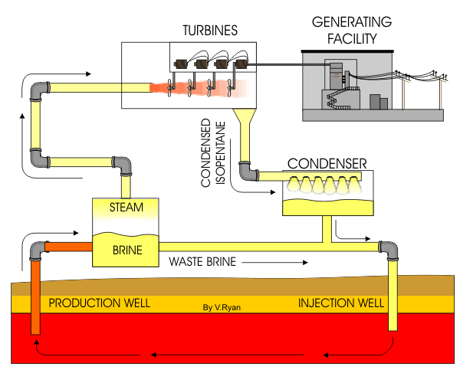
Fig. 9: Flash Steam Geothermal Power Plant (Source: V. Ryan, 2005-2009)

By completion of the project, a 10 MW geothermal power plant will be operational at Karthala and supplying electricity to the MAMWE grid. Moreover, it is expected that 10 MW of incremental capacity will be added every 2 years until the full expected capacity of 40 MW of the geothermal field is reached. This “staged” development to full 40 MW capacity has the advantage of making early use of the existing wells, thus reducing upfront expenditure and producing revenue to take the project forward. It also assists in building confidence in the resource and develop the country’s capacity to fully exploit the geothermal reservoir.

The following activities will be undertaken towards achieving this Output:

- Development and land permits, PPA, updated ESIA for geothermal development, etc.
- Production drilling – 3 wells, including waste brine injection wells: These will be drilled only if the 3 exploratory-cum-production wells that were drilled under Phase 2 prove to be unproductive.
- Bankable Feasibility Study and Business Plan: The detailed power station design is done simultaneously with the production drilling. The steam gathering system is updated continuously as the wells are tested, because some of the equipment like separators and pipes are sized according to the output and location of the wells.
Moreover, provision will be made while preparing the feasibility study for the future expansion of the geothermal power plant to the full expected geothermal field capacity of 40 MW.
- Interconnection to MAMWE grid: At the present time, the distance from the MAMWE 21 kV grid is some 10 km from where the geothermal power station will be located. Hence, a transformer sub-station at the power plant, a three-phase 21 kV and another substation at the receiving end will need to be constructed to connect the power station to the MAMWE grid. The connection voltage from the power station to the MAMWE grid may need to be upgraded and a step-down transformer installed at the receiving sub-station.
- Steam field development: Based on well enthalpy and in order to maximise power production, selection of material for pipes, pipe size with regard to temperature/pressure, pipe laying (under or above ground), type of steam separation station, etc.
- Engineering, Contracts, Project Management, Supervision, etc.
- Construction of 10 MW Power Station: A 10 MW geothermal power plant takes about 2 years to construct and commission. This stage includes the steam gathering and brine re-injection system; power house, electromechanical equipment, cooling towers and blow down re-injection system; substations and transmission line; and commissioning.

The private sector developers, in case they are locally-based, will likely associate themselves with international partners to benefit from the latter’s experience and exposure with geothermal power development for electricity generation in developing countries like Costa Rica, Ethiopia, Honduras, Kenya and others (UNDP participated in geothermal power development in most of these countries) and/or developed countries like Iceland, Italy, Japan, New Zealand, etc.

Component 3: Knowledge management and investment promotion.

Outcome 3: Increased awareness about geothermal potential and investment climate.

The expected outputs are:

Output 3.1: Public Relations and investment promotion campaign conducted.
- National Plan to implement outreach/promotional activities targeting both domestic and international investors. This will include the preparation of promotional materials, briefing sessions with potential investors interested in participating in the country’s geothermal development, local businesses that have interest in expanding their activities to include geothermal energy and organising road shows to attract foreign investors to establish consortia with local businesses for geothermal energy development.
Output 3.2: Guidebook on geothermal development in Comoros published.
- Published Guidebook on development of geothermal resources for base-load grid-electricity generation. This Guidebook will provide a detailed step-by-step approach for geothermal development and will serve as a tool for the benefit of system designers, installers and operators to enable them to properly design, build, operate and manage, and assist all stakeholders to enhance their common understanding and commitment about geothermal energy. It will also aim at facilitating discussions between community groups and the private sector and serve to demonstrate how geothermal energy can be a vehicle to foster economic and social growth, through the achievement of development imperatives, while minimizing negative social, cultural and environmental impacts in the country. Finally, it will contain model applications forms and will provide information/guidelines on the required documentation for the issuance of construction licenses and permits to potential developers, together with any associated fees.
Output 3.3: Published materials (including video) and informational meetings with stakeholders in SIDS countries having geothermal potential on project experience/best practices and lessons learned.
- Project results on best practices and lessons learned, in electronic form, will be widely disseminated throughout the region and among those countries planning to implement similar geothermal resources development for electricity generation. These will also be posted on the project website. In addition, towards completion of project activities, an information-sharing event involving the participation of all in-country stakeholders and international participants will be organised to discuss lessons learned and next steps towards replication of results within the SIDS group of countries, especially those in the Caribbean (Dominica, Grenada, Guadeloupe, Montserrat, St. Kitts & Nevis, St. Lucia and St. Vincent & the Grenadines) and the Pacific (Fiji, Solomon Islands., Papua New Guinea and Vanuatu) that plan to develop their potential geothermal resources for electricity generation.
Key Indicators, Assumptions and Risks

Indicators
Key indicators of the project’s success will include:
- 10 MW base-load geothermal power station operational and supplying electricity to the MAMWE grid.
- Direct CO₂ emissions avoided by 1,882,125 tonnes (without addition of incremental capacity), under the assumption of a 30-year equipment projected life.
- Consequential post-project CO₂ emissions with additional incremental capacity avoided by 43,200,000 tonnes, again assuming a 30-year equipment projected life and 80% GEF causality factor.
- 70,000 MWh generated by project end and an annual electricity generation of 80,000 MWh sustained over an expected 30-year projected life of the 10 MW power plant installed under the project.
- Capacity developed within Comoros Geological Authority and other relevant Ministries/Government Departments to promote investment in geothermal development for electricity generation.
- 200 jobs created in the geothermal sub-sector related to administrative, accounting, communications/public relations, engineering, legal fields, etc.
- 2,000 jobs in income-generating activities created as a result of a stable and continuous electricity service on Grande Comore.
- Lessons learned documented and distributed to potential stakeholders/interested SIDS countries through publications, public awareness campaigns and project website.
Detailed indicators are provided in the Project Results Framework in Section IV further below.
Assumptions
The assumptions are also outlined in the Project Results Framework in Section IV further below.
Risks
- The project presents some risks which are discussed in the Table 7 further below:

i. Financial modality:

The project is aimed at policy development, capacity building, technical assistance and the provision of derisking incentives to catalyse private sector investment in the development of geothermal resources for base-load electricity generation in Comoros. A substantial portion of GEF climate change resources will be allocated as a financial derisking contribution that will be computed as public equity co-investment, thus making the Government a shareholder of geothermal power plant.

The project objective will be attained through technical assistance and facilitating third parties’ investment in geothermal resource development for base-load electricity generation. No loan or revolving-fund mechanisms with GEF funds are considered appropriate, and, therefore, grant-type funding is considered as the most suitable to enable successful delivery of the project outcomes.

ii. Mainstreaming gender:

Gender will be mainstreamed in all the activities planned by the project. To facilitate such action, a gender expert will be part of the Project Board, members of the Project Management Unit will receive training on gender mainstreaming and be supported periodically by a gender expert.

The development and operation of the geothermal power plant is expected to be male-dominated because women are generally absent from sectors considered too technical and that require heavy capital investments. However, even without the technical know-how, business-women can recruit engineers in their team and participate to provide technical services during implementation of the geothermal power project; hence, women entrepreneurs will be strongly encouraged to apply for the provision of these services. In addition, the Comoros Geological Authority will be encouraged to recruit women engineers to participate in the project and emphasis will be placed on including as many women as men, and particularly tailoring some of the training to recent high school and college graduates, a group that has a higher presence of young women in the country.

On the demand side, access to a stable supply of electricity will assist in creating or expanding small enterprises and this activity will target women groups and individual women entrepreneurs. Further, the project developer will be sensitized on how to respond to the different electricity needs of men and women. For instance, when consulting with the population, the project developer should ensure that women are well represented and are gathered in a setting that allows them to freely voice their opinion. In market studies, both men and women should be surveyed. In general, only heads of the household (mostly men) are asked their opinion and this does not always reflect the needs of women in the household.

As an example of women participation in the energy business in the US, the January 2017 US Energy and Employment Report states that the “energy-related sectors are relatively less diverse compared to the overall national workforce. Women are a smaller portion of the workforce in these sectors, ranging from 22 to 34 percent, compared to the overall economy, where women make up 47 percent of the workforce”. The percentage of women in Comoros working in the energy sector is perceived to be very low and this project will endeavour to make a positive difference by empowering more women to join this sector of the national economy through employment in administrative, accounting, communications/public relations, engineering, legal fields, etc.

iii. South-South and Triangular Cooperation (SSTrC):

UNDP has a strong role to play as knowledge broker, capacity development supporter and partnership facilitator when developing countries work together to find solutions to common development challenges. This UNDP-GEF project will support South-South and Triangular Cooperation (SSTrC) through cooperation modalities that will involve bi-lateral knowledge exchange on implementation procedures and technology transfer. Towards this end, UNDP will facilitate interaction between Comoros and other countries where it has participated in geothermal development for electricity generation like, for example, Costa, Ethiopia, Honduras and Kenya. and where geothermal power plants are already generating electricity. In addition, collaboration will be sought with other countries in Asia, Latin America and the Caribbean where similar geothermal projects have been/are being implemented. For example, St. Lucia is planning to develop a 30 MW geothermal power station and activities there are approx. at the same stage as those in Comoros; this will provide for very useful collaboration between these two countries, especially in view of the fact that New Zealand is supporting both projects.

PROJECT MANAGEMENT

i. Cost efficiency and effectiveness:

As discussed above in presentation of renewable energy options, Geothermal is the most promising source of renewable energy in Comoros, followed by solar energy and hydropower; the latter is limited in potential, whilst wind has sub-par technical and economic performance. Solar power is known to be economically competitive in this region, and the LCOE comparison for a hypothetical 48 MW solar farm (designed to deliver the same amount of energy at the proposed 10 MW geothermal plant) shows this to be true, since Solar PV has an LCOE of USD 0.05/kWh. This, however, is based on the notion that the existing diesel setup provides baseload power, and consumption is offset by the Solar PV farm. If Solar PV is to be compared against Geothermal, it must also provide the same quality of power i.e. firm power.

To do so forces Solar PV to require storage to not only compensate for diurnal intermittency but seasonal intermittency, too. The costs associated with such vast storage can have a dramatic impact on the LCOE of Solar PV, making it far less competitive than Geothermal. This is demonstrated in Annex H, which also includes the complete LCOE analysis is for Solar PV as well as alternative sustainable energy sources. The LCOE calculation is based on the ratio of discounted lifetime cost and discounted lifetime generation as used by IRENA in its renewable cost analysis series and excludes externalities such as CO2 emissions and health impacts as well as any exemptions of import duties on renewable energy technologies.

The geothermal project is expected to be approved in time to commence activities in early 2018. Under this scenario, activities addressing the policy, regulatory and institutional issues should be completed by the end of Year 1 of project activities, including fully established procedures for determining tariffs. It is also expected that activities under Phases 2 and 3 would be completed by the end of Year 6 of project activities, signalling that 10 MW geothermal power plant has undergone through all pre-operation tests and is ready to start supplying electricity to the MAMWE grid.

Assuming that the 10 MW geothermal power station will commence operation at the beginning of Year 6 (final year) of project, electricity generation will be 70,000 MWh during its first year of operation, on the basis of a capacity factor of 80% that accounts for “teething problems” during that year. Thus, by project completion, 70,000 MWh would have been generated and an annual generation of 80,000 MWh (90% capacity factor, including allocation for maintenance/repair, as appropriate) will be sustained over an expected 30-year projected life of the equipment. All this geothermal power generation, if not implemented, would have otherwise been accomplished through thermal power stations burning imported diesel fuel, with an emission factor of 0.875 tCO₂/MWh (Ref. Second National Communication to UNFCCC). Consequently, during the 6-year project period, 55,125 (61,250 derated by 10% to account for emissions from a geothermal power plant) tonnes of CO₂ would have been avoided as a direct result of geothermal power electricity generation. Furthermore, the 10 MW power station will continue avoiding 63,000 (70,000 derated by 10%) tonnes of CO₂ annually during its remaining 29 years of project life. When one looks at the 30-year lifetime of the geothermal power station earmarked for development during the 6-year project period, the 10 MW power station would have generated 2,390,000 MWh, thus avoiding 1,882,125 (2,091,250 derated by 10%) tonnes of CO₂; this is equivalent to $ 3.14 of GEF funds per tCO₂.

Table 7: Electricity Generation from Geothermal Power Plant

Year of  Operation* | 1 | 2 | 3 | 4 | 5 | 6 | 7
Installed  Capacity, MW | 10 | 10 | 20 | 20 | 30 | 30 | 40
MWh/year | 70,000 | 80,000 | 160,000 | 160,000 | 240,000 | 240,000 | 320,000
*Year 1 of operation of geothermal power station corresponds to Year 6 (final year) of project.

Finally, it is assumed that successful implementation of the 10 MW geothermal power station and confirmation of the exploitable resources through drilling of additional wells will enable an incremental capacity increase of 10 MW every 2 years (Table 7) until the total installed capacity of 40 MW is reached. Thus, the consequential post-project emission reduction estimates related to only the additional capacity amounting to 30 MW over the next 10 years of project influence and 30-year equipment lifetime – on the basis of a GEF causality factor of 80% (top-down approach) and a 10% deration factor attributed to emissions from a geothermal power plant -- can be computed at 43,200,000 (48,000,000 derated by 10%) tonnes of CO₂ avoided, which translates into an abatement cost of $ 0.14 of GEF funds per tCO₂ avoided. In the case of the bottom-up approach, with a replication factor of 3 (in view of the market transformation potential and associated capacity development), the consequential post-project emission avoided are computed to be 5,481,000 (6,090,000 derated by 10%) tonnes of CO₂, translating into an abatement cost of $ 1.08 of GEF funds per tonne of CO₂ avoided.

Table 8: Project GHG emission reduction impacts

Time-frame | Direct project without replication (30-year equipment projected life). | Consequential post-project (top-down) with replication over next 10 years of project influence and 30-year equipment projected life). | Consequential post-project (bottom-up)
Total CO₂ emissions reduced (tonnes) | 1,882,125 | 43,200,000 | 5,481,000
Unit abatement cost ($/tonne CO₂) | 3.14 | 0.14 | 1.08

Project Management : The project will be operationalised through the use of a Project Management Unit (PMU). Key PMU management roles include:
- Lead the development of project design including preparation of consultants’ and sub-contractors’ terms of reference, identification and selection of national and international sub-contractors/consultants, cost estimation, time scheduling, contracting, and reporting on project activities and budget.
- Support the activities of international/national experts, potential investors and sub-contractors and provide general administrative/financial support to project activities.

Agreement on intellectual property rights and use of logo on the project’s deliverables and disclosure of information: In order to accord proper acknowledgement to the GEF for providing grant funding, the GEF logo will appear together with the UNDP logo on all promotional materials, other written materials like publications developed by the project, and project hardware. Any citation on publications regarding projects funded by the GEF will also accord proper acknowledgement to the GEF. Information will be disclosed in accordance with relevant policies notably the UNDP Disclosure Policy and the GEF policy on public involvement.

ii Risk Management:
Consistent with the Article III of the SBAA [or the Supplemental Provisions to the Project Document], the responsibility for the safety and security of the Implementing Partner and its personnel and property, and of UNDP’s property in the Implementing Partner’s custody, rests with the Implementing Partner. To this end, the Implementing Partner shall:
- put in place an appropriate security plan and maintain the security plan, taking into account the security situation in the country where the project is being carried;
- assume all risks and liabilities related to the Implementing Partner’s security, and the full implementation of the security plan.

UNDP reserves the right to verify whether such a plan is in place, and to suggest modifications to the plan when necessary. Failure to maintain and implement an appropriate security plan as required hereunder shall be deemed a breach of the Implementing Partner’s obligations under this Project Document.

The Implementing Partner agrees to undertake all reasonable efforts to ensure that no UNDP funds received pursuant to the Project Document are used to provide support to individuals or entities associated with terrorism and that the recipients of any amounts provided by UNDP hereunder do not appear on the list maintained by the Security Council Committee established pursuant to resolution 1267 (1999). The list can be accessed via http://www.un.org/sc/committees/1267/aq_sanctions_list.shtml.

Social and environmental sustainability will be enhanced through application of the UNDP Social and Environmental Standards (http://www.undp.org/ses) and related Accountability Mechanism (http://www.undp.org/secu-srm).

The Implementing Partner shall: (a) conduct project and programme-related activities in a manner consistent with the UNDP Social and Environmental Standards, (b) implement any management or mitigation plan prepared for the project or programme to comply with such standards, and (c) engage in a constructive and timely manner to address any concerns and complaints raised through the Accountability Mechanism. UNDP will seek to ensure that communities and other project stakeholders are informed of and have access to the Accountability Mechanism.

All signatories to the Project Document shall cooperate in good faith with any exercise to evaluate any programme or project-related commitments or compliance with the UNDP Social and Environmental Standards. This includes providing access to project sites, relevant personnel, information, and documentation.

The Implementing Partner will take appropriate steps to prevent misuse of funds, fraud or corruption, by its officials, consultants, responsible parties, subcontractors and sub-recipients in implementing the project or using UNDP funds. The Implementing Partner will ensure that its financial management, anti-corruption and anti-fraud policies are in place and enforced for all funding received from or through UNDP.

The requirements of the following documents, then in force at the time of signature of the Project Document, apply to the Implementing Partner: (a) UNDP Policy on Fraud and other Corrupt Practices and (b) UNDP Office of Audit and Investigations Investigation Guidelines. The Implementing Partner agrees to the requirements of the above documents, which are an integral part of this Project Document and are available online at www.undp.org.

In the event that an investigation is required, UNDP has the obligation to conduct investigations relating to any aspect of UNDP projects and programmes. The Implementing Partner shall provide its full cooperation, including making available personnel, relevant documentation, and granting access to the Implementing Partner’s (and its consultants’, responsible parties’, subcontractors’ and sub-recipients’) premises, for such purposes at reasonable times and on reasonable conditions as may be required for the purpose of an investigation. Should there be a limitation in meeting this obligation, UNDP shall consult with the Implementing Partner to find a solution.

The signatories to this Project Document will promptly inform one another in case of any incidence of inappropriate use of funds, or credible allegation of fraud or corruption with due confidentiality.

Where the Implementing Partner becomes aware that a UNDP project or activity, in whole or in part, is the focus of investigation for alleged fraud/corruption, the Implementing Partner will inform the UNDP Resident Representative/Head of Office, who will promptly inform UNDP’s Office of Audit and Investigations (OAI). The Implementing Partner shall provide regular updates to the head of UNDP in the country and OAI of the status of, and actions relating to, such investigation.

UNDP shall be entitled to a refund from the Implementing Partner of any funds provided that have been used inappropriately, including through fraud or corruption, or otherwise paid other than in accordance with the terms and conditions of the Project Document. Such amount may be deducted by UNDP from any payment due to the Implementing Partner under this or any other agreement.

Where such funds have not been refunded to UNDP, the Implementing Partner agrees that donors to UNDP (including the Government) whose funding is the source, in whole or in part, of the funds for the activities under this Project Document, may seek recourse to the Implementing Partner for the recovery of any funds determined by UNDP to have been used inappropriately, including through fraud or corruption, or otherwise paid other than in accordance with the terms and conditions of the Project Document.

Note: The term “Project Document” as used in this clause shall be deemed to include any relevant subsidiary agreement further to the Project Document, including those with responsible parties, subcontractors and sub-recipients.

Each contract issued by the Implementing Partner in connection with this Project Document shall include a provision representing that no fees, gratuities, rebates, gifts, commissions or other payments, other than those shown in the proposal, have been given, received, or promised in connection with the selection process or in contract execution, and that the recipient of funds from the Implementing Partner shall cooperate with any and all investigations and post-payment audits.

Should UNDP refer to the relevant national authorities for appropriate legal action any alleged wrongdoing relating to the project, the Government will ensure that the relevant national authorities shall actively investigate the same and take appropriate legal action against all individuals found to have participated in the wrongdoing, recover and return any recovered funds to UNDP.

The Implementing Partner shall ensure that all of its obligations set forth under this section entitled “Risk Management” are passed on to each responsible party, subcontractor and sub-recipient and that all the clauses under this section entitled “Risk Management Standard Clauses” are included, mutatis mutandis, in all sub-contracts or sub-agreements entered into further to this Project Document.

Table 9: Project Risks
Description | Type | Probability &  Impact | Mitigation Measures | Owner | Status
Political Conflict: The project will need long-term commitment such as conducive environment for private sector participation in the electricity sub-sector. With the high turnover at the highest level of Government, with several putsches in the recent years, these commitments may not be fulfilled. | Political | P=3  I=3 | UNDP has played and will continue to play a key role to assist in resolving the political crisis that can feed into any civil unrest. UN Security continuously monitors the country situation and implements adaptation strategies as warranted by events on the ground.  The country situation will be closely monitored by the UNDP Country Office, which will support implementation of the project and its inputs/advice will be sought on the security situation whenever warranted. Also, community involvement and consultation will be an integral part of project activities in order to ensure civil society buy-in and minimize the risk of conflict escalation and other potential tensions. | UNDP CO | No change
Policy: The success of this project will be determined to a large degree by adoption and effective enforcement of the proposed policies. Lack of political support may jeopardise the achievement of immediate results and overall impact. | Operational | P=2  I=3 | There exists the possibility that the Government may not act soon enough on a policy framework that will encourage the private sector to invest in the development of geothermal resources for base-load grid-connected electricity generation; in this regard, the absence in the Electricity Code of the accompanying guidelines and procedures for private sector participation in the electricity sub-sector has proved to be a bottleneck. However, the Government is strongly motivated to reduce its foreign currency expenditures for diesel fuel through utilisation of locally-available geothermal resources to provide stable and efficient electricity services to the population to improve their quality of life and for income-generating activities, and is driven by its plans to meet the Sustainable Development Goals. Towards this end, it plans to rectify these shortcomings through the forthcoming Energy Code, thus sending the right signal to stakeholders. The donor community, including AfDB, EU and the World Bank, has been/is working with the Government to have the right policy for the electricity sub-sector.  Moreover, project interventions under Component 1 will assist in mitigating this risk. | UNDP CO | No change
Geothermal Resource Availability: Explorations may reveal that no utilisable resource is available. | Operational | P=3  I=5 | Preliminary results so far have led to an estimation of the potential of the geothermal reservoir to be approx. 40 MW, and possibly more. Recent surface explorations have further confirmed the geothermal resource. The uncertainty now remains only on how to best harness the resource, which is one of the objectives of this project. | UNDP CO | No change
Lack of Investor Appetite: Comoros ranks in the 153rd place among 190 countries in “Ease of doing Business”, as per the WB/IFC publication “Doing Business 2017”. | Operational | P=4  I=5 | The fact that Comoros ranks in the 153rd place among 190 countries in “Ease of doing Business”, as per the WB/IFC “Doing Business 2017” publication might act as a deterrent for investors in geothermal resources development, although this may not have tempered the willingness of some of them to invest in other sectors of the economy in the country. With this in mind, the project will implement financial derisking activities under Component 1 that will be directed at minimising the financial risks that lenders and investors alike may face in doing business targeting geothermal power development for grid-connected base-load electricity generation. This risk will be further mitigated under Component 2 through derisking support labelled as “public equity co-investment” that would accrue to the Government, making it a shareholder of the geothermal power plant when it is built. | UNDP CO | No change
Technology: Geothermal technology might be too advanced in a country like Comoros. | Operational | P=4  I=3 | Geothermal energy development being a new field in Comoros, it is highly likely that project developers will build partnerships with international partners to benefit from the latter’s experience with and exposure to geothermal power development for electricity generation in developing and developed countries. At the same time, the local operators will benefit from capacity development provided by these international partners. | UNDP CO | No change
Climate: Climate change may tend to cause changes in and increase the variability of Comoros rain patterns. This may cause floods or mud flows at Mount Karthala that hosts the volcano and that will be the site for the power station. | Operational | P=3  I=3 | There are multiple environmental risks, as outlined in Comoros’s Second National Communication to UNFCCC, e.g. reduced rainfall that can affect the water table, land degradation due to erosion and population pressures, etc. This risk will be mitigated through capacity development of Government staff on the key aspects to address national challenges associated with weather, climate and climate change. In addition, proper criteria and safeguards will be developed for each intervention (exploration, drilling, exploitation, etc.) on Mount Karthala to take into account potential extreme climate change-driven events, such as floods, mud flows and drought. | UNDP CO | No change
Geological risk: Geothermal development is always associated with the risk of eruption, accompanied by environmental and social risks. |  | P=3  I=3 | Exploitation of geothermal resources often acts as a “pressure release valve” by channelling the energy build-up in the magma in a controlled manner for electricity generation. This, in turn, can decrease the frequency of eruptions. The project will ensure that proper and adequate environmental and social safeguards are taken into account during project implementation. This is in line with UNDP’s policy on Social and Environmental Screening. | UNDP CO | No change
P = Probability on a scale from 1 (low) to 5 (high). I = Impact on a scale from 1 (low) to 5 (high).

iii Social and environmental safeguards:
At the PIF stage, the potential Social and Environmental risks were identified through the Social and Environmental Risk Screening Checklist. During project preparation, the SESP analysis was thoroughly revisited to explore each Social and Environmental risk in detail. Each risk identified is defined and rated according to its level of ‘impact’ and ‘probability’ rated on a scale of 1 (low) to 5 (high) for each risk. Depending on the combination of both scores, risks are considered either: Low, Moderate or High significance. Furthermore, assessment and management measures are formulated to address risks with Moderate and High Significance. For a full description of social and environmental safeguards employed by the project please see Annex F: UNDP Social and Environmental and Social Screening Template (SESP).
The present project design includes the identification of the potential location for the geothermal power station through working with stakeholders. It is expected that the details of certain components of the project will not be known at the time of project approval and therefore the E&S safeguards cannot be fully assessed. Under this scenario and according to the latest UNDP SES guidelines, the SESP is still applied, disclosed and discussed with stakeholders prior to implementation to identify potential risks even if they cannot yet be fully assessed. Furthermore, an initial Environmental and Social Management Framework (ESMF) is prepared as part of the project document. The objective of the framework is to ensure that there is a detailed strategy tailored for each site for addressing any negative consequences that may occur due to the adaptation measures or capacity building measures taken as part of the project.

Environmental and social grievances will be reported to the GEF in the annual PIR.

iv Sustainability, Replicability and Scaling Up:

Sustainability

From a technical point of view, the viability of tapping geothermal energy for bulk electricity generation to supply the grid has been demonstrated in several developed and developing countries, including some located in Africa. By addressing the non-technical barriers that impede the development of geothermal energy for baseload electricity generation on Grande Comore, this project will assist in creating a sustainable niche through strengthening the policy, institutional, legal, regulatory and operational capabilities of the key national institutions, supporting the development of the technology through a market-driven approach, developing national capabilities and disseminating information. These efforts should ensure the sustainability of electricity generation in the country for at least the next 30 years.

From a financial point of view, the project will support the integration of local industries into the geothermal resource development sector. This will be achieved through the provision of focused support to local engineering firms/specialised engineering workshops for construction, installation, operation, maintenance and repair of equipment. With the increase over the next few years in electricity generation through geothermal resource utilisation, it is envisaged that such efforts will intensify with opportunities being created for additional players to provide such services.

Replicability

The Project’s potential for replicability within the country is very limited as Mount Karthala is the only active volcano in the country that holds a good promise for being exploited for grid-connected base-load electricity generation. The project will adopt a bottom-up approach within the overall policy/investment framework that is envisaged to be developed to promote geothermal development for on-grid electricity generation and expansion to fully utilise Karthala’s potential resources. Technical assistance for barrier removal and institutional strengthening to be provided under the project will facilitate the development of the required institutional, policy and technical conditions to enable the generation of renewed investor interest for the development of additional capacity at Karthala over the next few years. Moreover, the lessons learned will be of great value to the SIDS countries that share a similar resource base and have plans to tap into their respective geothermal potential for electricity generation.
Scaling up
As indicated earlier, the initial geothermal capacity of 10 MW to be installed on Grande Comore is expected to be followed by the incremental addition of 10 MW every 2 years until the total potential capacity of the geothermal reservoir of 40 MW is reached. This initial capacity of 10 MW presents a huge potential for scaling up, utilising a sound business model involving a robust financial modality, coupled with an effective awareness/outreach programme, that will encourage private sector participation to increase the installed capacity to the full 40 MW. This, in turn, will enable the Government to utilise a clean and renewable energy source to generate electricity, to provide a more efficient and reliable electricity service to the population, in contrast to the present situation that involves power cuts on a daily basis that negatively affect economic growth and considerably reduce its foreign currency expenditures for the purchase of imported diesel fuel.

PROJECT RESULTS FRAMEWORK

This project will contribute to the following Sustainable Development Goal (s): Goal 7: Ensure access to affordable, reliable, sustainable and modern energy for all; Goal 13: Take urgent action to combat climate change and its impacts; and Goal 5: Achieve gender equality and empower all women and girls.
This project will contribute to the following country outcome included in the UNDAF/Country Programme Document: The most vulnerable segment of the population is resilient to climate change and crises.
This project will be linked to the following output of the UNDP Strategic Plan: The country has in place a political, legal and regulatory framework to promote and develop renewable energy.

 | Indicator/  Sub-Indicator | Baseline | Targets  Mid-Project | Targets  End of Project | Sources of Verification | Risks and Assumptions
Objective
To promote geothermal energy resource development in the country for base-load electricity generation. | Emission reduction (in tCO₂ over 30-year plant economic lifetime).  Investment in electricity generation from geothermal energy.  Capacity installed (MW) and annual energy produced (MWh) by Geothermal Power Station(s).  Number of jobs created.  Number of beneficiary households and enterprises countrywide. | GHG emissions in the country was 995,354 tCO₂ and with the implementation of remedial measures, including the development of geothermal energy for electricity generation is forecasted to be reduced by 84% by 2030 (Source: INDC)  The present contribution of geothermal energy for electricity generation is non-existent.  No investment taking place in electricity generation from geothermal energy. | Surface exploration completed.  Streamlined policies and strategies in place.  Exploratory-cum- production wells, front-end engineering design and contract preparation completed.  Bankable feasibility study and business plan under preparation.  800 jobs created. | 10 MW of geothermal capacity installed, resulting in almost $ 46 million in investment for Phase 2 and the further $ 47.7 million for Phase 3.  Geothermal-based electricity generation of 80,000 MWh/year.  Reduction of 63,000 tonnes of CO₂/year over the 30-year lifetime of the geothermal power station.  Estimated cumulative consequential post-project (bottom-up) GHG emission reduction of 5,481,000 tonnes of CO₂ during the equipment lifetime, applying a replication factor of 3.  An additional 1,400 jobs created. | Project’s annual reports, GHG monitoring and verification reports.  Project mid-term review and terminal evaluation reports. | Continued commitment of project partners, including Government agencies and investors/developers.
Component 1: Policy, regulatory, legislative and financial de-risking instruments for geothermal energy development.
Outcome 1: Streamlined and comprehensive market-oriented energy policy, legal/regulatory framework and financial instruments for geothermal energy based power plants. | Policies and strategies for geothermal power development approved and operational | Not available at the present time. | Completed and approved by Government within 12 months of project initiation. | Already completed. | Project documentation. | Commitment of Government entities.
Output 1.1: Policy and legislative package for Geothermal Energy development adopted. | Existence of policy package for geothermal energy development. | Not available at the present time. | Completed and approved by Government within 12 months of project initiation. | Already completed. | Project documentation. | Cooperation and interest of Government entities.
Output 1.2: Cornerstone financial de-risking instruments for geothermal energy development defined, adopted and implemented. | Existence of financial de-risking instruments for geothermal development. | Not available at the present time. | Completed and approved by Government within 12 months of project initiation. | Already completed. | Project documentation. | Continued interest of private sector investors.
Component 2: Upstream geothermal preparation and development.
Outcome 2: Geothermal resource availability is assessed, established and 10 MW power station is operational. | Evidence that a 10 MW geothermal power plant has been built and is operational | Not available at the present time. | Exploratory-cum- production wells, front-end engineering design completed. | Completed by the end of Year 5 of project initiation. | Project documentation. | Cooperation of all stakeholders.
Output 2.1: Completed surface exploration assessment of Comoros geothermal resource potential. | Existence of data on country’s geothermal resource potential for development on basis of surface exploration. | Already completed. | Already completed. | Already completed. | Published reports. | Commitment of the various Government institutions.
Output 2.2: Exploration-cum-production wells drilling and testing completed. | Existence of exploration-cum-production drilling and testing results. | Not available at the present time. | Completed within 24 months of project initiation. | Already completed. | Project reports. | Continued commitment of various Government institutions and project developers.
Output 2.3: 10 MW of geothermal-based power generation capacity. | Evidence of 10 MW of geothermal generation capacity being operational. | None at the present time. | Bankable feasibility study and business plan under preparation. | Completed within 60 months of project start. | Reports that a total of 10 MW geothermal capacity has been constructed and is operational. | Continued interest of Government entities and private investors.
Component 3: Knowledge management and investment promotion.
Outcome 3: Increased awareness about geothermal potential and investment climate. | Public relations and investment promotion programme defined, approved and rolled out | Lack of sufficient information to attract investors. | Completed within 24 months of project start. | Already completed. | Project reports and website. | Growth of programme will be sustained.
Output 3.1: Public Relations and investment promotion campaign conducted. | Plan for public relations and investment promotion available and operationalised. | No such plan available. | Completed within 24 months of project initiation. | Already completed. | Project reports. | Designation of staff by relevant Government Departments/other Institutions.
Output 3.2: Guidebook on geothermal development in Comoros published. | Existence of Guidebook. | None at the present time. | Completed within 24 months of project initiation. | Already completed. | Project documentation and website. | Continued interest of Government entities and private investors.
Output 3.3: Published materials (including video) and informational meetings with stakeholders in SIDS countries having geothermal potential on project experience/best practices and lessons learned. | Existence of published material. | Lack of information on best practices and lessons learned. | Information gathering on-going. | Completed within 3 months of project end. | Project documentation and website. | Continued interest of stakeholders.

Monitoring and Evaluation (M&E) Plan

The project results as outlined in the project results framework will be monitored annually and evaluated periodically during project implementation to ensure the project effectively achieves these results.

Project-level monitoring and evaluation will be undertaken in compliance with UNDP requirements as outlined in the UNDP POPP and UNDP Evaluation Policy. While these UNDP requirements are not outlined in this project document, the UNDP Country Office will work with the relevant project stakeholders to ensure UNDP M&E requirements are met in a timely fashion and to high quality standards. Additional mandatory GEF-specific M&E requirements (as outlined below) will be undertaken in accordance with the GEF M&E policy and other relevant GEF policies.

In addition to these mandatory UNDP and GEF M&E requirements, other M&E activities deemed necessary to support project-level adaptive management will be agreed during the Project Inception Workshop and will be detailed in the Inception Report. This will include the exact role of project target groups and other stakeholders in project M&E activities including the GEF Operational Focal Point and national/regional institutes assigned to undertake project monitoring. The GEF Operational Focal Point will strive to ensure consistency in the approach taken to the GEF-specific M&E requirements (notably the GEF Tracking Tools) across all GEF-financed projects in the country. This could be achieved for example by using one national institute to complete the GEF Tracking Tools for all GEF-financed projects in the country, including projects supported by other GEF Agencies.

M&E Oversight and monitoring responsibilities:
Project Manager: The Project Manager will be responsible for day-to-day project management and regular monitoring of project results and risks, including social and environmental risks. The Project Manager will ensure that all project staff maintain a high level of transparency, responsibility and accountability in M&E and reporting of project results. The Project Manager will inform the Project Board, the UNDP Country Office and the UNDP-GEF RTA of any delays or difficulties as they arise during implementation so that appropriate support and corrective measures can be adopted.

The Project Manager will develop annual work plans based on the multi-year work plan included in Annex A, including annual output targets to support the efficient implementation of the project. The Project Manager will ensure that the standard UNDP and GEF M&E requirements are fulfilled to the highest quality. This includes, but is not limited to, ensuring the results framework indicators are monitored annually on time for evidence-based reporting in the GEF PIR, and that the monitoring of risks and the various plans/strategies developed to support project implementation (e.g. gender strategy, KM strategy etc..) occur on a regular basis.

Project Board: The Project Board will take corrective action as needed to ensure the project achieves the desired results. The Project Board will hold project reviews to assess the performance of the project and appraise the Annual Work Plan for the following year. In the project’s final year, the Project Board will hold an end-of-project review to capture lessons learned and discuss opportunities for scaling up and to highlight project results and lessons learned with relevant audiences. This final review meeting will also discuss the findings outlined in the project terminal evaluation report and the management response.

Project Implementing Partner: The Implementing Partner is responsible for providing any and all required information and data necessary for timely, comprehensive and evidence-based project reporting, including results and financial data, as necessary and appropriate. The Implementing Partner will strive to ensure project-level M&E is undertaken by national institutes, and is aligned with national systems so that the data used and generated by the project supports national systems.

UNDP Country Office: The UNDP Country Office will support the Project Manager as needed, including through annual supervision missions. The annual supervision missions will take place according to the schedule outlined in the annual work plan. Supervision mission reports will be circulated to the project team and Project Board within one month of the mission. The UNDP Country Office will initiate and organize key GEF M&E activities including the annual GEF PIR, the independent mid-term review (MTR) and the independent terminal evaluation (TE). The UNDP Country Office will also ensure that the standard UNDP and GEF M&E requirements are fulfilled to the highest quality.

The UNDP Country Office is responsible for complying with all UNDP project-level M&E requirements as outlined in the UNDP POPP. This includes ensuring the UNDP Quality Assurance Assessment during implementation is undertaken annually; that annual targets at the output level are developed, and monitored and reported using UNDP corporate systems; the regular updating of the ATLAS risk log; and, the updating of the UNDP gender marker on an annual basis based on gender mainstreaming progress reported in the GEF PIR and the UNDP ROAR. Any quality concerns flagged during these M&E activities (e.g. annual GEF PIR quality assessment ratings) must be addressed by the UNDP Country Office and the Project Manager.

The UNDP Country Office will retain all M&E records for this project for up to seven years after project financial closure in order to support ex-post evaluations undertaken by the UNDP Independent Evaluation Office (IEO) and/or the GEF Independent Evaluation Office (IEO).

UNDP-GEF Unit: Additional M&E and implementation quality assurance and troubleshooting support will be provided by the UNDP-GEF Regional Technical Advisor and the UNDP-GEF Directorate as needed.

Audit: The project will be audited according to UNDP Financial Regulations and Rules and applicable audit policies on NIM implemented projects.

Additional GEF monitoring and reporting requirements:

Inception Workshop and Report: A project inception workshop will be held within two months after the project document has been signed by all relevant parties to, amongst others:
a) Re-orient project stakeholders to the project strategy and discuss any changes in the overall context that influence project implementation;
b) Discuss the roles and responsibilities of the project team, including reporting and communication lines and conflict resolution mechanisms;
c) Review the results framework and finalize the indicators, means of verification and monitoring plan;
d) Discuss reporting, monitoring and evaluation roles and responsibilities and finalize the M&E budget; identify national/regional institutes to be involved in project-level M&E; discuss the role of the GEF OFP in M&E;
e) Update and review responsibilities for monitoring the various project plans and strategies, including the risk log; Environmental and Social Management Plan and other safeguard requirements; the gender strategy; the knowledge management strategy, and other relevant strategies;
f) Review financial reporting procedures and mandatory requirements, and agree on the arrangements for the annual audit; and
g) Plan and schedule Project Board meetings and finalize the first-year annual work plan.

The Project Manager will prepare the inception report no later than one month after the inception workshop. The inception report will be cleared by the UNDP Country Office and the UNDP-GEF Regional Technical Adviser, and will be approved by the Project Board.

GEF Project Implementation Report (PIR): The Project Manager, the UNDP Country Office, and the UNDP-GEF Regional Technical Advisor will provide objective input to the annual GEF PIR covering the reporting period July (previous year) to June (current year) for each year of project implementation. The Project Manager will ensure that the indicators included in the project results framework are monitored annually in advance of the PIR submission deadline so that progress can be reported in the PIR. Any environmental and social risks and related management plans will be monitored regularly, and progress will be reported in the PIR.

The PIR submitted to the GEF will be shared with the Project Board. The UNDP Country Office will coordinate the input of the GEF Operational Focal Point and other stakeholders to the PIR as appropriate. The quality rating of the previous year’s PIR will be used to inform the preparation of the subsequent PIR.

Lessons learned and knowledge generation: Results from the project will be disseminated within and beyond the project intervention area through existing information sharing networks and forums. The project will identify and participate, as relevant and appropriate, in scientific, policy-based and/or any other networks, which may be of benefit to the project. The project will identify, analyse and share lessons learned that might be beneficial to the design and implementation of similar projects and disseminate these lessons widely. There will be continuous information exchange between this project and other projects of similar focus in the same country, region and globally.

GEF Focal Area Tracking Tools: The following GEF Tracking Tool(s) will be used to monitor global environmental benefit results:
The baseline/CEO Endorsement GEF Focal Area Tracking Tool(s) – submitted in Annex D to this project document – will be updated by the Project Manager/Team and shared with the mid-term review consultants and terminal evaluation consultants (not the evaluation consultants hired to undertake the MTR or the TE) before the required review/evaluation missions take place. The updated GEF Tracking Tool(s) will be submitted to the GEF along with the completed Mid-term Review report and Terminal Evaluation report.

Independent Mid-term Review (MTR): An independent mid-term review process will begin after the second PIR has been submitted to the GEF, and the MTR report will be submitted to the GEF in the same year as the 3rd PIR. The MTR findings and responses outlined in the management response will be incorporated as recommendations for enhanced implementation during the final half of the project’s duration. The terms of reference, the review process and the MTR report will follow the standard templates and guidance prepared by the UNDP IEO for GEF-financed projects available on the UNDP Evaluation Resource Centre (ERC) website. As noted in this guidance, the evaluation will be ‘independent, impartial and rigorous’. The consultants who will be recruited to undertake the assignment will be independent from organisations that were involved in designing, executing or advising on the project to be evaluated. The GEF Operational Focal Point and other stakeholders will be involved and consulted during the terminal evaluation process. Additional quality assurance support is available from the UNDP-GEF Directorate. The final MTR report will be available in English and will be cleared by the UNDP Country Office and the UNDP-GEF Regional Technical Adviser, and approved by the Project Board.

Terminal Evaluation (TE): An independent terminal evaluation (TE) will take place upon completion of all major project outputs and activities. The terminal evaluation process will begin three months before operational closure of the project allowing the evaluation mission to proceed while the project team is still in place, yet ensuring the project is close enough to completion for the evaluation team to reach conclusions on key aspects such as project sustainability. The Project Manager will remain on contract until the TE report and management response have been finalized. The terms of reference, the evaluation process and the final TE report will follow the standard templates and guidance prepared by the UNDP IEO for GEF-financed projects available on the UNDP Evaluation Resource Centre website. As noted in this guidance, the evaluation will be ‘independent, impartial and rigorous’. The consultants who will be recruited to undertake the assignment will be independent from organisations that were involved in designing, executing or advising on the project to be evaluated. The GEF Operational Focal Point and other stakeholders will be involved and consulted during the terminal evaluation process. Additional quality assurance support is available from the UNDP-GEF Directorate. The final TE report will be cleared by the UNDP Country Office and the UNDP-GEF Regional Technical Adviser, and will be approved by the Project Board. The TE report will be available to the public in English on the UNDP ERC website.

The UNDP Country Office will include the planned project terminal evaluation in the UNDP Country Office evaluation plan, and will upload the final terminal evaluation report in English and the corresponding management response to the UNDP Evaluation Resource Centre (ERC). Once uploaded to the ERC, the UNDP IEO will undertake a quality assessment and validate the findings and ratings in the TE report, and rate the quality of the TE report. The UNDP IEO assessment report will be sent to the GEF IEO along with the project terminal evaluation report.

Final Report: The project’s terminal PIR along with the terminal evaluation (TE) report and corresponding management response will serve as the final project report package. The final project report package shall be discussed with the Project Board during an end-of-project review meeting to discuss lesson learned and opportunities for scaling up.

Mandatory GEF M&E Requirements and M&E Budget:

GEF M&E requirements | Primary responsibility | Indicative costs to be charged to the Project Budget (US$) |  | Time frame
 | Primary responsibility | GEF grant | Co-financing
Inception Workshop. | UNDP Country Office | 5,000 | 5,000 | Within two months of project document signature
Inception Report. | Project Manager | None | None | Within two weeks of inception workshop
Standard UNDP monitoring and reporting requirements as outlined in the UNDP POPP. | UNDP Country Office | None | None | Quarterly, annually
Monitoring of indicators in project results framework. | Project Manager | 12,000 | 12,000 | $ 4,000/year carried out annually
GEF Project Implementation Report (PIR). | Project Manager and UNDP Country Office and UNDP-GEF team | None | None | Annually
NIM Audit as per UNDP audit policies. | UNDP Country Office | 15,000 | 15,000 | Annually or other frequency as per UNDP Audit policies -$ 3,000/year
Lessons learned and knowledge generation. | Project Manager |  | 3,000 | Annually
Monitoring of environmental and social risks, and corresponding management plans as relevant. | Project Manager  UNDP CO | None | 3,000 | On-going
Addressing environmental and social grievances. | Project Manager  UNDP Country Office  BPPS as needed | None for time of Project Manager, and UNDP CO | None
Project Board meetings. | Project Board  UNDP Country Office  Project Manager | None | 3,000 | At minimum, annually
Supervision missions. | UNDP Country Office | None | 4,000 | Annually
Oversight missions. | UNDP-GEF team | None3 | 4,000 | Troubleshooting as needed
Knowledge management as outlined in Outcome 3. | Project Manager | 26,450 | None | On-going – to be covered as part of project fees
GEF Secretariat learning missions/site visits. | UNDP Country Office and Project Manager and UNDP-GEF team | None | None | To be determined.
Mid-term GEF Tracking Tool to be updated by (add name of national/regional institute if relevant). | Project Manager | 10,000 | 5,000 | Before mid-term review mission takes place.
Independent Mid-term Review (MTR) and management response. | UNDP Country Office and Project team and UNDP-GEF team | 25,000 | 5,000 | At or around completion of Year 3 of project activities.
Terminal GEF Tracking Tool to be updated by (add name of national/regional institute if relevant). | Project Manager | 10,000 | 5,000 | Before terminal evaluation mission takes place.
Independent Terminal Evaluation (TE) included in UNDP evaluation plan, and management response. | UNDP Country Office and Project team and UNDP-GEF team | 40,000 | 5,000 | At least three months before operational closure.
Translation of MTR and TE reports into English or French, as appropriate. | UNDP Country Office | 10,000 | 5,000
Total Indicative Cost, excluding project team staff time, and UNDP staff and travel expenses. |  | 153,450 | 74,000

Governance and Management Arrangements

Roles and responsibilities of the project’s governance mechanism: The project will be implemented following UNDP’s National Implementation Modality, according to the Standard Basic Assistance Agreement between UNDP and the Government of the Union of Comoros and the Country Programme.

The Implementing Partner for this project is the Vice-Presidency responsible for Energy – Comoros Geological Authority. The Implementing Partner is responsible and accountable for managing this project, including the monitoring and evaluation of project interventions, achieving project outcomes, and for the effective use of UNDP resources.

The project organisation structure is as follows:

Project Manager

Project Board
Senior Beneficiary:
Relevant state bodies and civil society
Executive: Vice-Presidency responsible for Energy

Senior Supplier:
UNDP Country Office

Project Assurance
UNDP Comoros

Project Support (Project Manager, Assistant, Non-Resident CTA, Consultants)

Project Organisation Structure
Component 1:
Policy, regulatory, legislative and financial de-risking instruments for renewable energy development.

Component 3:
Knowledge management and investment promotion.
Component 2:
Upstream geothermal preparation and development.
Institutions dealing with energy policy, geothermal resources development, electricity generation, and environment

Institutions dealing with geothermal resources development, electricity generation, credit financing and investment promotion.

Institutions dealing with energy policy, electricity generation, environment and NGOs.

Fig. 10: Project Organisation Structure

The Project Board (also called Project Steering Committee) will be responsible for making, by consensus, management decisions when guidance is required by the Project Manager, including recommendations for UNDP/Implementing Partner approval of project plans and revisions. In order to ensure UNDP’s ultimate accountability, Project Board decisions should be made in accordance with standards that shall ensure management for development results, best value for money, fairness, integrity, transparency and effective international competition. In case a consensus cannot be reached within the Board, the final decision shall rest with the UNDP Programme Manager. The Project Board will be chaired by the Vice-Presidency responsible for Energy and will consist of representatives of the various organisations/institutions indicated in Fig. 10 above.

Specific responsibilities of the Project Board include:
- Provide overall guidance and direction to the project, ensuring it remains within any specified constraints;
- Address project issues as raised by the project manager;
- Provide guidance on new project risks, and agree on possible countermeasures and management actions to address specific risks;
- Agree on project manager’s tolerances as required;
- Review the project progress, and provide direction and recommendations to ensure that the agreed deliverables are produced satisfactorily according to plans;
- Appraise the annual project implementation report, including the quality assessment rating report; make recommendations for the workplan;
- Provide ad hoc direction and advice for exceptional situations when the project manager’s tolerances are exceeded; and
- Assess and decide to proceed on project changes through appropriate revisions.

The composition of the Project Board must include the following roles:

Executive: The Executive is an individual who represents ownership of the project who will chair the Project Board. This role can be held by a representative from the Government Cooperating Agency or UNDP. The Executive is: Vice-Presidency responsible for Energy – Comoros Geological Authority

The Executive is ultimately responsible for the project, supported by the Senior Beneficiary and Senior Supplier. The Executive’s role is to ensure that the project is focused throughout its life cycle on achieving its objectives and delivering outputs that will contribute to higher level outcomes. The executive has to ensure that the project gives value for money, ensuring cost-conscious approach to the project, balancing the demands of beneficiary and suppler.

Specific Responsibilities: (as part of the above responsibilities for the Project Board)
- Ensure that there is a coherent project organisation structure and logical set of plans;
- Set tolerances in the AWP and other plans as required for the Project Manager;
- Monitor and control the progress of the project at a strategic level;
- Ensure that risks are being tracked and mitigated as effectively as possible;
- Brief relevant stakeholders about project progress;
- Organise and chair Project Board meetings.

Senior Supplier: The Senior Supplier is an individual or group representing the interests of the parties concerned which provide funding and/or technical expertise to the project (designing, developing, facilitating, procuring, implementing). The Senior Supplier’s primary function within the Board is to provide guidance regarding the technical feasibility of the project. The Senior Supplier role must have the authority to commit or acquire supplier resources required. If necessary, more than one person may be required for this role. Typically, the implementing partner, UNDP and/or donor(s) would be represented under this role. The Senior Suppler is: UNDP Country Office

Specific Responsibilities (as part of the above responsibilities for the Project Board)
- Make sure that progress towards the outputs remains consistent from the supplier perspective;
- Promote and maintain focus on the expected project output(s) from the point of view of supplier management;
- Ensure that the supplier resources required for the project are made available;
- Contribute supplier opinions on Project Board decisions on whether to implement recommendations on proposed changes;
- Arbitrate on, and ensure resolution of, any supplier priority or resource conflicts.

Senior Beneficiary: The Senior Beneficiary is an individual or group of individuals representing the interests of those who will ultimately benefit from the project. The Senior Beneficiary’s primary function within the Board is to ensure the realization of project results from the perspective of project beneficiaries. The Senior Beneficiary role is held by a representative of the government or civil society. The Senior Beneficiary is: Relevant state bodies and civil society

The Senior Beneficiary is responsible for validating the needs and for monitoring that the solution will meet those needs within the constraints of the project. The Senior Beneficiary role monitors progress against targets and quality criteria. This role may require more than one person to cover all the beneficiary interests. For the sake of effectiveness, the role should not be split between too many people.

Specific Responsibilities (as part of the above responsibilities for the Project Board)
- Prioritize and contribute beneficiaries’ opinions on Project Board decisions on whether to implement recommendations on proposed changes;
- Specification of the Beneficiary’s needs is accurate, complete and unambiguous;
- Implementation of activities at all stages is monitored to ensure that they will meet the beneficiary’s needs and are progressing towards that target;
- Impact of potential changes is evaluated from the beneficiary point of view;
- Risks to the beneficiaries are frequently monitored.

Project Manager: The Project Manager has the authority to run the project on a day-to-day basis on behalf of the Project Board within the constraints laid down by the Board. The Project Manager is responsible for day-to-day management and decision-making for the project. The Project Manager’s prime responsibility is to ensure that the project produces the results specified in the project document, to the required standard of quality and within the specified constraints of time and cost.
The Implementing Partner appoints the Project Manager, who should be different from the Implementing Partner’s representative in the Project Board.
Specific responsibilities include:
- Provide direction and guidance to project team(s)/ responsible party (ies);
- Liaise with the Project Board to assure the overall direction and integrity of the project;
- Identify and obtain any support and advice required for the management, planning and control of the project;
- Responsible for project administration;
- Plan the activities of the project and monitor progress against the project results framework and the approved annual workplan;
- Mobilize personnel, goods and services, training and micro-capital grants to initiative activities, including drafting terms of reference and work specifications, and overseeing all contractors’ work;
- Monitor events as determined in the project monitoring schedule plan/timetable, and update the plan as required;
- Manage requests for the provision of financial resources by UNDP, through advance of funds, direct payments or reimbursement using the fund authorization and certificate of expenditures;
- Monitor financial resources and accounting to ensure the accuracy and reliability of financial reports;
- Be responsible for preparing and submitting financial reports to UNDP on a quarterly basis;
- Manage and monitor the project risks initially identified and submit new risks to the project board for consideration and decision on possible actions if required; update the status of these risks by maintaining the project risks log;
- Capture lessons learned during project implementation;
- Prepare the annual workplan for the following year; and update the Atlas Project Management module if external access is made available.
- Prepare the GEF PIR and submit the final report to the Project Board;
- Based on the GEF PIR and the Project Board review, prepare the AWP for the following year.
- Ensure the mid-term review process is undertaken as per the UNDP guidance, and submit the final MTR report to the Project Board.
- Identify follow-on actions and submit them for consideration to the Project Board;
- Ensure the terminal evaluation process is undertaken as per the UNDP guidance, and submit the final TE report to the Project Board;

Project Assurance: UNDP provides a three – tier supervision, oversight and quality assurance role – funded by the GEF agency fee – involving UNDP staff in Country Offices and at regional and headquarters levels. Project Assurance must be totally independent of the Project Management function. The quality assurance role supports the Project Board and Project Management Unit by carrying out objective and independent project oversight and monitoring functions. This role ensures appropriate project management milestones are managed and completed. The Project Board cannot delegate any of its quality assurance responsibilities to the Project Manager. This project oversight and quality assurance role is covered by the GEF Agency.

Governance role for project target groups: The composition of the Project Board has been determined so that all target groups are represented in the highest governance structure of the project. While recognizing that not all interested target audience can be represented on the Project Board, the project makes space for a larger number of individuals from target groups to participate in the project implementation through the technical working groups (TWGs) that will be established for each component of the project. The TWGs will be set up to review the operational policies and progress on project outputs, provide project assurance, and provides regular reports to the Project Board. In this capacity, the TWGs will support the Project Board in monitoring functions and delivery of project outputs, ensuring that the project is on-track towards achieving the overall outcomes. The TWGs will be constituted from the cohort of stakeholders listed in the Project Document. Additional specific responsibilities of the TWGs will include, but are not limited to, ensuring: beneficiary needs and expectations are being met or managed; risks are being controlled; the project remains viable; internal and external communications are working; quality management procedures are properly followed; and that the Project Board decisions are followed and revisions are managed in line with procedures laid-down in the project implementation manual.

Financial Planning and Management

The total cost of the project is USD 54,265,662. This is financed through a GEF grant of USD 5,905,662 USD 500,000 in cash co-financing to be administered by UNDP and USD 47,860,000 in parallel co-financing. UNDP, as the GEF Implementing Agency, is responsible for the execution of the GEF resources and any cash co-financing transferred to UNDP bank account only.

Parallel co-financing: The actual realization of project co-financing will be monitored during the mid-term review and terminal evaluation process and will be reported to the GEF. The planned parallel co-financing will be used as follows:

Co-financing Source | Co-financing type | Co-financing Amount ($) | Planned Activities/Outputs | Risks | Risk Mitigation Measures
National Government | Cash | 680,000 | (i) Contribution towards  Component 1 to jumpstart the participation of the private sector in geothermal power development for base-load electricity generation.  (ii) Contribution towards Component 3 to support knowledge management and investment promotion. | Shift in Government focus to other priorities. | On-going dialogue and partnership with authorities.
UNDP | Cash | 500,000 | Grant for Component 1 Policy, Institutional and Regulatory Framework and Component 2 re. financial derisking. | Risk of reallocation of TRAC resources. | Project success will be shared with UNDP regional and global offices.
World Bank | Cash | 5,000,000 | Credit financing for geothermal power development under Component 2. | Shift in technical assistance priorities. | On-going dialogue and partnership.
European Union | Cash | 3,700,000 | Grant financing for geothermal power development under Component 2. | Shift in technical assistance priorities. | On-going dialogue and partnership.
African Development Fund | Cash | 20,000,000 | Credit financing for geothermal power development under Component 2. | Shift in investment priorities. | On-going dialogue and partnership.
Arab Fund for Economic Develop. | Cash | 10,000,000 | Credit financing for geothermal power development under Component 2. | Shift in technical assistance priorities. | On-going dialogue and partnership.
Government of New Zealand | Cash | 5,000,000 | Grant financing for geothermal power development under Component 2. | Shift in technical assistance priorities. | On-going dialogue and partnership.
Fund for Countries in Transition (FAT) | Cash | 3,000,000 | Grant financing for geothermal power development under Component 2. | Shift in technical assistance priorities. | On-going dialogue and partnership.
Sustainable Energy Fund for Africa | Cash | 480,000 | Grant financing for policy development under Component 1, and knowledge management and investment promotion under Component 3. | Shift in technical assistance priorities. | On-going dialogue and partnership.

UNDP Direct Project Services as requested by Government (if any): UNDP will provide Direct Project Services (DPS). in full compliance with the UNDP recovery of direct costs policies. The DPS will be charged annually using the UNDP Universal Price List. The Letter of Agreement (LOA) specifying the services to be provided and their costs are attached as Annex H. These costs are summarized in Table 4.

Budget Revision and Tolerance: As per UNDP requirements outlined in the UNDP POPP, the project board will agree on a budget tolerance level for each plan under the overall annual work plan allowing the project manager to expend up to the tolerance level beyond the approved project budget amount for the year without requiring a revision from the Project Board. Should the following deviations occur, the Project Manager and UNDP Country Office will seek the approval of the UNDP-GEF team as these are considered major amendments by the GEF:
a) Budget re-allocations among components in the project with amounts involving 10% of the total project grant or more;
b) Introduction of new budget items/or components that exceed 5% of original GEF allocation.

Any over expenditure incurred beyond the available GEF grant amount will be absorbed by non-GEF resources (e.g. UNDP TRAC or cash co-financing).

Refund to Donor: Should a refund of unspent funds to the GEF be necessary, this will be managed directly by the UNDP-GEF Unit in New York.

Project Closure: Project closure will be conducted as per UNDP requirements outlined in the UNDP POPP. Only on an exceptional basis, a no-cost extension beyond the initial duration of the project will be sought from in-country UNDP colleagues and then the UNDP-GEF Executive Coordinator.

Operational completion: The project will be operationally completed when the last UNDP-financed inputs have been provided and the related activities have been completed. This includes the final clearance of the Terminal Evaluation Report (that will be available in English) and the corresponding management response, and the end-of-project review Project Board meeting. The Implementing Partner through a Project Board decision will notify the UNDP Country Office when operational closure has been completed. At this time, the relevant parties will have already agreed and confirmed in writing on the arrangements for the disposal of any equipment that is still the property of UNDP.

Financial completion: The project will be financially closed when the following conditions have been met:
a) The project is operationally completed or has been cancelled;
b) The Implementing Partner has reported all financial transactions to UNDP;
c) UNDP has closed the accounts for the project;
d) UNDP and the Implementing Partner have certified a final Combined Delivery Report (which serves as final budget revision).

The project will be financially completed within 12 months of operational closure or after the date of cancellation. Between operational and financial closure, the implementing partner will identify and settle all financial obligations and prepare a final expenditure report. The UNDP Country Office will send the final signed closure documents including confirmation of final cumulative expenditure and unspent balance to the UNDP-GEF Unit for confirmation before the project will be financially closed in Atlas by the UNDP Country Office.

Total Budget and Work Plan
Total Budget and Work Plan
Atlas Proposal or Award ID: | 106929 | Atlas Primary Output Project ID: | 107410
Atlas Proposal or Award Title: | Project Title: Sustainable development of Comoros Islands by promoting geothermal energy resources.
Atlas Business Unit | COM10
Atlas Primary Output Project Title | PIMS 5484: Sustainable Development of Comoros Islands
UNDP-GEF PIMS No. | 5484
Implementing Partner | Vice-Presidency responsible for Energy – Comoros Geological Authority

GEF Outcome/ Atlas Activity | Resp. Party / Impl. Agent | Fund ID | Donor Name | ATLAS Budget Code | Atlas Budget Description | Amount Year 1 (USD) | Amount Year 2 (USD) | Amount Year 3 (USD) | Amount Year 4 (USD) | Amount Year 5 (USD) | Amount Year 6 (USD) | TOTAL Amount (USD) | Notes
Component 1: Policy, regulatory, legislative and financial de-risking instruments for geothermal energy development. | NIM | 62000 | GEF | 71200 | International Consultants | 30,000 | 30,000 | 30,000 | 20,000 | 20,000 | 20,000 | 150,000 | a
Outcome 1: Streamlined and comprehensive market-oriented energy policy, legal/regulatory framework and financial instruments for geothermal energy-based power plants. | NIM | 62000 | GEF | 71300 | Local Consultants | 30,000 | 30,000 | 30,000 | 30,000 | 20,000 | 20,000 | 160,000 | b
 |  |  |  | 71600 | Travel | 5,000 | 5,000 | 5,000 | 5,000 | 5,000 | 5,000 | 30,000 | c
 |  |  |  | 72200 | Equipment and Furniture | 20,000 | 20,000 | 20,000 | 5,000 | 5,000 | - | 70,000 | d
 |  |  |  | 74200 | Publications | 5,000 | 5,000 | 5,000 | 5,000 | 5,000 | 5,000 | 30,000 | e
 |  |  |  | 74500 | Miscellaneous | 5,000 | 5,000 | 5,000 | 5,000 | 5,000 | 5,000 | 30,000 | f
 |  |  |  | 75700 | Training, Workshops and Conferences | 5,000 | 5,000 | 5,000 | 5,000 | 5,000 | 5,000 | 30,000 | g
 | NIM | Total Outcome 1 (GEF only) |  |  |  | 100,000 | 100,000 | 100,000 | 75,000 | 65,000 | 60,000 | 500,000
Component 2: Upstream geothermal preparation and development. | NIM | 62000 | GEF | 71200 | International Consultants | 80,000 | 80,000 | 75,000 | 75,000 | 75,000 | 75,000 | 460,000 | h
Outcome 2: Geothermal resource availability is assessed, established and 10 MW power station is operational. | NIM | 62000 | GEF | 71300 | Local Consultants | 30,000 | 30,000 | 30,000 | 30,000 | 30,000 | 25,000 | 175,000 | i
 |  |  |  | 71600 | Travel | 5,000 | 5,000 | 5,000 | 5,000 | 5,000 | 5,000 | 30,000 | j
 |  |  |  | 72100 | Contractual Services - Companies | 1,000,000 | 750,000 | 750,000 | - | - | - | 2,500,000 | k
 |  |  |  | 72200 | Equipment/Software | 250,000 | 250,000 | 200,000 | 200,000 | 200,000 | 200,000 | 1,300,000 | l
 |  |  |  | 74500 | Miscellaneous | 10,000 | 5,000 | 5,000 | 5,000 | 5,000 | 5,000 | 35,000 | m
 | NIM | Total Outcome 2 (GEF only) |  |  |  | 1,375,000 | 1,120,000 | 1,065,000 | 315,000 | 315,000 | 310,000 | 4,500,000
 | NIM | 4000 | UNDP | 72100 | Contractual Services - Companies | 16,550 | 38,690 | 38,690 | 38,690 | 38,690 | 38,690 | 210,000 | k
 | NIM | Total Outcome 2 (UNDP only) |  |  |  | 16,550 | 38,690 | 38,690 | 38,690 | 38,690 | 38,690 | 210,000
 | NIM | Total Outcome 2 (GEF+UNDP) |  |  |  | 1,391,550 | 1,158,690 | 1,103,690 | 353,690 | 353,690 | 348,690 | 4,710,000
Component 3: Knowledge management and investment promotion. | NIM | 62000 | GEF | 71200 | International Consultants | 75,000 | 75,000 | 75,000 | 75,000 | 75,000 | 75,000 | 450,000 | n
Outcome 3: Increased awareness about geothermal potential and investment climate. | NIM | 62000 | GEF | 71300 | Local Consultants | 30,000 | 30,000 | 20,000 | 20,000 | 20,000 | 20,000 | 140,000 | o
 |  |  |  | 71600 | Travel | 5,000 | 5,000 | 5,000 | 5,000 | 5,000 | 5,000 | 30,000 | p
 |  |  |  | 72200 | Publications | 3,000 | 3,000 | 3,000 | 3,000 | 3,000 | 3,000 | 18,000 | q
 |  |  |  | 74500 | Miscellaneous | 2,000 | 2,000 | 2,000 | 2,000 | 2,000 | 2,000 | 12,000 | r
 | NIM | Total Outcome 3 (GEF only) |  |  |  | 115,000 | 115,000 | 105,000 | 105,000 | 105,000 | 105,000 | 650,000
Project Management | NIM | 62000 | GEF | 71400 | Service contract-Individuals | 32,610 | 29,610 | 29,610 | 29,610 | 29,610 | 29,612 | 180,662 | s
Project Management | NIM | 62000 | GEF | 74596 | Services to Projects | 10,000 | 10,000 | 10,000 | 10,000 | 10,000 | 10,000 | 60,000 | t
Project Management | NIM | 62000 | GEF | 74100 | Professional Services | 0 | 3,000 | 3,000 | 3,000 | 3,000 | 3,000 | 15,000 | u
Project Management | NIM | GEF Total Management |  |  |  | 42,610 | 42,610 | 42,610 | 42,610 | 42,610 | 42,612 | 255,662
Project Management | NIM | 4000 | UNDP | 71400 | Service contract-Individuals | 33,263 | 33,263 | 33,263 | 33,263 | 33,263 | 33,260 | 199,575 | v
Project Management | NIM | 4000 | UNDP | 74596 | Services to projects | 15,070 | 15,070 | 15,070 | 15,070 | 15,070 | 15,075 | 90,425 | t
Project Management | NIM | UNDP Total Management |  |  |  | 48,333 | 48,333 | 48,333 | 48,333 | 48,333 | 48,335 | 290,000
Project Management | NIM | GEF+UNDP Total Management |  |  |  | 90,943 | 90,943 | 90,943 | 90,943 | 90,943 | 90,947 | 545,662
SUB-TOTAL GEF |  |  |  |  |  | 1,632,610 | 1,377,610 | 1,312,610 | 537,610 | 527,610 | 517,612 | 5,905,662
SUB-TOTAL UNDP TRAC |  |  |  |  |  | 64,883 | 87,023 | 87,023 | 87,023 | 87,023 | 87,025 | 500,000
PROJECT TOTAL (GEF + UNDP) |  |  |  |  |  | 1,697,493 | 1,464,633 | 1,399,633 | 624,633 | 614,633 | 604,637 | 6,405,662

 | Budget Notes
a | Partial costs of NR (Non-Resident) CTA and International Consultants for policy, strategy and financial de-risking instruments for geothermal energy development.
b | Local consultancy support to NR CTA and Int. Consultants for policy, strategy and financial de-risking instruments for geothermal energy development.
c | Domestic travel to project sites.
d | Project equipment and furniture.
e | Publication of policy and strategy documents, training material, etc.
f | Miscellaneous expenses.
g | Inception and end-of-project workshops.
h | Partial costs of NR CTA and Int. Consultants for exploration-cum-production drilling.
i | Local consultancy support to NR CTA and Int. Consultants for capacity development.
j | Domestic travel to project sites.
k | Contractual Services for Phase 2 activities
l | Equipment and software for geothermal development.
m | Miscellaneous expenses.
n | Partial costs of NR CTA and Int. Consultants for knowledge management programme.
o | Local consultants to support NR CTA and Int. Consultants for knowledge management programme.
p | Domestic travel to project sites.
q | Publications of results obtained, lessons learned, etc.
r | Miscellaneous expenses.
s | Project personnel expenses.
t | UNDP will provide Direct Project Services (DPS). in full compliance with the UNDP recovery of direct costs policies.
u | Project annual audit.
v | Project personnel expenses.

Summary of Funds
 | Amount ($) Year 1 | Amount ($) Year 2 | Amount ($) Year 3 | Amount ($) Year 4 | Amount ($) Year 5 | Amount ($) Year 6 | Total ($)
GEF | 1,602,610 | 1,347,610 | 1,332,610 | 557,610 | 547,610 | 517,612 | 5,905,662.00
UNDP | 200,000 | 90,000 | 90,000 | 40,000 | 40,000 | 40,000 | 500,000.00
National Government | 120,000 | 120,000 | 110,000 | 110,000 | 110,000 | 110,000 | 680,000.00
World Bank | - | 1,000,000 | 1,000,000 | 1,500,000 | 1,500,000 | - | 5,000,000.00
European Union | 700,000 | 700,000 | 700,000 | 700,000 | 700,000 | 200,000 | 3,700,000.00
AfDB | 4,000,000 | 4,000,000 | 4,000,000 | 4,000,000 | 4,000,000 | - | 20,000,000.00
Arab Fund for Econ. Development | 2,000,000 | 2,000,000 | 2,000,000 | 2,000,000 | 2,000,000 | - | 10,000,000.00
Govt. of New Zealand | 1,000,000 | 1,000,000 | 1,000,000 | 1,000,000 | 500,000 | 500,000 | 5,000,000.00
Fund for Countries in Transition (FAT) | 500,000 | 500,000 | 500,000 | 500,000 | 500,000 | 500,000 | 3,000,000.00
Sustainable Energy Fund for Africa | 80,000 | 80,000 | 80,000 | 80,000 | 80,000 | 80,000 | 480,000.00
TOTAL | 10,202,610 | 10,837,610 | 10,812,610 | 10,487,610 | 9,977,610 | 1,947,612 | 54,265,662

Legal Context
Any designations on maps or other references employed in this project document do not imply the expression of any opinion whatsoever on the part of UNDP concerning the legal status of any country, territory, city or area or its authorities, or concerning the delimitation of its frontiers or boundaries.

Option b. Where the country has NOT signed the Standard Basic Assistance Agreement (SBAA)

The project document shall be the instrument envisaged and defined in the Supplemental Provisions to the Project Document, attached hereto and forming an integral part hereof, as “the Project Document”.
This project will be implemented by Vice-Presidency responsible for Energy – Comoros Geological Authority (“Implementing Partner”) in accordance with its financial regulations, rules, practices and procedures only to the extent that they do not contravene the principles of the Financial Regulations and Rules of UNDP. Where the financial governance of an Implementing Partner does not provide the required guidance to ensure best value for money, fairness, integrity, transparency, and effective international competition, the financial governance of UNDP shall apply.

Mandatory Annexes
- Multiyear Workplan
- Monitoring Plan
- Evaluation Plan
- GEF Tracking Tool (s) at baseline
- Terms of Reference for Project Manager, Chief Technical Advisor and other positions as appropriate
- UNDP Social and Environmental and Social Screening Template (SESP)
- UNDP Risk Log
- GHG Calculations
- Environmental and Social Management Framework (ESMF)

Annex A - Multi Year Work Plan:

Task/Output | Responsible Party | Year 1 |  |  |  | Year 2 |  |  |  |  |  |  | Year 3 |  |  |  |  |  |  | Year 4 |  |  |  |  |  |  | Year 5 |  |  |  |  |  |  |  |  | Year 6
Task/Output | Responsible Party | Q1 | Q2 | Q3 | Q4 | Q1 |  | Q2 | Q3 |  |  | Q4 | Q1 |  | Q2 | Q3 |  |  | Q4 | Q1 |  | Q2 | Q3 |  | Q4 |  |  | Q1 | Q2 |  |  | Q3 | Q4 |  | Q1 |  |  | Q2 | Q3 | Q4
Component 1: Policy, regulatory, legislative and financial de-risking instruments for geothermal energy development.
Output 1.1: Policy and legislative package for Geothermal Energy development adopted. | Comoros Geological Authority (CGA)
Output 1.2: Cornerstone financial de-risking instruments for geothermal energy development defined, adopted and implemented. | CGA
Component 2: Upstream geothermal preparation and development.
Output 2.1: Completed surface exploration assessment of Comoros geothermal resource potential. | CGA | Already completed.
Output 2.2: Exploration-cum-production wells drilling and testing completed. | CGA
Output 2.3: 10 MW of geothermal-based power generation capacity. | CGA
Component 3: Knowledge management and investment promotion.
Output 3.1: Public Relations and investment promotion campaign conducted. | CGA
Output 3.2: Guidebook on geothermal development in Comoros published. | CGA
Output 3.3: Published materials (including video) and informational meetings with stakeholders in SIDS countries having geothermal potential on project experience/best practices and lessons learned. | CGA
Project Reviews and Evaluation
Annual Implementation Review. | UNDP
Mid-Term Review. | UNDP
Terminal Evaluation. | UNDP
Annex B - Monitoring Plan: The Project Manager will collect results data according to the following monitoring plan.

Monitoring | Indicators | Description | Data source/Collection Methods | Frequency | Responsible for data collection | Means of verification | Assumptions and Risks
Project Objective: To promote geothermal energy resource development in the country for base-load electricity generation. | Indicator 1: Emission reduction (in tCO₂ over 30-year project equipment lifetime). | Emission reduction of 1,882,125 tCO₂ achieved over 30-year project equipment lifetime. | Audit reports. | End-of-project report. | UNDP CO | Project’s annual reports, GHG monitoring and verification reports. | Continued commitment of project partners, including Government agencies and investors/developers.
 | Indicator 2: Investment in geothermal electricity production. | $ 46 million invested in geothermal development. | Audit reports. | End-of-project report. | UNDP CO | Project terminal evaluation report. | Continued commitment of project partners, including Government agencies and investors/developers.
 | Indicator 3: Capacity installed (MW) and annual energy produced (MWh) by geothermal power stations. | 10 MW of geothermal power installed by end of project.  70,000 MWh from geothermal power station generated by end of project. | Audit reports. | End-of-project report. | UNDP CO | Project terminal evaluation report. | Continued commitment of project partners, including Government agencies and investors/developers.
 | Indicator 4: Number of jobs created. | 200 jobs created. | Audit reports. | End-of-project report. | UNDP CO | Project terminal evaluation report. | Continued commitment of project partners, including Government agencies and investors/developers.
 | Indicator 5: Number of beneficiary households and enterprises countrywide. | 2,000 beneficiary households and businesses have access to electricity services. | Audit reports. | End-of-project report. | UNDP CO | Project terminal evaluation report. | Continued commitment of project partners, including Government agencies and investors/developers.
Outcome 1: Streamlined and comprehensive market-oriented energy policy, legal/regulatory framework and financial instruments for geothermal energy based power plants. | Indicator 1: Existence of policies and strategies. | Polices and strategies in place. | Project reports. | End-of-activity reporting. | UNDP CO | Project documentation. | Commitment of Government entities.
 | Sub-Indicator 1.1: Existence of policy package for renewable energy development. | Policy package for renewable energy development available. | Project reports. | End-of-activity reporting. | UNDP CO | Project documentation. | Cooperation and interest of Government entities.
 | Sub-Indicator 1.2: Existence of financial de-risking instruments for geothermal development. | Financial de-risking instruments for geothermal development in place. | Project reports. | End-of-activity reporting. | UNDP CO | Published report. | Continued interest of private sector investors.
Outcome 2: Geothermal resource availability is assessed, established and 10 MW power station is operational. | Indicator 2: Existence of 10 MW geothermal power plant. | 10 MW geothermal power plant operational. | Project reports. | End-of-activity reporting. | UNDP CO | Project documentation. | Cooperation of all stakeholders.
 | Sub-Indicator 2.1: Existence of data on country’s geothermal resource potential for development on basis of surface exploration. | Data on country’s geothermal resource potential for development from surface exploration. | Project reports. | End-of-activity reporting. | UNDP CO | Published documents. | Commitment of the various Government institutions and project developers.
 | Sub-Indicator 2.2: Existence of exploration-cum-production drilling and testing results. | Test results of exploration-cum-production drilling and available. | Project reports. | Annual reporting. | UNDP CO | Project reports. | Continued commitment of project developers.
 | Sub-Indicator 2.3: Evidence of 10 MW of geothermal generation capacity being operational. | 10 MW of geothermal generation capacity operational. | Project reports. | End-of-activity reporting. | UNDP CO | Evidence of fully operational 10 MW plant.  Project reports. | Continued commitment of the various Government institutions and project developers.
Outcome 3: Increased awareness about geothermal potential and investment climate. | Indicator 3: Existence of public relations and investment promotion programme. | Public relations and investment promotion programme operationalised. | Project reports. | Annual reporting. | UNDP CO | Project reports and website. | Growth of programme will be sustained.
 | Sub-Indicator 3.1: Plan for public relations and investment promotion available and operationalised. | Plan for public relations and investment promotion operational. | End-of-activity report. | Annual reporting. | UNDP CO | Project reports. | Designation of staff by relevant Government Departments/other Institutions.
 | Sub-Indicator 3.2: Existence of Guidebook. | Material published. | End-of-activity report. | End-of-activity reporting. | UNDP CO | Project documentation and website. | Continued interest of stakeholders.
 | Sub-Indicator 3.3: Existence of published material. | Dissemination products and tools available. | End-of-activity report. | End-of-activity reporting. | UNDP CO | Project documentation and website. | Interest of local (and international) stakeholders.

Annex C - Evaluation Plan:

Evaluation Title | Planned start date  Month/year | Planned end date  Month/year | Included in the Country Office Evaluation Plan | Budget for consultants ($) | Other budget (i.e. travel, site visits etc. - $) | Budget for translation
Mid-Term Review | December 2020 | January 2021 | Yes | 23,000 | 7,000 | $ 5,000
Terminal Evaluation | September 2023 | November 2023 | Yes | 38,000 | 7,000 | $ 5,000
Total evaluation budget |  |  |  | 85,000

Annex D - GEF Tracking Tool (s) at baseline (Separate file attached)

ANNEX E: Terms of Reference

1. Project Manager

I. Position Information
Post title:  Office:  Organisation:  Duration of Employment:  Duty station: |  | Project Manager (Full-time)  Project Management Unit (PMU)  Vice-Presidency responsible for Energy (Comoros Geological Authority)  One year with possibility of extension  Moroni, Grande Comore
II. Duties
- Lead, manage and coordinate the day-to-day activities of the PMU to be established within the Comoros Geological Authority (CGA), including administration, accounting, technical expertise, and actual project implementation and reporting;
Lead the development of project design including preparation of consultants’ and sub-contractors’ terms of reference, identification and selection of national and international sub-contractors/consultants, cost estimation, time scheduling, contracting, and reporting on project activities and budget;
Monitor and follow-up on the status of delivery by consultants, sub-contractors, etc.
Coordinate activities of consultants including contract management, direction and supervision of field operations, logistical support, review of technical outputs/reports, measurement/assessment of project achievements and cost control;
Assist in the design, supervision and outreach activities of the project;
Provide technical support to policy discussions on renewable energy technologies, including geothermal energy development in the country;
Act as a liaison/facilitator among the various stakeholders, including the private sector, international and national partners;
Assume responsibility for the quality and timing of project outputs;
- Establish and maintain relationships and act as the key focal point with UNDP CO to ensure that all programming, financial and administrative matters related to the project are transparently, expediently and effectively managed, in line with established UNDP Rules and Regulations.
- Undertake other management duties that contribute to the effective implementation of the project.

III. Qualifications and Experience
Education: | - Master’s degree or equivalent in engineering, economics, international development, social sciences, public administration or another relevant field.
Experience: | - Minimum of 5 years of experience in management, preferably in the geothermal energy field.  - Proven ability to draft, edit and produce written proposals and results-focussed reports.  - Proven experience working with Government, civil society, international organizations or donors in combination with the knowledge of economic and financial analysis, institutional, regulatory and policy frameworks.  - Good knowledge of and experience GEF Climate Change issues, operational modalities and familiarity with UNDP-GEF procedures would be an advantage.  - Familiarity with UNDP rules, regulations and administrative procedures would be an advantage.  - Prior knowledge and experience of the political, social and environmental factors and issues related to energy development and climate change mitigation in African countries;  - Experience in the use of computers and office software packages (MS Word, Excel, etc.)
Language Requirements: | - Excellent English and French, both written and oral.

2. Project Assistant

I. Position Information
Post title:  Office:  Organisation:  Duration of Employment:  Duty station: | Project Assistant (Full-time)  Project Management Unit (PMU)  Vice-Presidency responsible for Energy (Comoros Geological Authority)  One year with possibility of extension  Moroni, Grande Comore
II. Functions
Under the overall supervision of the Project Manager, the Project Assistant will:
Support the activities of international/national experts, potential investors and sub-contractors;
Provide administrative support re. typing, filing, arranging visas for international experts/sub-contractors, maintaining project’s financial records, etc.;
Administer project accounting as per UNDP procedures;
- Assist the Project Manager in organising workshops, meetings of the Project Board and other events.
- Assist in procurement of goods and services;
- Draft letters of invitation and agendas for meetings of Project Board/workshops;
- Prepare background information, briefing materials, reports, etc., as required;
- Draft minutes of meetings, monitor/follow-up on actions required.
III. Qualifications and Experience
Education:
- Higher education in economics, management, accounting, finance or another related field.
- Specialized training in finance is desirable
Experience:
- 3 years of relevant administrative, accounting and financial experience at national and/or international level.
- Experience in the usage of computers and office software packages (MS Word, Excel, etc.).
- Previous experience of working for nationally executed programme (s) funded by bilateral/multilateral organisations.
- Practical experience in procurement will be an asset.
Language Requirements:
- Excellent English and French, both written and oral.

3. Safeguards Officer

Post title:  Office:  Organisation:  Duration of Employment:  Duty station: |  | Safeguards Officer (Full-time)  Project Management Unit (PMU)  Vice-Presidency responsible for Energy (Comoros Geological Authority)  One year with possibility of extension  Moroni, Grande Comore
II. Duties
Under the overall supervision of the Project Manager, the Safeguards Officer will:

Appraise the Environmental and Social Impact Assessment (ESIA) aspects of the Project interventions;
Lead the Environmental and Social Management Plan (ESMP) to be prepared at the start of project implementation.
Establish the system of screening forms, set out in the Environmental and Social Management Framework (ESMF) and oversee their smooth operation;
Establish a monitoring and evaluation system for the implementation of the ESMP.
Provide overall coordination and assistance in the implementation of the ESMP.
Lead the delivery of capacity building programs for implementing institutions offices on the ESMP and produce training plan;
Ensure that each activity under the project is subjected to the Project ESMP process and procedures, and carry out environmental screening of activities;
Prepare environmental information materials and help the client in disseminating the information to the relevant stakeholders; and organize environmental and social orientation & awareness, consultations, and training programs;
Undertake site visits during project execution and operation to assess how environmental and social screening and mitigation measures are succeeding or have succeeded in minimizing impacts.
Be responsible for collating information related to the ESM;
Liaise with stakeholders on regular basis;
Provide technical advice on labor and working conditions;
Communicate with vendors, contractors, and subcontractors for necessary environmental compliance;
Produce and document environmental and social safeguards implementation reports; and
Undertake other duties as per the requirements of the project or as directed by Project Manager.

III. Qualifications and Experience
Education: | - Master’s Degree in environmental sciences, environmental engineering, environmental studies, or equivalent.
Experience: | - Experience in implementation of ESIA, preparation of an Environmental and Social Management Plan and carrying out supervision on the implementation of ESIA.  - Experience on environmental and social impacts and mitigation measures of energy projects are an advantage  - Good knowledge of and experience GEF Climate Change issues, operational modalities and familiarity with UNDP-GEF procedures would be an advantage;  - Familiarity with UNDP rules, regulations and administrative procedures would be an advantage;  - Prior knowledge and experience of the political, social and environmental factors and issues related to energy development and climate change mitigation in African Developing States/Small Island Developing States;  - Computer proficiency, especially related to professional office software packages;  - Excellent drafting and communication skills.
Language Requirements: | - Excellent English and French, both oral and written.

4. Chief Technical Adviser (Non-resident)

Post title:  Office:  Organisation:  Duration of Employment:  Duty station: |  | Chief Technical Adviser (Non-Resident)  Project Management Unit (PMU)  Vice-Presidency responsible for Energy (Comoros Geological Authority)  18 weeks (over a 6-year period) (15 days per year including 2 missions of 5 days each. Contract for 12 months, renewable based on satisfactory performance)  Home based + travel to Moroni, Grande Comore
II. Duties
Under the overall supervision of the Project Manager, the non-resident Chief Technical Adviser will:
Work closely with the PM in coordinating and facilitating inputs of government agencies, partner organizations, scientific and research institutions, subcontractors, and national and international experts in a timely and effective manner;
Provide guidance and assistance to the PM and project staff to ensure that the project activities conform to the approved project document;
Assist the PM during the initial 2 months of the project, in the preparation of an “inception report” which will elaborate on the project Logical Framework Matrix and planned project activities, the 1st year Annual Work Plan and Budget, ToRs for key project staff, and an M&E plan;
Assist the PMU in development of relevant ToRs and recruitment/mobilization of qualified national and international experts and organizations as needed to provide specific consultancy and engineering services;
In close cooperation with the PMU and UNDP’s Focal Point on Energy and Environment, and in consultation with the project partner organizations and stakeholders, prepare Annual Project Work Plans to be agreed upon by the Project Board (PB);
Provide “on-the-job” technical guidance and mentoring to the PMU in order to strengthen their capacity to effectively implement the technical aspects of the project;
Support the PM in reporting to the PB on the progress of project implementation and achievement of project results in accordance with the project's logical framework matrix;
Support the PMU in project-related meetings, as required;
Review reports of national and international consultants, project budget revisions, and administrative arrangements as required by UNDP/GEF procedures;
Assist the PM in the development of a concrete Monitoring and Evaluation Plan at the outset of the project (within inception report);
Support the PM in preparing project progress reports, information releases, as well as monitoring and review reports in accordance with UNDP/GEF monitoring and evaluation rules and procedures;
Support the PM in the preparation and implementation of Mid-Term Review and Terminal Independent Evaluation Missions (TOR’s, identification and recruitment of appropriate candidates, organization of missions, joint field missions and discussion with evaluators, etc.);
Support UNDP CO staff on their annual monitoring visits to project sites.

III. Qualifications and Experience
Education: | - Postgraduate degree in geothermal energy development.
Experience: | - Minimum ten years of experience in implementing geothermal energy projects in combination with knowledge of economic and financial analysis, institutional, regulatory and policy frameworks;  - Good knowledge of and experience GEF Climate Change issues, operational modalities and familiarity with UNDP-GEF procedures would be an advantage;  - Familiarity with UNDP rules, regulations and administrative procedures would be an advantage;  - Prior knowledge and experience of the political, social and environmental factors and issues related to energy development and climate change mitigation in African Developing States/Small Island Developing States;  - Computer proficiency, especially related to professional office software packages;  - Excellent drafting and communication skills.
Language Requirements: | - Excellent English and French, both oral and written.

Annex F. Social and Environmental Screening Template
The completed template, which constitutes the Social and Environmental Screening Report, must be included as an annex to the Project Document. Please refer to the Social and Environmental Screening Procedure and Toolkit for guidance on how to answer the 6 questions.
Project Information
Project Information
- Project Title | Sustainable development of Comoros Islands by promoting the geothermal energy resources.
- Project Number | PIMS 5484; Atlas Award ID 10629
- Location (Global/Region/Country) | Union of Comoros

Part A. Integrating Overarching Principles to Strengthen Social and Environmental Sustainability
QUESTION 1: How Does the Project Integrate the Overarching Principles in order to Strengthen Social and Environmental Sustainability?
Briefly describe in the space below how the Project mainstreams the human-rights based approach

The project fully endorses the human rights-based approach and will not lead to any adverse impacts on enjoyment of human rights (civil, political, economic, environmental, social or cultural) of any key or potential stakeholders, communities involved or the population at large.
The project will focus on the provision of base-load on-grid electricity generated from geothermal resources on Grande Comore, in replacement of imported diesel fuel that is presently used. In the process, it will demonstrate the benefits that geothermal technology can provide to improve the quality of life and livelihoods for the population on Grande Comore. These relate to social and economic benefits in terms of a healthier environment for the population, opportunities for income-generating activities through a reliable and efficient electricity supply and improved natural resource management. In addition, the utilisation of geothermal resources for electricity generation, in lieu of imported diesel fuel, will reduce the country’s GHG emissions and contribute to a safer environment for the population in the Comoros Islands.
Briefly describe in the space below how the Project is likely to improve gender equality and women’s empowerment
Gender is an important aspect of national plans as women and men have different access to resources and opportunities and are affected differently by energy programmes and policies. The aim of gender mainstreaming is to ensure that the needs of both women and men are taken into account. Gender experts will be included in implementation and coordination mechanisms and stakeholder consultations will purposefully include women and men. As part of the national action planning process for geothermal resource development for grid-based electricity generation, the project will encourage capacity development activities to be undertaken on gender analysis and mainstreaming tools.
Moreover, baseline data collection under the PPG already took into consideration gender-disaggregated baseline information and this will continue during implementation of project activities.
Briefly describe in the space below how the Project mainstreams environmental sustainability

Comoros will draw upon all its strategies for addressing climate change to systematically mainstream climate change considerations in geothermal resource development. This will aid decision-making on energy infrastructure and service delivery options to take into account the uncertainty associated with climate change predictions and to assess the climate resilience of different options. For instance, decisions to invest in geothermal resource development should take into account possible issues related to air pollution from waste gases, brine disposal, noise reduction and impacts on flora and fauna during construction and operation of the station. The project will ensure that the agencies tasked with the country’s climate change portfolio are actively engaged in the project coordination mechanism so as to promote an integrated approach.

The project will have a direct positive effect on environmental sustainability, as the primary objective of the project is to accelerate utilisation of geothermal resources and technology for the global good of the population. This will be beneficial to both the country’s economy and to the global environment, through the reduction of greenhouse gas emissions.
The estimated direct total reduction of CO₂ emissions resulting from project activities without replication is estimated at 1,882,125 tonnes by the equipment lifetime, while the estimated post-project CO₂ emissions reduction over the next 10 years of project influence, 30-year equipment life and 80% causality factor is estimated at 43,200,000 tonnes.

Part B. Identifying and Managing Social and Environmental Risks

QUESTION 2: What are the Potential Social and Environmental Risks?  Note: Describe briefly potential social and environmental risks identified in Attachment 1 – Risk Screening Checklist (based on any “Yes” responses). If no risks have been identified in Attachment 1 then note “No Risks Identified” and skip to Question 4 and Select “Low Risk”. Questions 5 and 6 not required for Low Risk Projects. | QUESTION 3: What is the level of significance of the potential social and environmental risks?  Note: Respond to Questions 4 and 5 below before proceeding to Question 6 |  |  | QUESTION 6: What social and environmental assessment and management measures have been conducted and/or are required to address potential risks (for Risks with Moderate and High Significance)?
Risk Description | Impact and Probability (1-5) | Significance  (Low, Moderate, High) | Comments | Description of assessment and management measures as reflected in the Project design. If ESIA or SESA is required note that the assessment should consider all potential impacts and risks.
Risk 1: Climate change may tend to cause changes in and increase the variability of Comoros rain patterns. This may cause floods or mud flows at Mount Karthala that hosts the volcano and that will be the site for the power station.  Standard 2 Climate Change, question 2.2 | I = 4  P = 3 | High | Environmental Risk | These risks are being and will continue to be addressed through capacity development of Government staff on the key aspects to address national challenges associated with weather, climate and climate change. This risk will be further assessed during the ESIA, as documented in the ESMF in Annex J, and will be managed during project implementation in line with the ESMP that is developed in accordance with UNDP’s SES.
Risk 2: Land degradation: The building of roads for transportation of geothermal drilling and power station equipment will necessitate clearance of forest that, if not addressed, can lead to soil erosion/land degradation at these locations.  Standard 2 Climate Change, question 2.3 | I = 4  P = 4 | High | Environmental Risk | This risk will be managed through ensuring that the geothermal developers re-forest those locations that had to be cleared during construction, but that do not require to remain cleared once construction has been completed. Moreover, geothermal developers will be required to ensure that no deforestation creeps into their area of operations and, in case it happens, they will need to take immediate action to remedy the situation.
Risk 3: Adverse impacts to habitats (e.g. modified, natural, and critical habitats)  Standard 1 Biodiversity, question 1.1 | I=2  P=3 | Moderate | Environmental Risk | There will be some habitat loss where birds nest. Upon project completion, appropriate reforestation activities will need to be implemented to minimise this risk.
Risk 4: Development of activities which could lead to adverse social and environmental effects such using built road to accelerate deforestation.  Standard 1 Biodiversity, question 1.11 | I=4  P=2 | Moderate | Environmental and Social Risks | A new road will have to be built to transport equipment during construction and this road will have to stay for the duration the power station will be operational. However, this road will follow the route of the existing dirt road to the site presently used by wood cutters and banana growers. In fact, the new road will provide them with better access to their banana plantations, but also accelerate deforestation. As a mitigation measure, it will be recommended to the Government to ban cutting of trees.
Risk 5: There may be chemicals used during the construction process.  Standard 3, Community Health, question 3.2 | I=3  P=2 | Moderate | Environmental and Social Risks | All necessary precautions will be taken to prevent them from leaching into the ground and they will be disposed of in an environmentally safe manner.
Risk 6: The project involves large-scale infrastructure development such as roads and pipeline.  Standard 3, Community Health, question 3.3 | I=4  P=4 | High | Environmental Risk | A road will have to be built to the project site and it will follow the present dirt road. In addition, buildings will be erected to house the power station, piping will have to be put in place to carry the geothermal fluid and power lines will have to be built to transport the electricity generated to the load centres. All these will be done with great attention to the environment and appropriate remedial measures will be implemented once construction has been completed. This risk will be further assessed during the ESIA, as documented in the ESMF in Annex J, and will be managed during project implementation in line with the ESMP that is developed in accordance with UNDP’s SES.
Risk 7: Would the proposed Project be susceptible to or lead to increased vulnerability to earthquakes, subsidence, landslides, erosion, flooding or extreme climatic conditions?  Standard 3, Community Health, question 3.5 | I=3  P=3 | Moderate | Environmental Risk | The drilling process may trigger minor earthquakes, as evidenced elsewhere in the world. However, these tremors hardly ever register above a magnitude of 3 and most go unnoticed by the public. This risk will be further assessed during the ESIA, as documented in the ESMF in Annex J, and will be managed during project implementation in line with the ESMP that is developed in accordance with UNDP’s SES.
Risk 8: Would the proposed Project potentially result in the generation of waste (both hazardous and non-hazardous)?  Standard 7 Pollution Prevention, question 7.2 | I=3  P=3 | Moderate | Environmental Risk | Any brine produced during operation of the power station will be recycled by being injected back through separate wells.
Risk 9: The drilling process will necessitate a large amount of water to be carried up the mountain to the project site.  Standard 7 Pollution Prevention, question 7.5 | I=2  P=4 | Moderate | Environmental Risk | The project will ensure that the amount of water needed will be extracted from the nearby ocean and pumped towards the mountain through a motorized pump and pipe system.
 | QUESTION 4: What is the overall Project risk categorization?
 | Select one (see SESP for guidance) |  |  | Comments
 | Low Risk |  | ☐
 | Moderate Risk |  | ☐
 | High Risk |  | ⌧ | Geothermal power plants may have an unintended and potentially dangerous side effect: earthquakes, as some experts actually believe that drilling into the rocks around a fault line could trigger quakes, e.g. in Switzerland in 2006, Germany in 2009. However, so far, none of these quakes has registered above a magnitude of 3; most go unnoticed by the public.
 | QUESTION 5: Based on the identified risks and risk categorization, what requirements of the SES are relevant?
 | Check all that apply |  |  | Comments
 | Principle 1: Human Rights |  | ☐
 | Principle 2: Gender Equality and Women’s Empowerment |  | ☐
 | 1. Biodiversity Conservation and Natural Resource Management |  | ⌧ | The project will conduct a ESIA and put in place a ESMP that will ensure adequate biodiversity conservation and natural resource management.
 | 2. Climate Change Mitigation and Adaptation |  | ⌧ | The project will substantially reduce GHG emissions that would have otherwise been emitted if diesel generators were instead used to produce and supply electricity in Grande Comore.
 | 3. Community Health, Safety and Working Conditions |  | ⌧ | The project will conduct a ESIA and put in place a ESMP that will ensure community health, safety and working conditions are adequate.
 | 4. Cultural Heritage |  | ☐
 | 5. Displacement and Resettlement |  | ☐
 | 6. Indigenous Peoples |  | ☐
 | 7. Pollution Prevention and Resource Efficiency |  | ⌧ | Operation of a geothermal power station does not generate that level of noise pollution that is generated by a diesel power station that is normally located “in town”, close to the load centres. In addition, there are no villages close to the geothermal site nor it is expected that there will be any in the future, as the site is up in the mountains. In addition, it is efficient use of a locally-available and non-polluting resource that eliminates the need for imported fossil fuel.

Final Sign Off
Signature | Date | Description
QA Assessor |  | UNDP staff member responsible for the Project, typically a UNDP Programme Officer. Final signature confirms they have “checked” to ensure that the SESP is adequately conducted.
QA Approver |  | UNDP senior manager, typically the UNDP Deputy Country Director (DCD), Country Director (CD), Deputy Resident Representative (DRR), or Resident Representative (RR). The QA Approver cannot also be the QA Assessor. Final signature confirms they have “cleared” the SESP prior to submittal to the PAC.
PAC Chair |  | UNDP chair of the PAC. In some cases, PAC Chair may also be the QA Approver. Final signature confirms that the SESP was considered as part of the project appraisal and considered in recommendations of the PAC.

SESP Attachment 1. Social and Environmental Risk Screening Checklist

Checklist Potential Social and Environmental Risks
Principles 1: Human Rights | Answer  (Yes/No)
1. Could the Project lead to adverse impacts on enjoyment of the human rights (civil, political, economic, social or cultural) of the affected population and particularly of marginalized groups? | No
2. Is there a likelihood that the Project would have inequitable or discriminatory adverse impacts on affected populations, particularly people living in poverty or marginalized or excluded individuals or groups? | No
3. Could the Project potentially restrict availability, quality of and access to resources or basic services, in particular to marginalized individuals or groups? | No
4. Is there a likelihood that the Project would exclude any potentially affected stakeholders, in particular marginalized groups, from fully participating in decisions that may affect them? | No
5. Is there a risk that duty-bearers do not have the capacity to meet their obligations in the Project? | No
6. Is there a risk that rights-holders do not have the capacity to claim their rights? | No
7. Have local communities or individuals, given the opportunity, raised human rights concerns regarding the Project during the stakeholder engagement process? | No
8. Is there a risk that the Project would exacerbate conflicts among and/or the risk of violence to project-affected communities and individuals? | No
Principle 2: Gender Equality and Women’s Empowerment
1. Is there a likelihood that the proposed Project would have adverse impacts on gender equality and/or the situation of women and girls? | No
2. Would the Project potentially reproduce discriminations against women based on gender, especially regarding participation in design and implementation or access to opportunities and benefits? | No
3. Have women’s groups/leaders raised gender equality concerns regarding the Project during the stakeholder engagement process and has this been included in the overall Project proposal and in the risk assessment? | No
4. Would the Project potentially limit women’s ability to use, develop and protect natural resources, taking into account different roles and positions of women and men in accessing environmental goods and services?  For example, activities that could lead to natural resources degradation or depletion in communities who depend on these resources for their livelihoods and well being | No
Principle 3: Environmental Sustainability: Screening questions regarding environmental risks are encompassed by the specific Standard-related questions below
Standard 1: Biodiversity Conservation and Sustainable Natural Resource Management
- Would the Project potentially cause adverse impacts to habitats (e.g. modified, natural, and critical habitats) and/or ecosystems and ecosystem services?  For example, through habitat loss, conversion or degradation, fragmentation, hydrological changes | Yes
1.2 Are any Project activities proposed within or adjacent to critical habitats and/or environmentally sensitive areas, including legally protected areas (e.g. nature reserve, national park), areas proposed for protection, or recognized as such by authoritative sources and/or indigenous peoples or local communities? | Yes
1.3 Does the Project involve changes to the use of lands and resources that may have adverse impacts on habitats, ecosystems, and/or livelihoods? (Note: if restrictions and/or limitations of access to lands would apply, refer to Standard 5) | No
1.4 Would Project activities pose risks to endangered species? | No
1.5 Would the Project pose a risk of introducing invasive alien species? | Yes
1.6 Does the Project involve harvesting of natural forests, plantation development, or reforestation? | Yes
1.7 Does the Project involve the production and/or harvesting of fish populations or other aquatic species? | No
1.8 Does the Project involve significant extraction, diversion or containment of surface or ground water?  For example, construction of dams, reservoirs, river basin developments, groundwater extraction | Yes
1.9 Does the Project involve utilization of genetic resources? (e.g. collection and/or harvesting, commercial development) | No
1.10 Would the Project generate potential adverse transboundary or global environmental concerns? | No
1.11 Would the Project result in secondary or consequential development activities which could lead to adverse social and environmental effects, or would it generate cumulative impacts with other known existing or planned activities in the area?  For example, a new road through forested lands will generate direct environmental and social impacts (e.g. felling of trees, earthworks, potential relocation of inhabitants). The new road may also facilitate encroachment on lands by illegal settlers or generate unplanned commercial development along the route, potentially in sensitive areas. These are indirect, secondary, or induced impacts that need to be considered. Also, if similar developments in the same forested area are planned, then cumulative impacts of multiple activities (even if not part of the same Project) need to be considered. | Yes
Standard 2: Climate Change Mitigation and Adaptation
2.1 Will the proposed Project result in significant greenhouse gas emissions or may exacerbate climate change? | No
2.2 Would the potential outcomes of the Project be sensitive or vulnerable to potential impacts of climate change? | Yes
2.3 Is the proposed Project likely to directly or indirectly increase social and environmental vulnerability to climate change now or in the future (also known as maladaptive practices)?  For example, changes to land use planning may encourage further development of floodplains, potentially increasing the population’s vulnerability to climate change, specifically flooding | Yes
Standard 3: Community Health, Safety and Working Conditions
3.1 Would elements of Project construction, operation, or decommissioning pose potential safety risks to local communities? | Yes
3.2 Would the Project pose potential risks to community health and safety due to the transport, storage, and use and/or disposal of hazardous or dangerous materials (e.g. explosives, fuel and other chemicals during construction and operation)? | Yes
3.3 Does the Project involve large-scale infrastructure development (e.g. dams, roads, buildings)? | Yes
3.4 Would failure of structural elements of the Project pose risks to communities? (e.g. collapse of buildings or infrastructure) | No
3.5 Would the proposed Project be susceptible to or lead to increased vulnerability to earthquakes, subsidence, landslides, erosion, flooding or extreme climatic conditions? | Yes
3.6 Would the Project result in potential increased health risks (e.g. from water-borne or other vector-borne diseases or communicable infections such as HIV/AIDS)? | No
3.7 Does the Project pose potential risks and vulnerabilities related to occupational health and safety due to physical, chemical, biological, and radiological hazards during Project construction, operation, or decommissioning? | Yes
3.8 Does the Project involve support for employment or livelihoods that may fail to comply with national and international labour standards (i.e. principles and standards of ILO fundamental conventions)? | No
3.9 Does the Project engage security personnel that may pose a potential risk to health and safety of communities and/or individuals (e.g. due to a lack of adequate training or accountability)? | No
Standard 4: Cultural Heritage
4.1 Will the proposed Project result in interventions that would potentially adversely impact sites, structures, or objects with historical, cultural, artistic, traditional or religious values or intangible forms of culture (e.g. knowledge, innovations, practices)? (Note: Projects intended to protect and conserve Cultural Heritage may also have inadvertent adverse impacts) | No
4.2 Does the Project propose utilizing tangible and/or intangible forms of cultural heritage for commercial or other purposes? | No
Standard 5: Displacement and Resettlement
5.1 Would the Project potentially involve temporary or permanent and full or partial physical displacement? | No
5.2 Would the Project possibly result in economic displacement (e.g. loss of assets or access to resources due to land acquisition or access restrictions – even in the absence of physical relocation)? | Yes
5.3 Is there a risk that the Project would lead to forced evictions? | No
5.4 Would the proposed Project possibly affect land tenure arrangements and/or community based property rights/customary rights to land, territories and/or resources? | Yes
Standard 6: Indigenous Peoples
6.1 Are indigenous peoples present in the Project area (including Project area of influence)? | No
6.2 Is it likely that the Project or portions of the Project will be located on lands and territories claimed by indigenous peoples? | No
6.3 Would the proposed Project potentially affect the human rights, lands, natural resources, territories, and traditional livelihoods of indigenous peoples (regardless of whether indigenous peoples possess the legal titles to such areas, whether the Project is located within or outside of the lands and territories inhabited by the affected peoples, or whether the indigenous peoples are recognized as indigenous peoples by the country in question)?  If the answer to the screening question 6.3 is “yes” the potential risk impacts are considered potentially severe and/or critical and the Project would be categorized as either Moderate or High Risk. | No
6.4 Has there been an absence of culturally appropriate consultations carried out with the objective of achieving FPIC on matters that may affect the rights and interests, lands, resources, territories and traditional livelihoods of the indigenous peoples concerned? | No
6.5 Does the proposed Project involve the utilization and/or commercial development of natural resources on lands and territories claimed by indigenous peoples? | No
6.6 Is there a potential for forced eviction or the whole or partial physical or economic displacement of indigenous peoples, including through access restrictions to lands, territories, and resources? | No
6.7 Would the Project adversely affect the development priorities of indigenous peoples as defined by them? | No
6.8 Would the Project potentially affect the physical and cultural survival of indigenous peoples? | No
6.9 Would the Project potentially affect the Cultural Heritage of indigenous peoples, including through the commercialization or use of their traditional knowledge and practices? | No
Standard 7: Pollution Prevention and Resource Efficiency
7.1 Would the Project potentially result in the release of pollutants to the environment due to routine or non-routine circumstances with the potential for adverse local, regional, and/or transboundary impacts? | No
7.2 Would the proposed Project potentially result in the generation of waste (both hazardous and non-hazardous)? | Yes
7.3 Will the proposed Project potentially involve the manufacture, trade, release, and/or use of hazardous chemicals and/or materials? Does the Project propose use of chemicals or materials subject to international bans or phase-outs?  For example, DDT, PCBs and other chemicals listed in international conventions such as the Stockholm Conventions on Persistent Organic Pollutants or the Montreal Protocol | No
7.4 Will the proposed Project involve the application of pesticides that may have a negative effect on the environment or human health? | No
7.5 Does the Project include activities that require significant consumption of raw materials, energy, and/or water? | Yes

ANNEX G: UNDP Risk Log (see page 45 of this ProDoc)

ANNEX H: GHG Calculations

The geothermal project is expected to be approved in time to commence activities in early 2018. Under this scenario, activities addressing the policy, regulatory and institutional issues should be completed by the end of Year 1 of project activities, including fully established procedures for determining tariffs. It is also expected that activities under Phases 2 and 3 would be completed by the end of Year 6 of project activities, signalling that 10 MW geothermal power plant has undergone through all pre-operation tests and is ready to start supplying electricity to the MAMWE grid.

Assuming that the 10 MW geothermal power station will commence operation at the beginning of Year 6 (final year) of project, electricity generation will be 70,000 MWh during its first year of operation, on the basis of a capacity factor of 80% that accounts for “teething problems” during that year. Thus, by project completion, 70,000 MWh would have been generated and an annual generation of 80,000 MWh (90% capacity factor, including allocation for maintenance/repair, as appropriate) will be sustained over an expected 30-year projected life of the equipment. All this geothermal power generation, if not implemented, would have otherwise been accomplished through thermal power stations burning imported diesel fuel, with an emission factor of 0.875 tCO₂/MWh (Ref. Second National Communication to UNFCCC). Consequently, during the 6-year project period, 55, 125 (61,250 derated by 10%) tonnes of CO₂ would have been avoided as a direct result of geothermal power electricity generation. Furthermore, the 10 MW power station will continue avoiding 63,000 (70,000 derated by 10%) tonnes of CO₂ annually during its remaining 29 years of project life. When one looks at the 30-year lifetime of the geothermal power station earmarked for development during the 6-year project period, the 10 MW power station would have generated 2,390,000 MWh, thus avoiding 1,882,125 (2,091,250 derated by 10%) tonnes of CO₂; this is equivalent to $ 3.14 of GEF funds per tCO₂.

Table 7: Electricity Generation from Geothermal Power Plant

Year of  Operation* | 1 | 2 | 3 | 4 | 5 | 6 | 7
Installed  Capacity, MW | 10 | 10 | 20 | 20 | 30 | 30 | 40
MWh/year | 70,000 | 80,000 | 160,000 | 160,000 | 240,000 | 240,000 | 320,000
*Year 1 of operation of geothermal power station corresponds to Year 6 (final year) of project.

Finally, it is assumed that successful implementation of the 10 MW geothermal power station and confirmation of the exploitable resources through drilling of additional wells will enable an incremental capacity increase of 10 MW every 2 years (Table 7) until the total installed capacity of 40 MW is reached. Thus, the consequential post-project emission reduction estimates related to only the additional capacity amounting to 30 MW over the next 10 years of project influence and 30-year equipment lifetime – on the basis of a GEF causality factor of 80% (top-down approach) and a 10% deration factor attributed to emissions from a geothermal power plant-- can be computed at 43,200,000 (48,000,000 derated by 10%) tonnes of CO₂ avoided, which translates into an abatement cost of $ 0.14 of GEF funds per tCO₂ avoided. In the case of the bottom-up approach, with a replication factor of 3 (in view of the market transformation potential and associated capacity development), the consequential post-project emission avoided are computed to be 5,481,000 (6,090,000 derated by 10%) tonnes of CO₂, translating into an abatement cost of $ 0.93 of GEF funds per tonne of CO₂ avoided.

Table 8: Project GHG emission reduction impacts

Time-frame | Direct project without replication (30-year equipment projected life). | Consequential post-project (top-down) with replication over next 10 years of project influence and 30-year equipment projected life). | Consequential post-project (bottom-up)
Total CO₂ emissions reduced (tonnes) | 1,882,125 | 43,200,000 | 5,481,000
Unit abatement cost ($/tonne CO₂) | 3.14 | 0.14 | 1.08

ANNEX I: FEASIBILITY ANALYSIS

- Pre-Feasibility Assessments of Intermittent Sources
Integrating Intermittent Renewable Energy

Solar and wind energy are both intermittent sources of electricity, meaning that when integrated into a power system at large scale, these can pose challenges with respect to grid stability. Because of constantly falling costs, wind and solar also happen to be the fastest growing sources of capacity globally. This has prompted some RET advocates to suggest that these technologies ought to be used to power up to 100% of the electricity system in Comoros. To do so will require that these intermittent technologies be repurposed to fulfil a role that they are not suited to; achieving this will require the installed capacity of the intermittent RETs to be sized such that it can meet the annual electrical energy demand of the power system in question, whilst also being coupled with an appropriate storage technology.

This scenario will lead to periods throughout the year when solar and wind are producing excess energy and other periods when they are unable to match demand. These periods will exist over a range of time scales: hourly, diurnally, weekly, monthly and seasonally. Covering deficits over short time scales is well established, and has proven to be feasible because this results in higher utility rates and subsequently lower LCOS; for example, when used as a replacement of peaker plants, the LCOS of lithium-ion batteries ranges between $285-$581 per MWh, but the cost for the same technology was much lower at $190-$277 for frequency regulation. As time scales lengthen, the utility of storage technologies drops, making the LCOS rise in proportion. There is indeed a threshold over which the LCOS rises to a point upon which the renewable energy system becomes economically unviable.

An alternative view is to settle for a more diverse portfolio of technologies within the power system, utilising variable solar and wind to save diesel when they are available. Fast flexing resources, such as storage and demand response offer the flexibility needed to meet short term variations on the order of a few hours or days (thereby increasing their utility rate). Yet another approach is to make use of flexible base resources, which provide a solid foundation for a low carbon system. They are sources of firm power but are also flexible enough to integrate wind and solar over longer time scales, and typically comprise of fossil fuel powered heat engines.
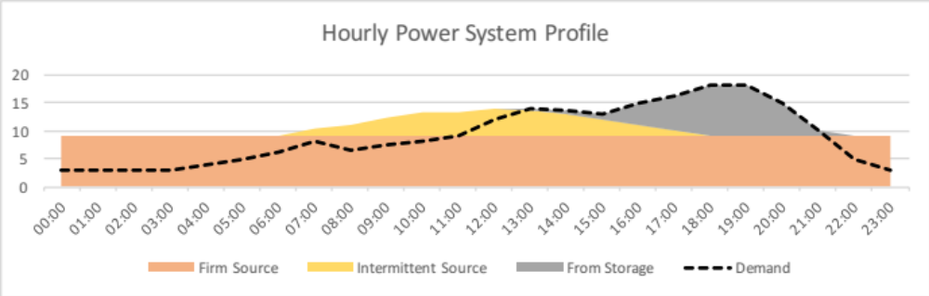
Figure 1 Example of System Relying on Solar, Storage and Geothermal.

In the context of this project, it has been clear that the appeal of geothermal energy is its capacity to meet baseload power; although not mentioned explicitly in the ToR for this consultancy, it has been pointed out that a like-for-like comparison of wind/solar vs geothermal implies that alternative technologies proposed must be in the context of providing baseload power. That is to say, they ought to provide, at the very least, firm power, and in an ideal scenario for geothermal, they would be capable of powering the entire grid. The studies below will explore this possibility for those renewable energy technologies which demonstrate themselves to be economically viable as a means of reducing diesel consumption (albeit intermittently).

At this stage, it is important to make mention of a key barrier to obtaining accurate results for a baseload power study: the frequent power cuts imposed by Ma-Mwe lead to a lack of load curves for periods that extend beyond several days of electricity supply. This significantly limits the scope of the study with regards to the analysis of intermittent technologies used in the context of providing baseload power. It must be noted that loose assumptions have been made to forecast the seasonal storage requirements for such power systems.

Wind
Background, Technology & Context
Wind is a promising source of renewable energy with significant potential in several parts of the world. The energy that can be converted by turbines is highly dependent on local wind speeds. Typically, the sort of topography that lends itself well to this technology is either a large expanse of open terrain, coasts and in some cases, mountainous areas.

Modern wind energy systems operate automatically. They are fitted with an anemometer, which continuously measures wind speeds; when wind speeds reach a minimum threshold (the cut-in speed) the rotors are free to rotate and generation ensues. If wind speeds continue to rise, the amount of power produced by the system increases until it reaches its peak (typically at around 15m/s), after which point further increases in wind speed do not yield additional power production.

There is, however, a maximum threshold upon which the rotors are stopped; this is called the cut-out speed. Typically, the cut-in speed is about 4m/s and the cut-out speed is 25m/s, but different systems will have varying cut-in and cut-out speeds depending on the design and size. When creating a feasibility study, the average wind speed is indicative of the projected performance of the system.

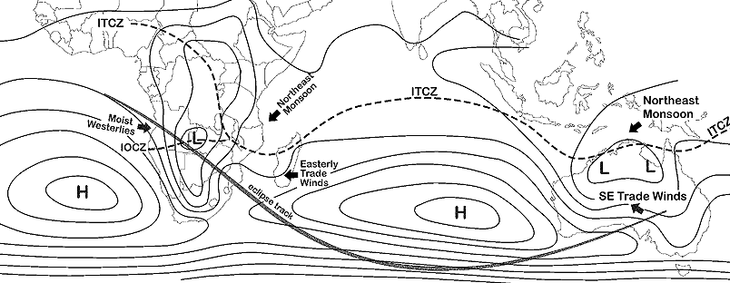
It is, therefore, of importance to have access to long term data of the wind resource, as this can dramatically impact the cost of wind energy production. Comoros’ wind regime is dominated by its latitude. It can be seen from the figure below that the islands lie within proximity of the ITCZ (Inter Tropical Convergence Zone), which gives rise to low average wind speeds.
Figure 2 Position of the ITCZ in Africa

This is inherent of tropical islands close to the equator, which is why wind power projects are not common at this latitude; the low wind speed negatively impacts the capacity factor of wind turbines. Despite this the expensive cost of diesel oil suggests that, notwithstanding the likelihood of a low capacity factor, the economic performance of wind systems in Comoros merits further investigation. Importantly, however, the existing wind data obtained for Comoros was captured from short towers of 10m; this compromises the accuracy of the forecasted yield and subsequent economic performance.

The installed capacity of wind systems in Comoros is low and limited to small scale (<5 kW) systems, but anecdotal evidence suggests their performance to be poor. In the context of this study, utility scale on-grid applications will be required to provide the equivalent yield to that of the Karthala geothermal project.

Benchmark
Not taking into account intermittency related constraints, including backup energy costs (i.e. integration costs), wind energy is among the most cost-effective RETs. In 2014, the LCOE for wind power averaged between $0.037/kWh and $0.081/kWh in the USA.

Model
Hourly wind data for Grand Comores was obtained. The figure below shows how this varies throughout the year.

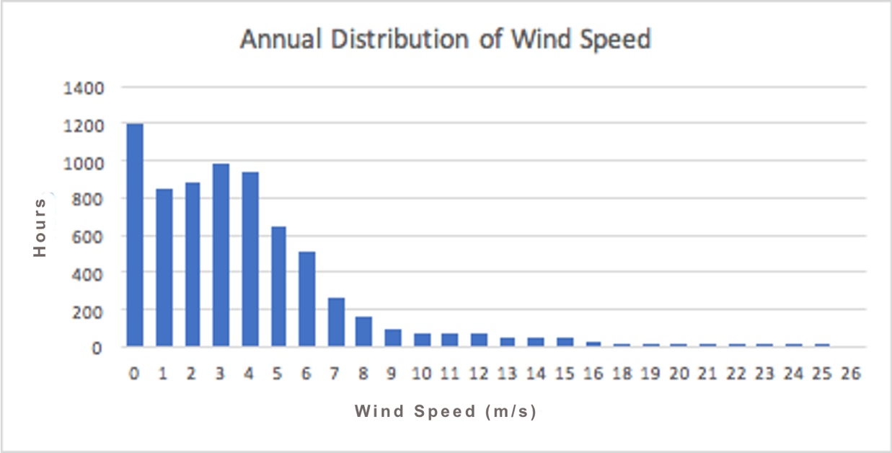
Figure 3 Annual Wind Speed Distribution on Grande Comores

This was used to estimate the production of electricity from a 1MW wind turbine, for which the power curve was provided by the manufacturer. This can be seen in the figure below.

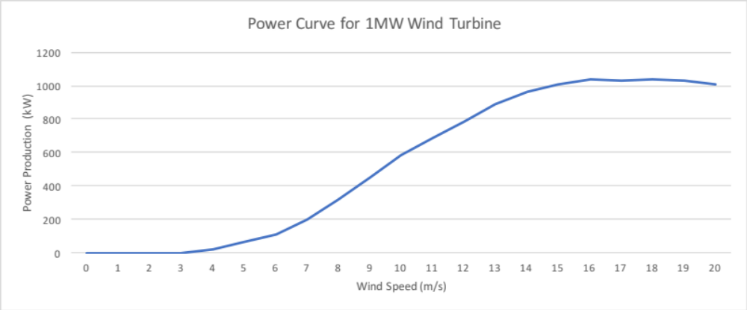
Figure 4 Typical Power Curve for 1MW Wind Turbine

It is clear from the power curve and Grande Comores’ wind speed distribution that the most frequent wind speeds (0-2m/s) will not produce power. The cut in speed for the turbine is approximately 4m/s, and power production increases steadily thenceforth. Using these data sets, the annual energy production for the 1 MW wind turbine was calculated; the distribution for this can be seen in the figure below.

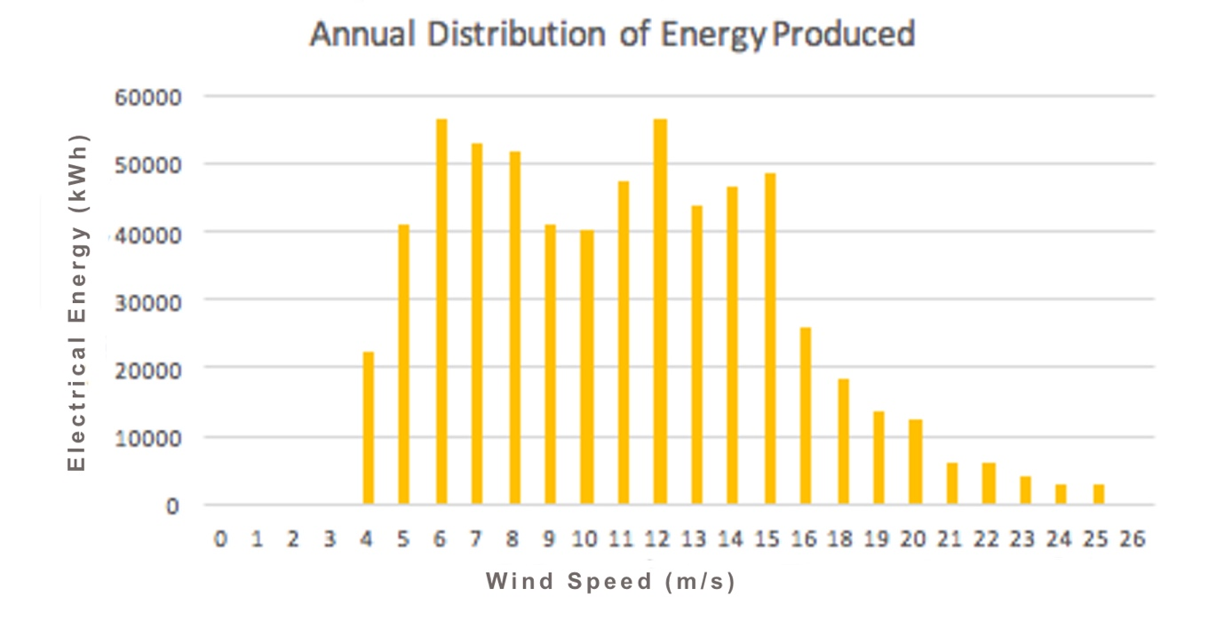
Figure 5 Annual Energy Production from 1 MW Wind Turbine

The capacity factor for this setup was calculated at approximately 7%, significantly lower than all other technologies explored in this study.

Economic Analysis
By using the energy production values obtained in the model (above), an economic analysis was made on a wind system capable of producing the equivalent energy to the proposed 10MW geothermal plant was undertaken. The tables and figure below gives an account of the results.

Energy | Capacity Factor | % | 0.07
 | System Size | MWp | 136
 | Base Yield | kWh/Year | 83,220,000
 | Deg Factor | % | 0.48%
 | System Fin Capacity Factor |  | 0.065

Financial | Specific Cost | $/kW | 2500
 | Capex | $ | 339,285,714
 | O&M Costs | $/Year | 20,357,143
 | Discount Rate | % | 0.05
 | NPV | $ | $(288,440,150)
 | IRR | % | -12%
 | Payback Period | Years | N/A
 | TLCC | $ | $626,198,157
 | LCOE | $/kWh | 0.314
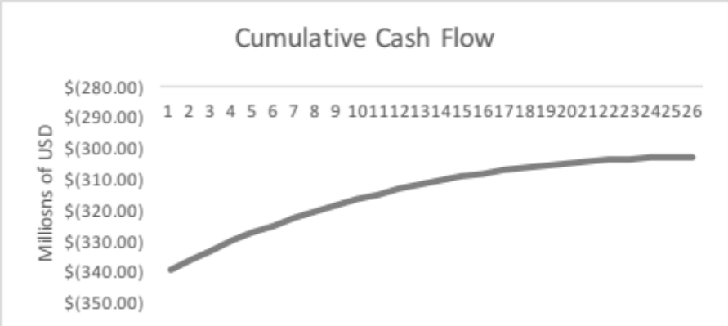
Figure 6

Given the very low capacity factor obtained for wind, using this technology to meet the baseload will require some 136MW of installed capacity. This will require significant space, over which the wind regime is likely to vary, perhaps compromising the overall capacity factor, cost and general performance of the farm. Moreover, it can be seen from the economic analysis that such a project would have a negative NPV, and an LCOE of >$0.3/kWh, which is close to an order of magnitude greater than alternative technologies.
Conclusion
Based on empirical wind data for the island, it is evident that wind energy does not perform well in Comoros. This having been said, it must be pointed out that little information was provided on the positioning of the weather station used to gather wind data, including the mast height and surrounding topography. It is recommended that further studies be made to gain a better understanding of wind speed distribution on the island of Grand Comoros, and if a higher value can be achieved for a large wind turbine’s capacity factor.

Solar Photovoltaics
Background, Technology & Context
Photovoltaic (PV) systems convert energy from the sunlight into electricity. PV cells, usually a thin wafer or strip of semiconductor material, generate a small current when sunlight strikes them. These cells can be assembled into modules that can be wired into an array of any size. Crucially, this allows solar PV systems to scale up or down without impacting their performance considerably. Because of this, solar PV is highly effective in both small and large applications.

Small systems (~5 kWp) are often mounted on the rooftops of buildings. These make use of an inverter, which converts electricity from DC to AC. Rooftop PV systems can act as standalone systems or can also be grid connected; the latter typically makes use of net metering or a feed-in-tariff, whilst the former is conventionally coupled to a battery system. In Comoros, there is currently no option to inject electricity into the grid from DG systems, so existing systems all make use of battery storage.

Like Wind Farms, Solar PV farms are set up to inject electricity directly into the grid, for which they are typically compensated by a feed-in-tariff. Also, these systems are sometimes fitted with trackers, which can significantly improve the capacity factor of systems located in higher latitudes. Comoros’ latitude suggests that trackers unlikely add a significant increase in the yield; even if this marginal increase is sought, the introduction of tracking systems will add to O&M costs as well as some element of downtime. For these reasons, the modelling exercise omits PV systems fitted with tracking systems.

Benchmark
The cost of solar has dropped dramatically over the past few years, leading to highly competitive LCOE. In 2016 utility scale solar PV costs fell by 11% to between $46 and $61 per MWh, which correlates well with the $35-$60 range for which new PPA agreements have been signed for the same period. In comparison, reciprocal diesel costs between $212 and $281. This having been said, these prices mentioned for solar do not include integration costs i.e. cost of transmission and back-up generation costs. These can have a strong bearing on the economic viability of solar, especially as its proportion in the energy mix of the grid increases beyond a certain threshold. For small islands located in proximity of the ITCZ, this threshold is lower than countries with larger networks. In 2014, the World Bank led a study on the thresholds for Mauritius and Seychelles, and it was concluded that the values were 20% and 15% of generation capacity respectively. For these islands to absorb additional renewables, specifically solar PV, enabling mechanisms such as battery storage would have to be introduced.
Models
As per the terms of reference of this consultancy, emphasis has been placed on assessing the performance of Solar PV as an alternative to Geothermal technology. To cover both options for Solar PV (Distributed Generation and Solar PV Farms), two separate models were developed to reflect their respective economic performance: small grid tied rooftop PV (distributed generation) and large, utility-scale PV (farms). In both cases, the results of the model are likely to be more accurate because of better quality input data that is currently available.
Option 1: Solar PV Farm with Diesel Offsets
In this model, a Solar PV farm of 48 MW has been modelled based to offset diesel consumption, but sized such that its total energy production matches the energy production of the proposed geothermal plant. No storage solutions have been included in this model. The results are highlighted in the tables and figure below.

Energy | Capacity Factor | % | 0.2
 | System Size | MWp | 48
 | Base Yield | kWh/Year | 83,220,000
Financial | Capex | $ | 95,000,000
 | NPV | $ | $207,899,109
 | IRR | % | 24%
 | Payback Period | Years | 5
 | LCOE | $/kWh | 0.053
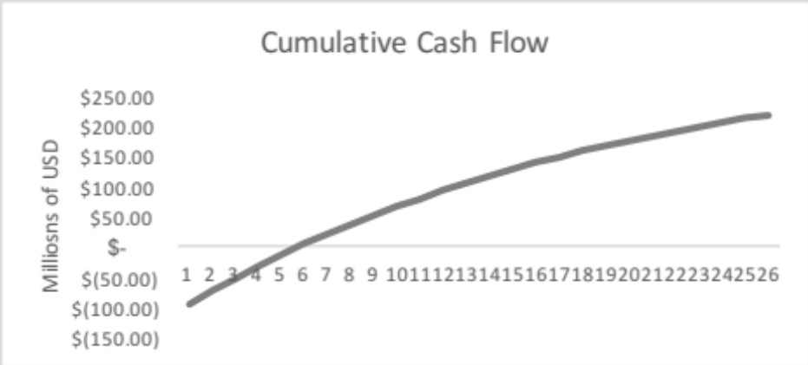
Figure 7

Based on these results, it is evident that Solar PV, when used conventionally, is economically viable. These findings warrant the next step of exploring the use of solar PV for the supply of baseload power, but it must be noted that such a study must also take into account the availability of land required for the installed capacity of solar PV. This has currently been estimated at 44.6 hectares.

Option 2: Solar PV Farm with Battery Storage to Provide Baseload Power

To ensure that an uninterrupted supply of baseload power can be achieved, storage technologies must be utilised in conjunction with solar PV. As discussed earlier, these technologies must be sized such that they can carry over energy produced during one part of the year to the next.

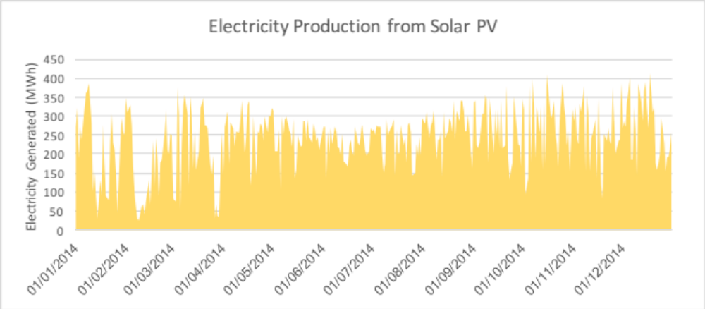
Figure 8 Annual Electricity Production from 48 MW Solar PV System

Given that there is a drop in the production of electricity from the 48MW farm during the first third of the year, energy must be carried over from the latter part of the year to balance out with demand. As mentioned previously, there is no data provided to indicate at which point in the year demand peaks. To proceed with this analysis, an assumption has been made i.e. to mimic a scenario whereby energy must be carried over from one part of the year (excess production) to another part of the year (a deficit in supply). This at least gives an indication of how much storage can be required should a 48MW solar PV plant be required to power Grand Comoros.
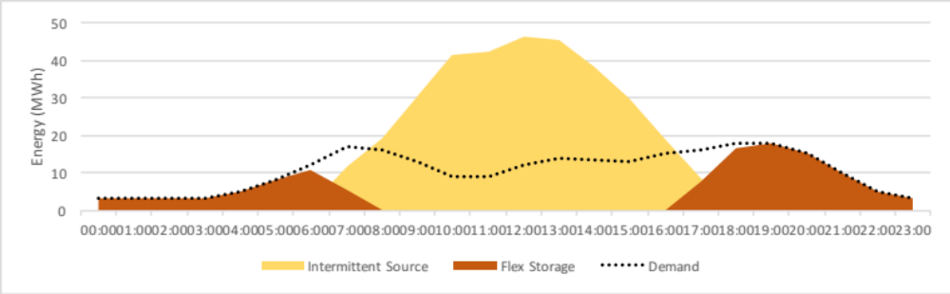
Figure 9 Typical Daily Performance of Solar PV and Battery Power System

The figure above illustrates how the system performs over a 24H/diurnal period; there is a period of excess production during the day, another period during which solar and storage work together to meet demand, and an evening period during which stored electricity is used to meet demand.

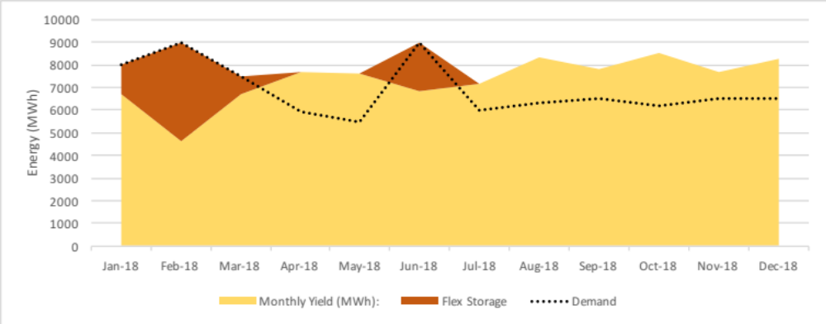
Figure 10 Annual Performance of Solar PV and Battery Power System

The figure above shows how the same relationship exists over an annual timescale. In the beginning of the year, a period of high demand coincides with a period of low production, thereby requiring the use of stored energy to meet demand. This relationship is inversed in the latter part of the year, and it is during this time that excess energy is stored. It can also be noted that the difference in energy required from the storage technology for the annual/seasonal timescale is several orders of magnitude higher than the diurnal timescale. For this hypothetical model, the size of the battery required to meet annual storage requirements is 6490MWh.
Recent studies show that island storage technologies, which are often used as replacements for peaker plants, have a specific cost between $273 and $1200 per kWh. Assuming a best-case scenario, the capital cost for the storage technology of this model is equivalent to approximately $1.7B.
Economic Analysis

Energy | Capacity Factor | % | 0.2
 | System Size | MWp | 48
 | Base Yield | kWh/Year | 83,220,000
FINANCIAL | Specific Cost | $/kW | 2000
 | Capex | $ | $1,847,300,000
 | NPV | $ | $(1,460,958,034)
 | IRR | % | -8%
 | Payback Period | Years | 0
 | TLCC | $ | $1,857,341,936
 | LCOE | $/kWh | 0.930

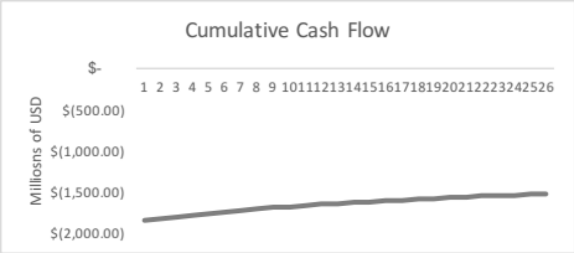
Figure 11

It can be seen from the results that this project has a poor economic performance; the LCOE is an order of magnitude higher than that of the PV farm used to offset diesel.

Overview of Results

As can be seen from the two figures below, the option which has the best economic performance is a Solar PV farm without storage. Its LCOE is approximately 5 USD cents per kWh, and it has a positive IRR of nearly 25%, but it cannot be relied upon to provide baseload power due to its intermittent nature.

Moreover, there are obvious barriers that stand in the way of implementing such a system. Using the rule of thumb of 9.3m²/kWp of Solar PV, the space requirement for 48 MWp will be equivalent to 44.6 hectares. It the government was to pursue a system of this size, one of the possible ‘sites’ is rooftops, but PV systems mounted onto these will have to perform as well (pro rata) as if they were ground-mounted i.e. correctly oriented and be free of overshadowing, as well as allowing easy access for maintenance work. This alone already limits what little roof space is available, forcing the lion’s share of the installed capacity to be ground-mounted, for which additional technical and logistic constraints (e.g. distance from the grid, associated O&M costs, orientation and overshadowing) will not only reduce economic performance, but will, in all likelihood, limit the installed capacity. Solar PV, therefore, makes economic sense as a technology to reduce diesel consumption, but its capacity is likely to be limited by the availability of eligible sites.

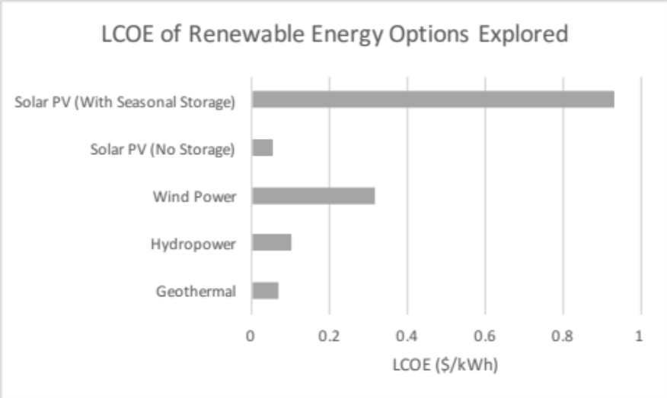
Figure 12

The least performant option is Wind Power, which has an IRR of close to -12.5% and LCOE of approximately 30 USD cents per kWh. Both Geothermal and Hydropower perform satisfactorily, but as discussed earlier, the limitations of the Hydropower option are that insufficient data has been made available to establish an accurate value for its capacity factor. Moreover, Hydropower is further limited by its low potential (~5MW, thereby unable to provide baseload power) and location (not on Grand Comores).

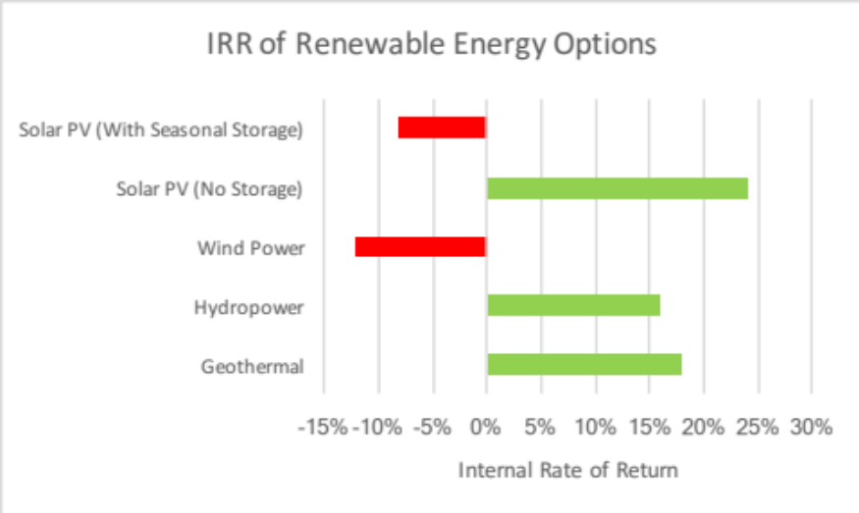
Figure 13 Internal Rate of Return for Renewable Technologies Analysed
The option for which Solar PV with battery storage was used to provide baseload has been demonstrated to be economically unviable (negative IRR and high LCOE). This having been said, loose assumptions were made to characterise the grid’s annual load curve. Despite this, even if the battery size was to be reduced by an order of magnitude, it is unlikely that the LCOE would be competitive with Geothermal.

- Conclusions and Recommendations
Based on these results, it is recommended that the proposed Geothermal project be prioritised as it is the only technology that can provide an economically viable firm source of power. Although there are significant risks associated with this technology, it is certain that alternatives seeking to provide the same quality of power are not economically viable or are not capable of scaling up (whether it be because of a lack of resources or space) to meet all of Grande Comoros’ electricity needs. It must be noted, however, that the process of developing this project will extend over several years, during which time the Solar PV auto producer market will continue to evolve. In this regard, it is also recommended that the regulatory environment for distributed generation be strengthened to safeguard the sustained growth of the Solar PV market. Over time, it is likely that as the cost of storage decrease decreases, electricity demand will increase and additional firm power be required. To this end, it is also recommended that the Government plans for the diversification renewable energy technologies within the power system, thereby reducing the inherent risks associated with Geothermal technology.

ANNEX J: Environment and Social Management Framework

A. Executive Summary

Geothermal development on Grande Comore for electricity generation is in line with the country’s objective of reducing poverty through the provision of better income-generating opportunities to the population. Indeed, the rehabilitation and expansion of production facilities as well as transmission and distribution lines will bring about a reduction in the pockets of rural and urban poverty due to the unreliable diesel electricity generation source, characterized by very frequent technical load shedding by MAMWE. The availability of an efficient and reliable power supply will result in development initiatives that will be beneficial, in particular, to women and the youth: establishment of SMEs and small grocery stores, organization of crafts and trades (sewing, embroidery, hairdressing, carpentry, sawmilling, metalwork, painting, vehicle bodywork, plumbing, welding), better time management for women (fewer daily errands and chores relating to fuelwood gathering), cold chains (good food and vaccine preservation), security lighting, media use (television, internet, computers), school lighting for evening/Koranic classes, etc.

B. Project Description

C. Potential Environmental and Social Impacts

- On the physical environment:
The present use of diesel fuel impact can lead to pollution of the soil and water system through contamination due to leakage of hydrocarbons, oils and other lubricants from construction equipment or transformers. In addition, air pollution is caused by exhaust fumes from diesel power stations which are located near residential areas and noise pollution from the exhausts of the diesel engines.
Geothermal development, on the other hand, will have minor environmental impacts. The disposal of waste water containing small quantities of chemicals (boron and arsenic) and gases (H₂S and CO₂) is an important issue, but various methods are used for dealing with it, including total reinjection of separated water, condensate and gases; chemical treatment; and mineral extraction. Costs associated with implementation of these measures 1-2% to the electricity generation cost. With regard to CO₂ emissions, it has already been pointed out that these amount to only 10% of emissions from a diesel generator of equal installed capacity.

- On the natural environment:
The impact on local fauna and flora will result mainly from the building of Medium Voltage (MV) lines that may involve pruning and sometimes the destruction of vegetation to protect new lines against the risk of damage.
The impact on the flora will be very limited given the location of MV lines along the road away from protected areas or areas with ecological value. This will be a factor limiting the impact on the remaining endemic flora; however, a number of trees must be felled, particularly at certain higher altitudes. The project will initiate a process of securing permission from the Directorate General of the Environment before vegetation is removed and a process will be initiated for trees to be replanted elsewhere.
Furthermore, the erection of MV pylons will not be an obstacle to the movement of wildlife or livestock, but may have a potential impact on bats and large birds with risks of accidents.

- On socio-economic aspects:
The major positive impact of reinforcing power generation facilities and transmission lines is that of providing MAMWE with a reliable source of electricity, thereby minimizing load shedding that is currently commonplace. Securing energy supply will have a very significant positive impact on socio-economic activities of the population in the catchment areas, especially with new network extensions. The new lines will help the authorities cope with growing demand for energy and will thus have positive economic and social effects on economic growth. Small business owners and craftsmen will better equip themselves, diversify their professional activities and provide better quality services. Agricultural production will benefit from cold chains working 24/7, processed foods (canned vegetables, tomato puree, fruit juice, etc.) and livestock products (meat, milk, butter, curd, etc.) will be better upgraded and losses currently incurred due to poor refrigeration significantly reduced. Women will have this efficient and reliable energy supply which will lead to the modernization and development of the cities served and improvement of the quality of life. Education and health (e.g., maternity, vaccine refrigeration) facilities will better meet the population’s needs.
Currently, livestock activities, market gardening (processing of tomatoes and other vegetables; preservation of fresh vegetables, etc.) and fruit farming suffer huge losses because they cannot develop without a cold chain running on a reliable electricity supply.
Handicrafts cannot develop due to the lack of the energy required (frequent power cuts) for water supply (borehole operation), lighting (safety and evening activities) or operation of work tools (moulding or pounding of cassava, maize, rice (real repetitive chores), sewing and embroidery, hairdressing, dyeing, literacy, operation of health and community centres and services (video games, media, mobile phone recharge etc.).

On Gender and Youth:
The situation of women and youth will improve due to the project’s major positive impact on employment. Organising mini-credit schemes for their benefit, grouping them into cooperatives and providing micro-credit will enable them to develop their crafts while organizing the marketing channels.
In rural areas, women's activities are primarily focused on agriculture and they suffer huge yield and income losses due to shortages of the electricity that is essential in operating the cooling equipment and mechanized irrigation of off-season crops.
Home comfort and hygiene, which are specifically ensured by women, also require adequate lighting and energy for the operation of equipment, including for water supply, fridges, media such as TV, radio, phones, video games, etc. Women will derive specific benefits from educational programmes resulting from the project, such as adult literacy. Women will also benefit from educational radio and television programmes intended for rural communities which will become more accessible.
The mechanization of repetitive tasks will help reduce drudgery in women’s work. The time freed up will enable them have access to informal education and to make time for other more rewarding activities. Children will also benefit: improved maternal care and a more motivating learning environment.
Improving the cold chain (better preservation of fresh food, vaccines, drugs, air-conditioning, etc.) will help preserve the Comorian population’s health, especially women, children and youths.

D. Legal and institutional framework

E. Procedures for screening, assessment and management
- Concerning the physical environment:
During the construction phase, MAMWE will take all measures to prevent erosion and restore the soil to its natural state after refilling trenches and completing the concrete foundations of the poles and pylons.
They will also ensure they do not discharge effluent pollutants into the ground and will organise site sanitation and remediation work.
The prime contractors will, as much as possible, avoid altering the soil. They will conduct the stripping of top-soil before carrying out operations and rehabilitate the area after the works.

- Concerning the ecosystems:
Mitigation measures will consist in choosing work routes outside natural parks and natural reserves, avoiding the destruction of the forests and minimizing as much as possible the project rights of way.
The prime contractors will, as much as possible, replace the trees destroyed during the works, through compensatory tree planting. They will seek to create mechanisms that will enable large birds to find suitable and secure nesting on pylons. MV lines laid across valleys crossed by flocks of birds will be made ​​visible at night through the use of flashing devices.

- Socio-economic and land-related components:
- The prime contractor must implement a participatory approach to disseminate project information to secure the cooperation of the population.
- Where works are envisaged that can affect cultivated fields, these should be done after harvesting.
- Promote the use of local labour, sub-contract to local craftsmen.
- Make an inventory of those who might be affected by the felling of fruit trees or other trees as a result of the connection of new MV lines and compensate them.

- Health and Safety Aspects
- MAMWE will regulate traffic in the works area.
- Residents will receive notification prior to the commencement of works concerning temporary problems of access to certain sites owing to the works organisation and for security reasons. The sites will be permanently and fully marked out (sign-posts, flashing lights, etc.) in collaboration with local road services, etc. Detours will eventually be created, as necessary.
- MAMWE will ensure that waste from the works sites is recycled or disposed of in controlled landfills.

F. Institutional arrangements and capacity building

G. Monitoring and evaluation arrangements

It will be the responsibility of MAMWE to verify the proper implementation by the contractors of the environmental and social impact mitigation measures contained in the ESMF. Their periodic inspection report will be forwarded to UNDP and other competent authorities; they will include their observations and comments on the relevance and feasibility of impact mitigation and remedial measures contained in the ESMF.
The environmental and social monitoring programme will be under the responsibility of the prime contractor or under its direct control, if there is a sub-contractor. Its nature and aspects covered in this programme will depend on the scale of the works to be carried out.
This programme will involve monitoring general measures (informing neighbouring population, employment conditions as relevant, site marking, and proper application of safety rules). The programme will also involve the monitoring of measures on soil quality and structure, protection of water resources, solid waste management, bio-diversity protection and private property and human environment protection.
A bi-monthly environmental and social monitoring report will be published by MAMWE during the construction phase. During the operational phase, this report will be published at six-month intervals.
Capacity development will be necessary to enable various stakeholders (Energy Department, MAMWE, Environmental Department, etc.) to be in a better position to carry out their responsibilities. This capacity development effort will be carried out through training/sensitisation of parties involved in environmental evaluations specific to the sector.
Comoros has a strong tradition of community or association management. Successful management of any electricity and environmental impact management initiative must involve the community. Its involvement from the start-up phase is highly desirable.
Presentations of the project and environmental measures and particularly of the constraints relating to these measures will be organized before the commencement of works by a Community Relations Officer.

H. Stakeholder engagement and information disclosure process

The views and concerns of those living in the project impact area have been noted through discussions and interviews. Three stakeholder groups have been identified:
- The local population, comprising traders, road users, district and village residents, etc...);
- Local authorities;
- Civil society and NGOs
Through the various discussions, great expectations were expressed at all levels (authorities, civil society, NGOs and general population) regarding the indisputable need for access and regular supply of electricity.
All concerned are aware and convinced that facilitated access to electricity will help make life easier for the population, preserve their health, and support the country's educational system and development.
This project will also assist in preserving the environment by reducing deforestation-related problems affecting the forests on Grande Comore, with the use of wood as an energy source for cooking, ylang-ylang, distilleries, etc.).
The success and sustainability of such a project is dependent on the involvement of all parties concerned, including the role of NGOs and the civil society in sensitising those who will derive benefits from its implementation.

Annex H: STANDARD LETTER OF AGREEMENT BETWEEN UNDP AND THE GOVERNMENT FOR THE PROVISION OF SUPPORT SERVICES

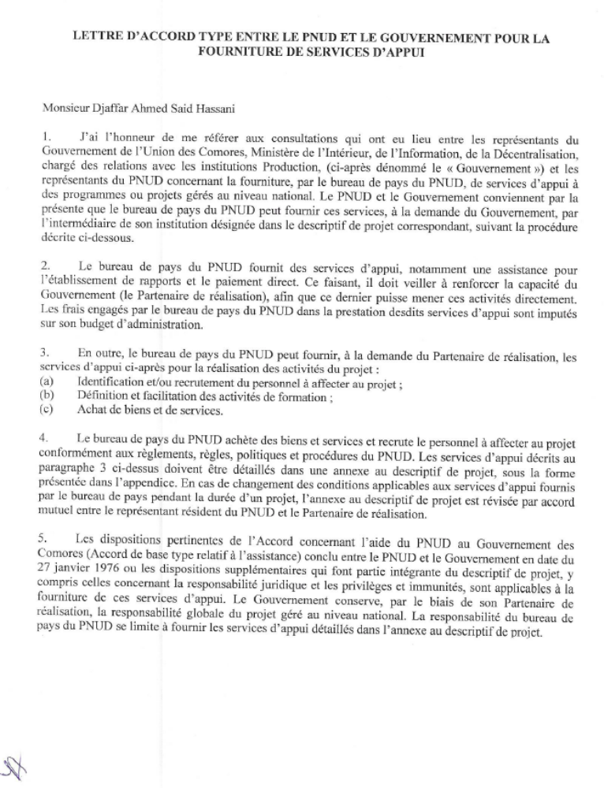

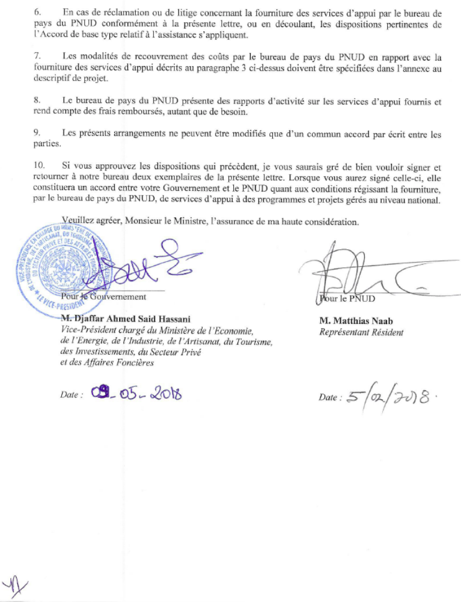

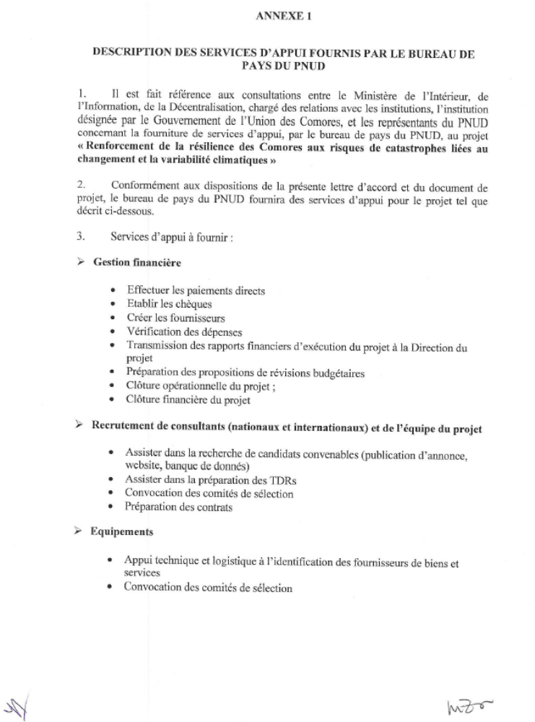
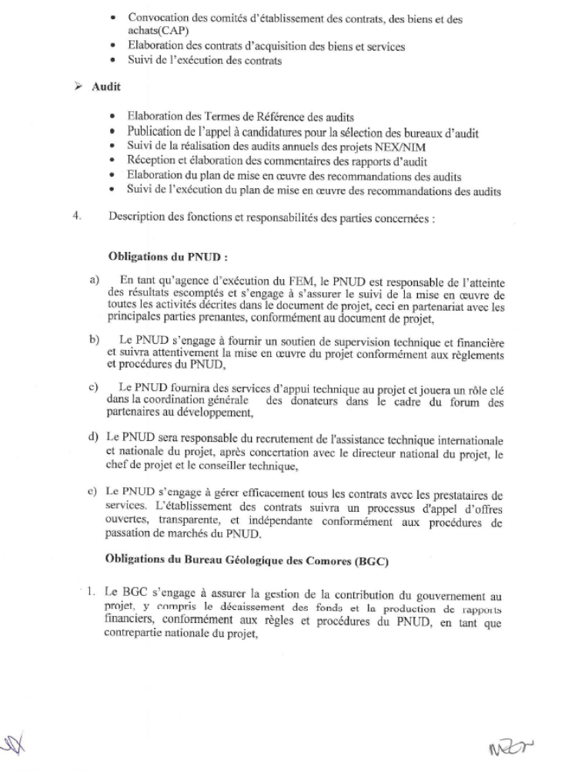
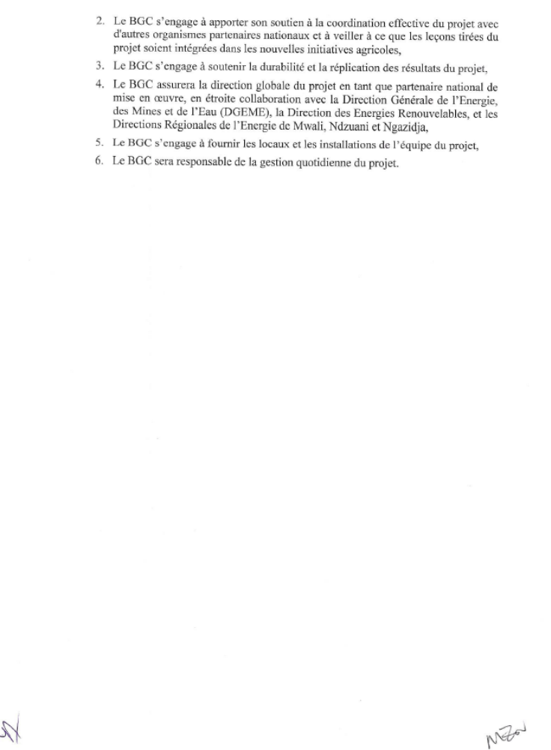
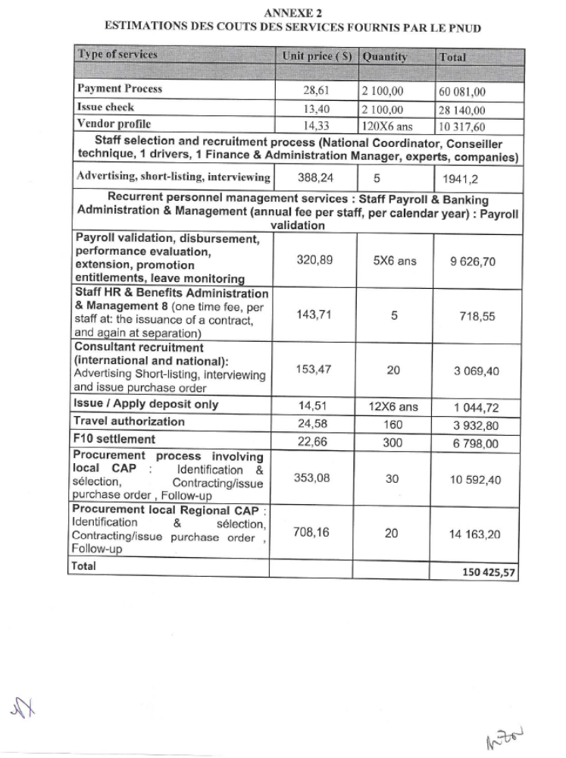
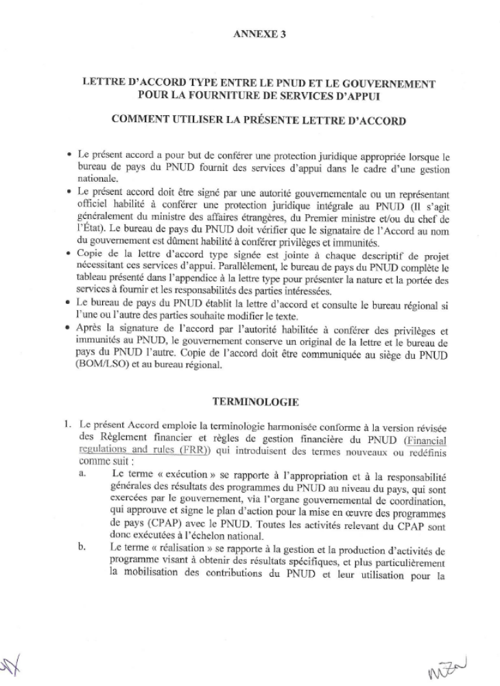
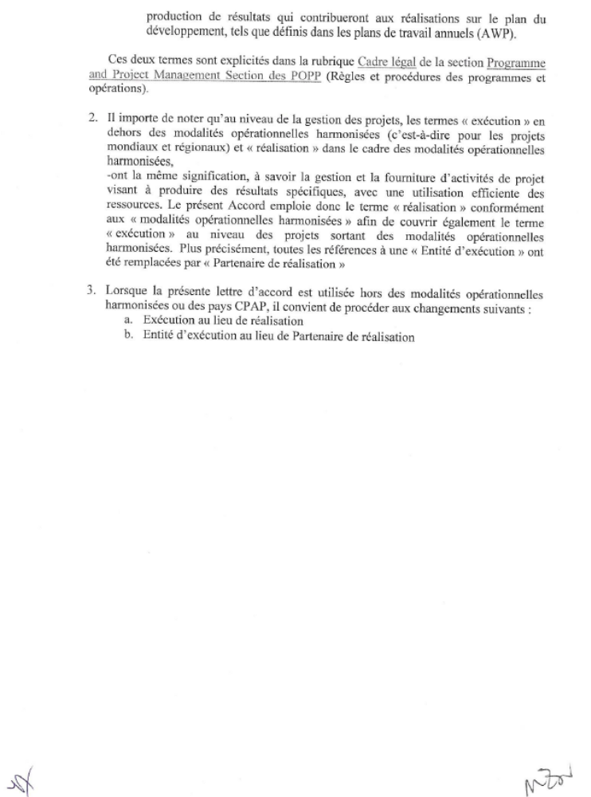
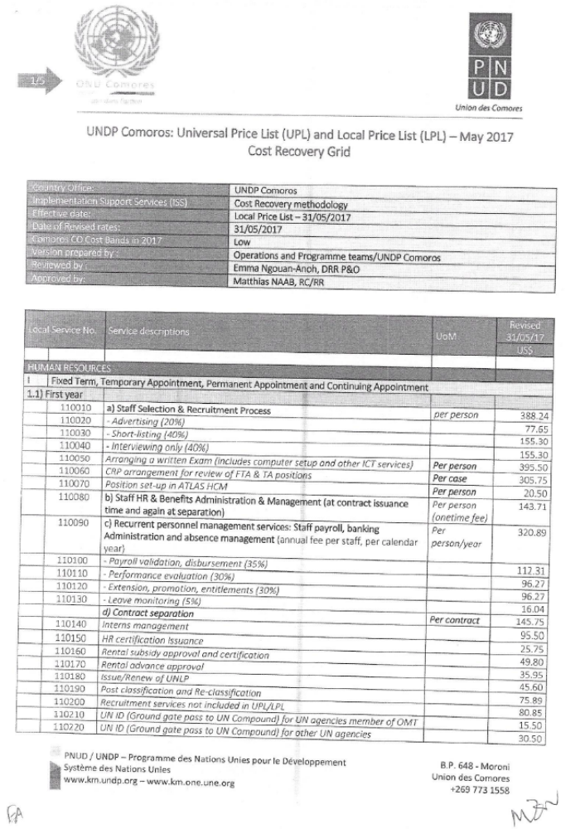
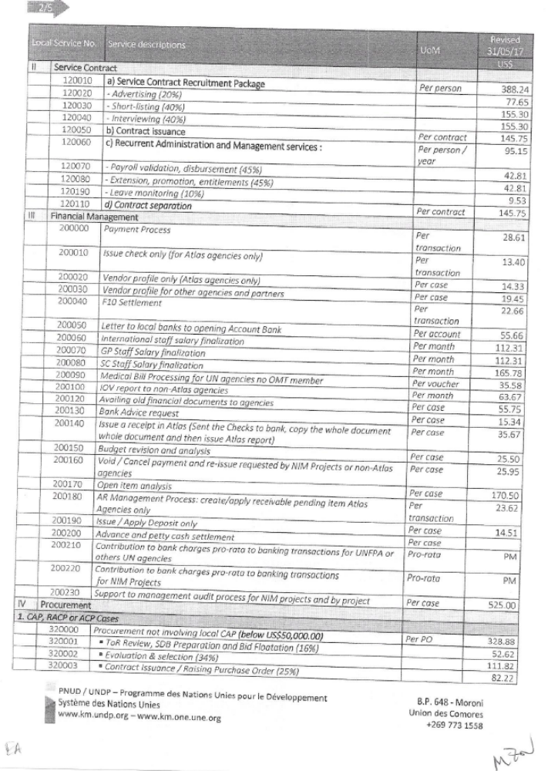
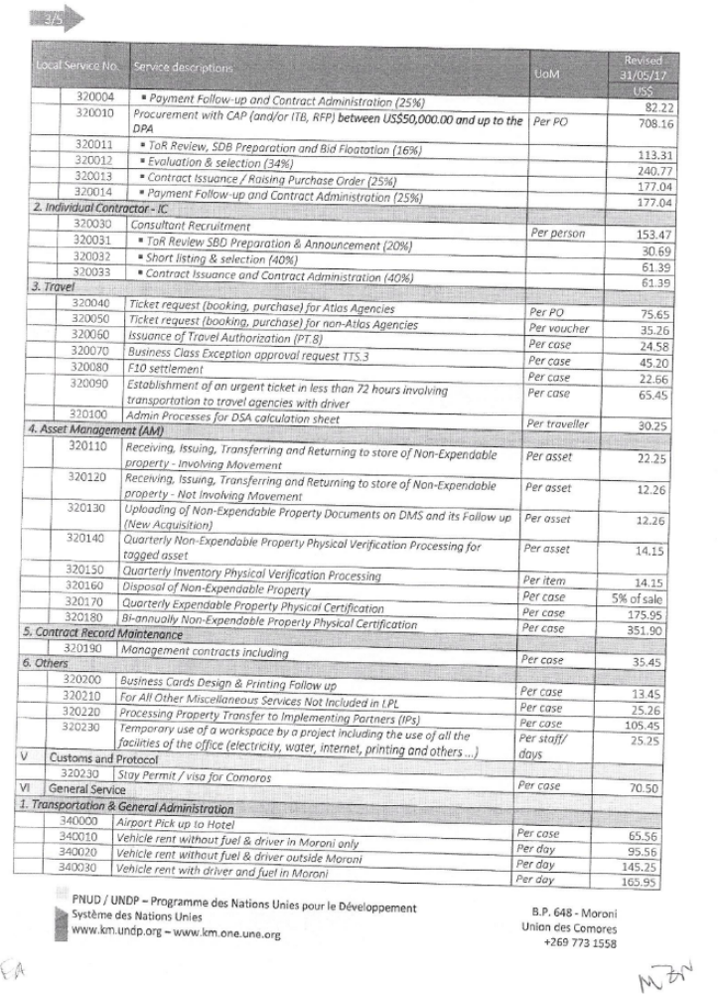
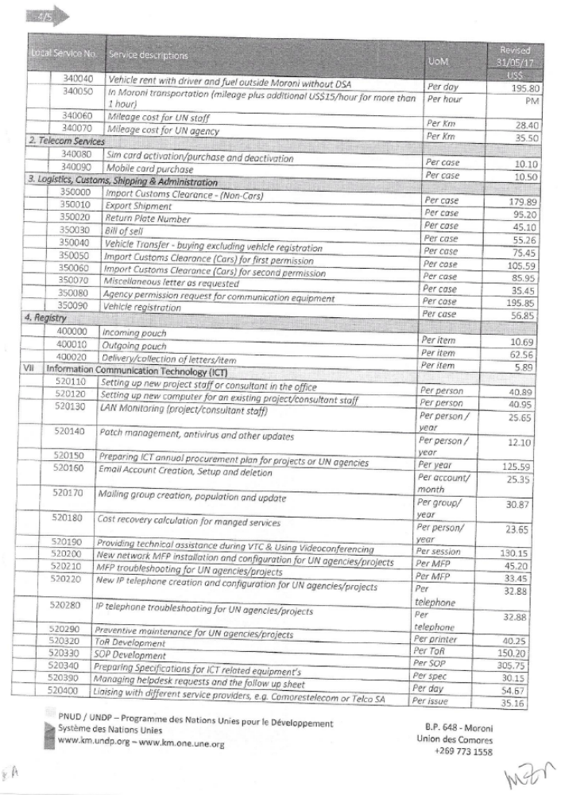
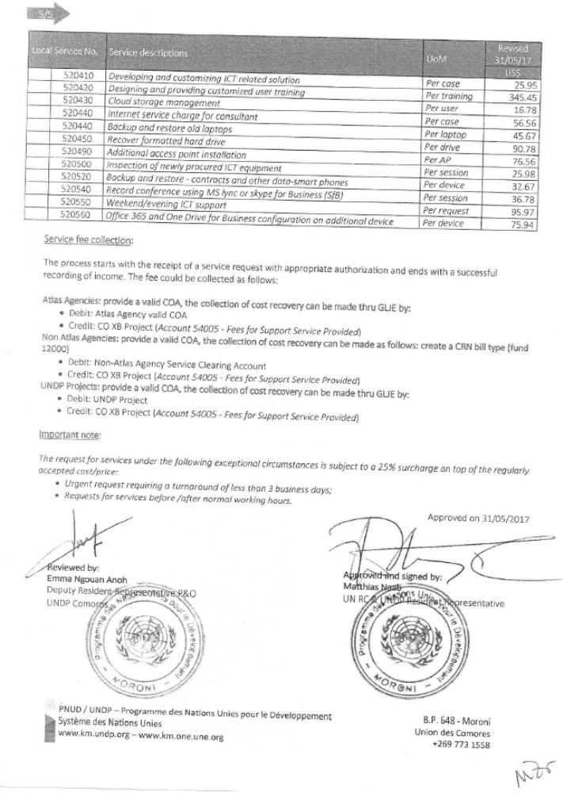

Source: Worlddata.info, 2016
Comoros Phase III - Comoros Renewable Energy Options Assessment, Jacobs 2016
Reference: Jacobs, Comoros Phase III - Comoros Renewable Energy Options Assessment.
Source: Reunion Island Energy Autonomy Objective by 2030, Sandrine Selosse, 2014
Source: US Energy Information Administration.
See http://www.undp.org/content/undp/en/home/operations/transparency/information_disclosurepolicy/
See https://www.thegef.org/gef/policies_guidelines
See guidance here: https://info.undp.org/global/popp/frm/pages/financial-management-and-execution-modalities.aspx
Excluding project team staff time and UNDP staff time and travel expenses.
The costs of UNDP Country Office and UNDP-GEF Unit’s participation and time are charged to the GEF Agency Fee.
Prohibited grounds of discrimination include race, ethnicity, gender, age, language, disability, sexual orientation, religion, political or other opinion, national or social or geographical origin, property, birth or other status including as an indigenous person or as a member of a minority. References to “women and men” or similar is understood to include women and men, boys and girls, and other groups discriminated against based on their gender identities, such as transgender people and transsexuals.
In regards to CO_{2,} ‘significant emissions’ corresponds generally to more than 25,000 tonnes per year (from both direct and consequential sources). [The Guidance Note on Climate Change Mitigation and Adaptation provides additional information on GHG emissions.]
Forced evictions include acts and/or omissions involving the coerced or involuntary displacement of individuals, groups, or communities from homes and/or lands and common property resources that were occupied or depended upon, thus eliminating the ability of an individual, group, or community to reside or work in a particular dwelling, residence, or location without the provision of, and access to, appropriate forms of legal or other protections.
Lazard (2016)
Lazard (2016)
Lazard's levelized cost of energy analysis (2014)
PV Magazine USA (2016)
Green Tech Media (2016)
Lazard’s levelized cost of storage—version 2.0 (2016)

